

Bank System

Prepared for: Catherine Moloney

Prepared by: Peter Elliott, Tom Anderson, Liam Maloney, Ciara McMahon

C2p Bank

23 March 2015

Abstract 3

Learning Goals 3

Technical Goals 3

User Interface Description 4

Font Choice 4

Menu Arrangement 4

Color Scheme 4

The Help Feature 4

system layout 5

Er diagram 6

Database layouts 7

accountHolder 7

customer 7

depositAccount 7

loanAccount 8

transaction 8

password 8

rate 8

Menu system 9

Menu Description 9

Menu Screenshots 9

index.php 10

bank.js 16

group css 18

common javascript 28

Iframe.js 28

individual work units (liam maloney) 31

individual work units (tom anderson) 79

individual work units (ciara mcmahon) 108

individual work units (peter elliott) 142

Table of contents

Summary

## Abstract

This Technical Manual has been compiled as part of the C2P Bank Project (Programming Stream). It outlines the following topics for review by class tutor, Catherine Moloney:

* + User Interface Description
  + System Layout
  + Database Layouts
  + Menu System
  + Style Sheets
  + Screen Shot and Code ( x 5 ) for each team member.

## Learning Goals

Increase understanding of technologies and methods used to develop and deploy a functioning application. In this case, a browser based, database backed, banking system. Technologies used include PHP, HTML, CSS, MySql, JavaScript, FTP/SFTP, and a variety of Development Environments. Methods undertaken include Database Design through use of ER diagrams, analysis and understanding of a functional spec to provide guidance on the functionality of a system, and organization of workflow to ensure good collaborative teamwork throughout the group. Skills necessary for effective teamwork will also be developed and acquired through completion of the project.

Summary

## Technical Goals

Produce a functioning Banking System for use by Bank employees. The system should be robust; error checking and validation of user input should be ever-present ensuring database integrity. Adequate feedback should be given to the user in event of incorrect input, and indicators of the desired input should be given to the user before input takes place where appropriate. Where errors do occur, a system crash should be avoided at all costs.

The system should contain a user friendly design and logical layout. All areas of the system should be easily reached, without the need to descend unnecessarily through menu layers. The system should contain a coherent visual layout for similar screens, and provide similar feedback for similar input elements. Styling should not be overbearing, as this system will be used by banking employees for long periods of time.

# User Interface Description

## Font Choice

The fonts chosen for the application were limited to two, a Helvetica based sans serif font stack for menu items and the logout tab, and a Times New Roman based serif stack for the rest of the text. The choice of Times New Roman was based on its wide spread availability and it’s no nonsense, intelligent, business like appearance which makes it an ideal font for anything that has to be checked or read carefully. As a font that was designed as a large format poster font, Helvetica was chosen for the larger items that need to convey their meaning at a glance such as the menu items and the logout tab. While Helvetica is not as widely available as Times New Roman its inclusion was felt to be justified by the fact that it is a particularly beautiful font and the default sans-serif fonts on most systems is Arial which Microsoft designed as an unlicensed Helvetica replacement.

## Menu Arrangement

The menu items are arranged in order of expected frequency of use in left to right reading order. The top level menu items require a click to show their submenus rather than having them shown on mouse over, as this is expected to be less distracting for the user. Once an item from the main menu has been selected, any child menus will pop up automatically. Open menus will close when the user clicks on another top level menu item or when the user clicks an area of the screen that is not the menu bar.

User interface description

## Color Scheme

The colour scheme was chosen to be physically easy on the eyes and to allow the user to operate the application for extended periods of time. A group of low contrast complementary colours were chosen comprising of pastel blues. The main body of the page has a deliberate flat appearance for ease of reading while drop shadows and brighter colours are limited to the top of the page for aesthetic interest.

The overall design of the forms was based on both ease of use and ease of programming through standardisation, with the screen being divided up into a small number of fieldsets which group the inputs and outputs in a standard manner across pages. The user’s progression across each page is from left to right and top to bottom as it is when reading. The button with the positive action e.g. Save, Submit, etc... is placed on the bottom right of the page in line with the flow of the rest of the page while the cancel button is placed on the left.

## The Help Feature

Each form includes a standard help box which the user can move to a convenient position by dragging. The help form is started and dismissed by clicking on a question mark image in the header of the form. On mouse over, the cursor changes to a question mark indicating that help is available. The help form can also be dismissed by clicking on an ‘x’ in the top right corner of the window.

# System

# layout

system layout

# 

## currentAccount

Er diagram

# Er diagram

# Database layouts

## accountHolder

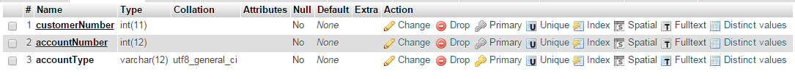

**currentAccount**

database layouts

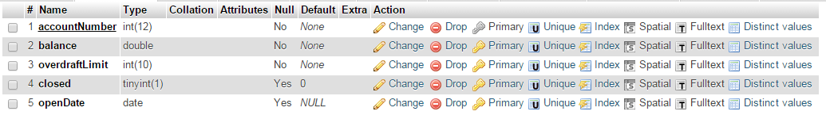

## customer

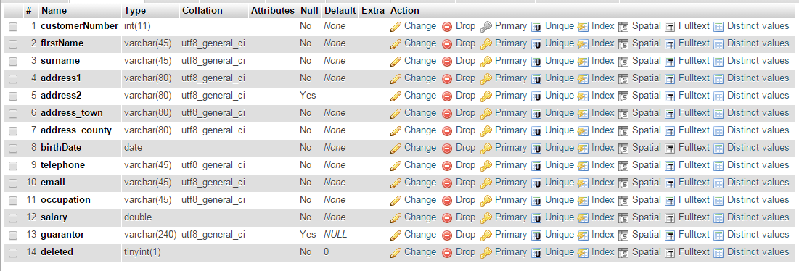

## depositAccount

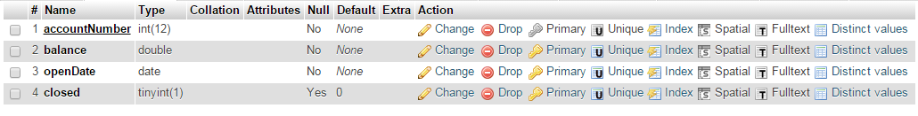

## loanAccount

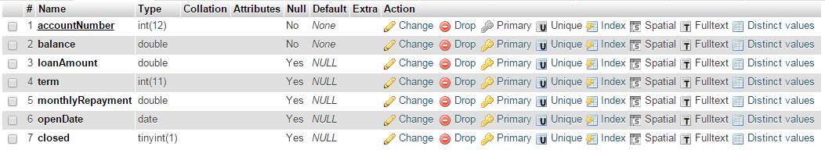

## transaction

Database layouts

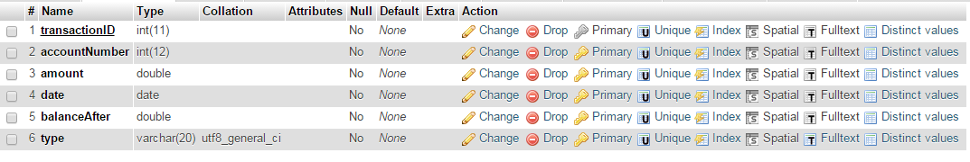

## password

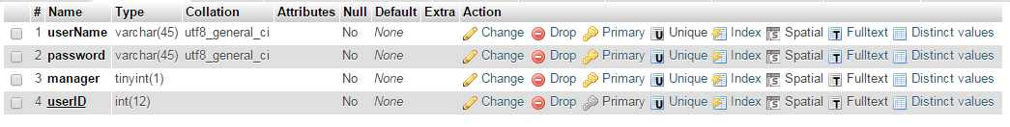

## rate



# Menu system

## Menu Description

The menu and help systems are both incorporated into the main index.php file with some of their functionality being coded into the pages held in the iframe and are included together for that reason.

The menu system was designed to be as intuitive as possible with the items organised from left to right in order of expected frequency of use. The menu system is activated by clicking on one of the items on the menu bar, after the click any child menus pop up and disappear automatically as the user moves the mouse. The intent of adapting this system was to reduce the chance of the user being distracted by flickering menus as he/she moved the mouse over the menu bar.

menu system

The menu system is loaded as part of the main index page when the user visits the server, and remains in the browser as the user navigates through the pages. As the user selects different menu options the contents of the iframe in the index page change, while the main index page is not reloaded unless the user refreshes the browser. The size and position of the main structural elements of the menu are set by styles in the menu.css file, while other decorative styles are at the end of the style.css file. The menus are drawn in place and shown or hidden by changing the visibility style with a number of JavaScript functions.

## Menu Screenshots

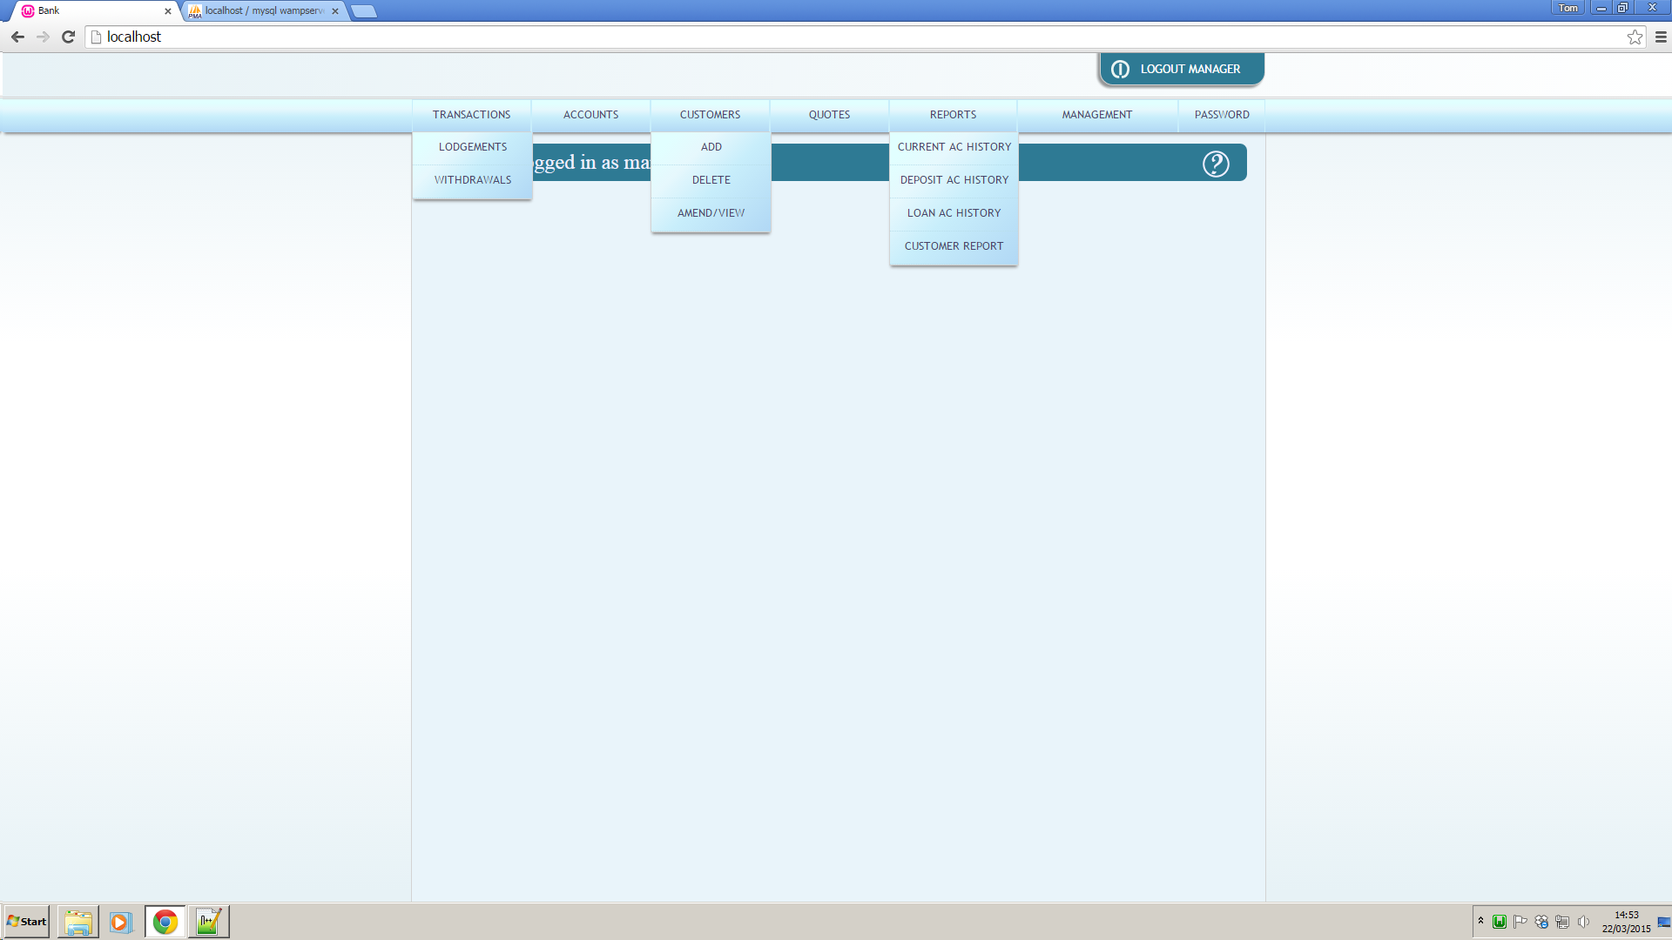

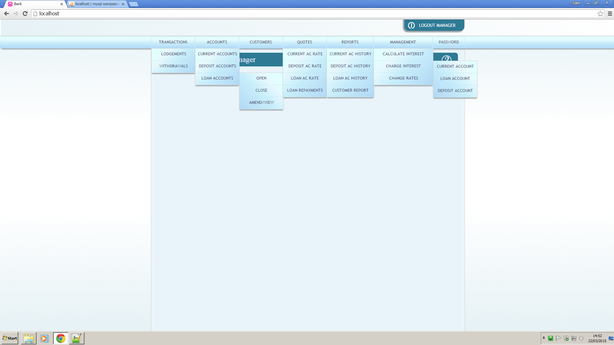

# menu source

menu system

## index.php

# 

menu system

# 

menu system

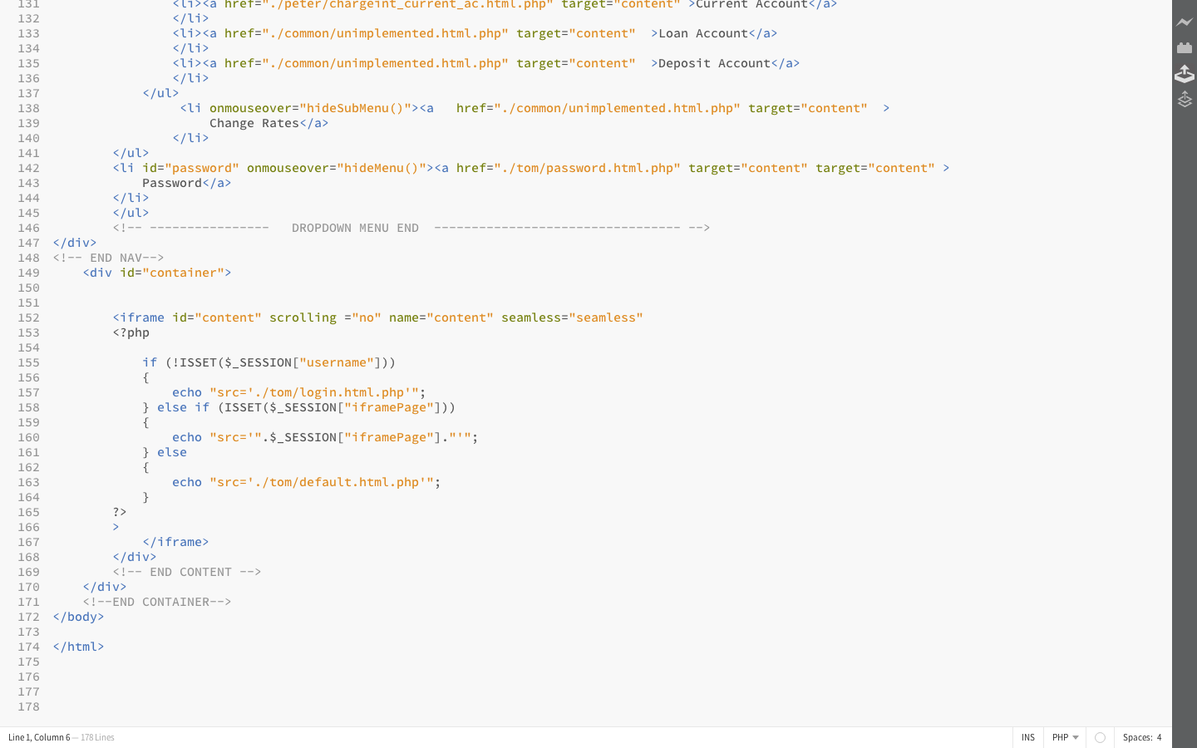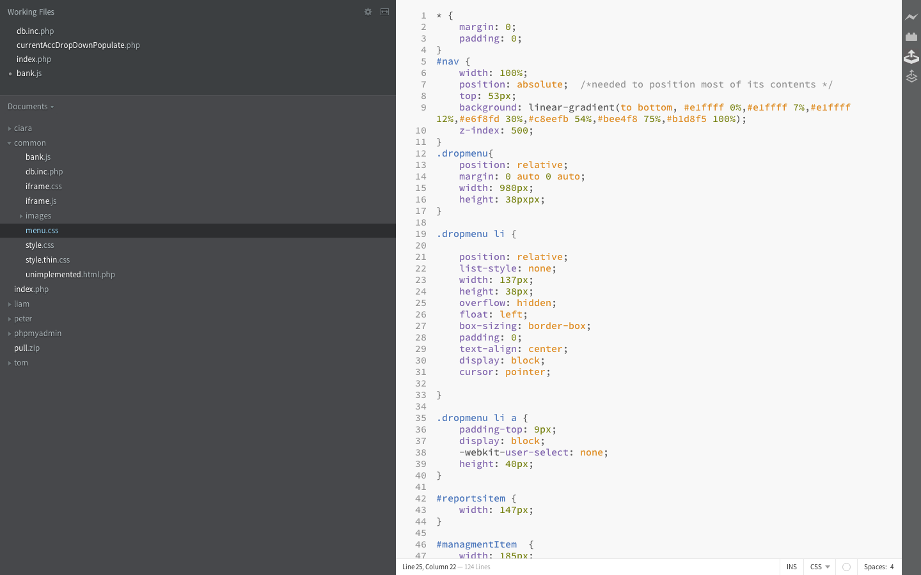

menu system

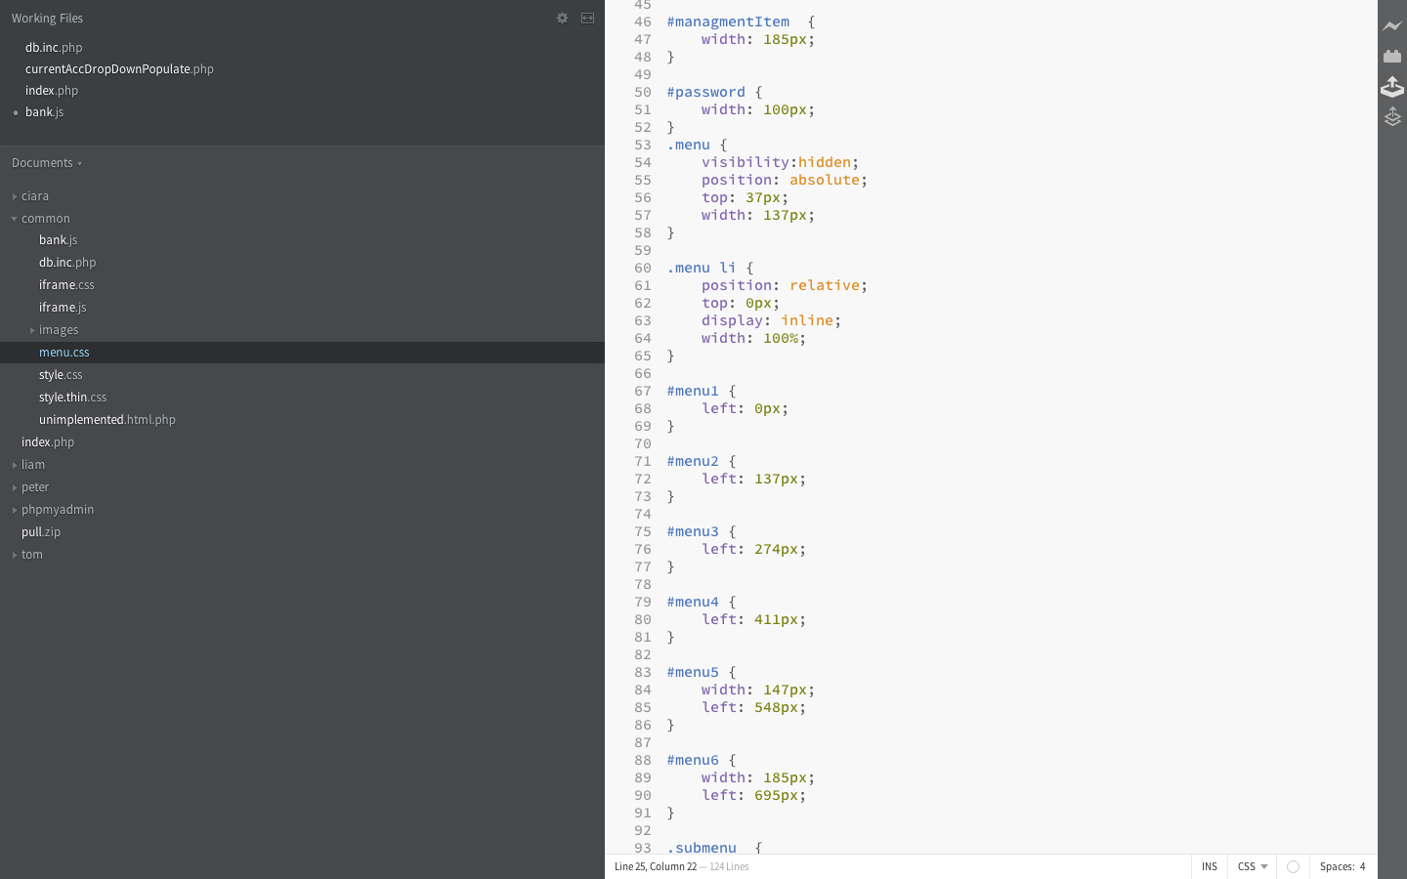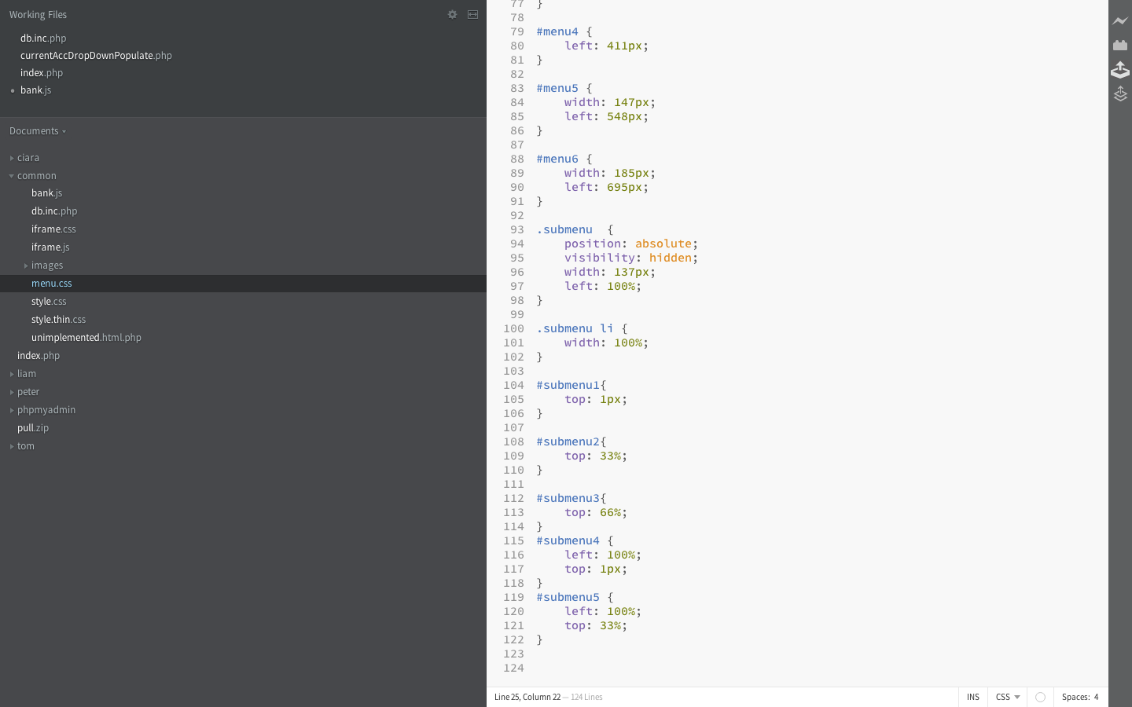

menu system

## bank.js

menu system

## 

# 

# group css

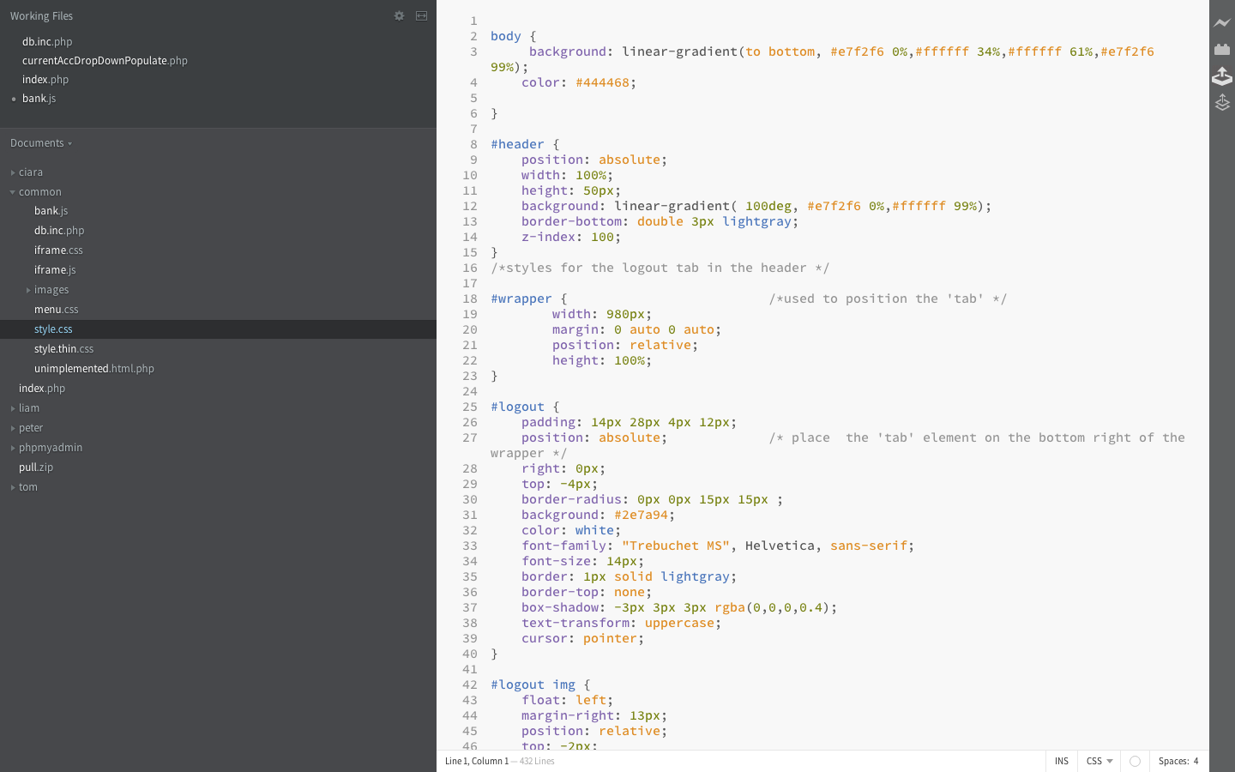style.css

# 

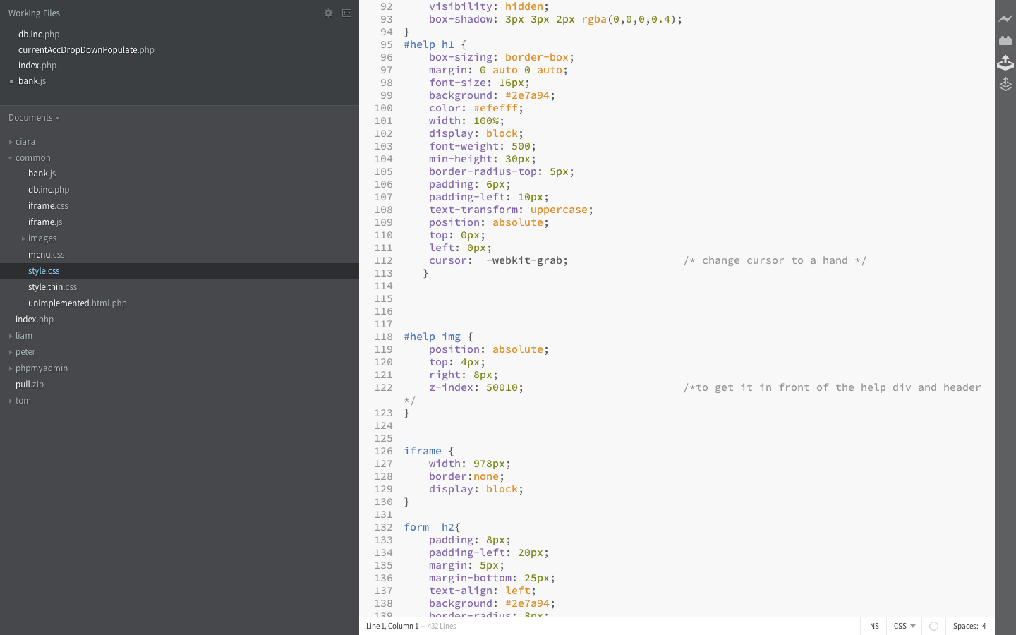

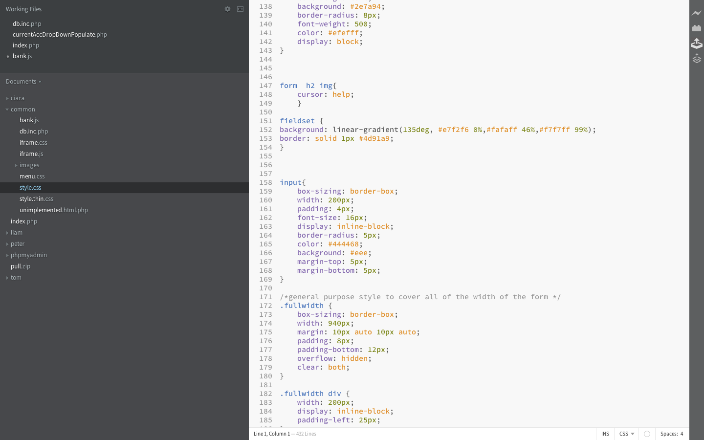

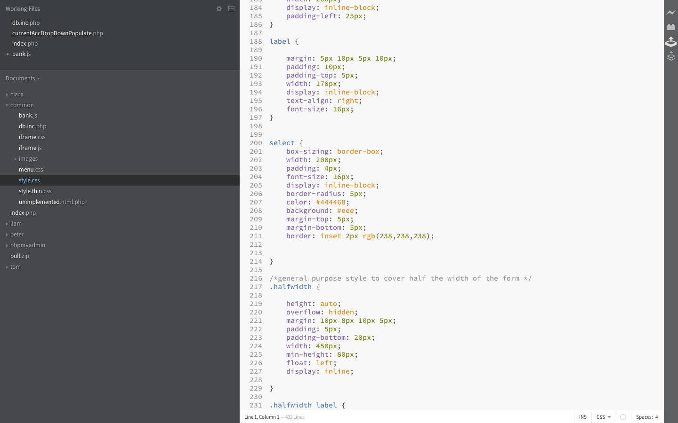

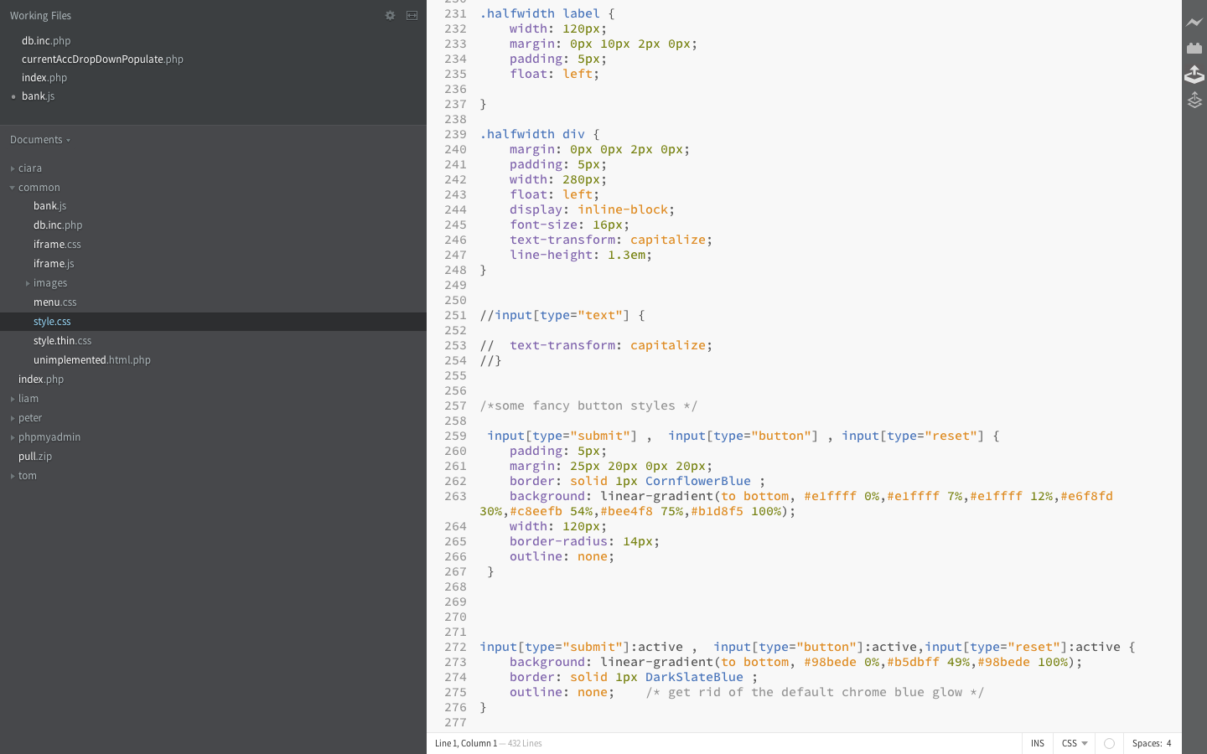

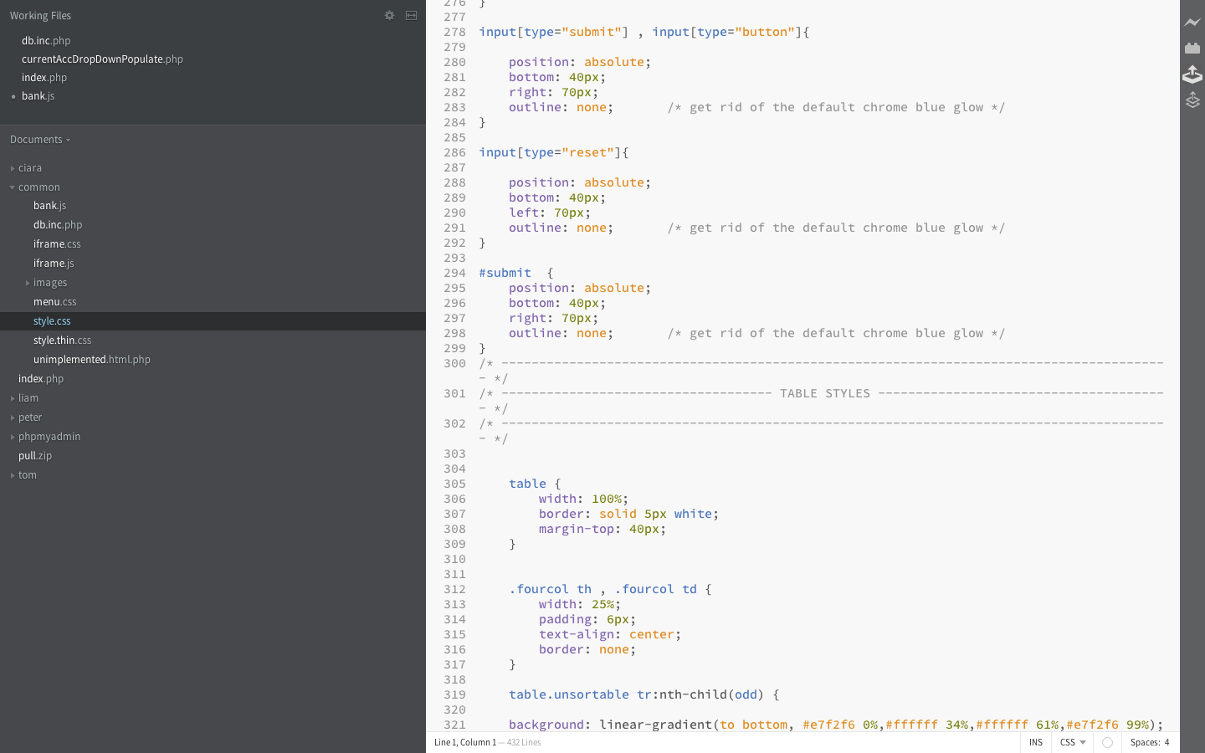

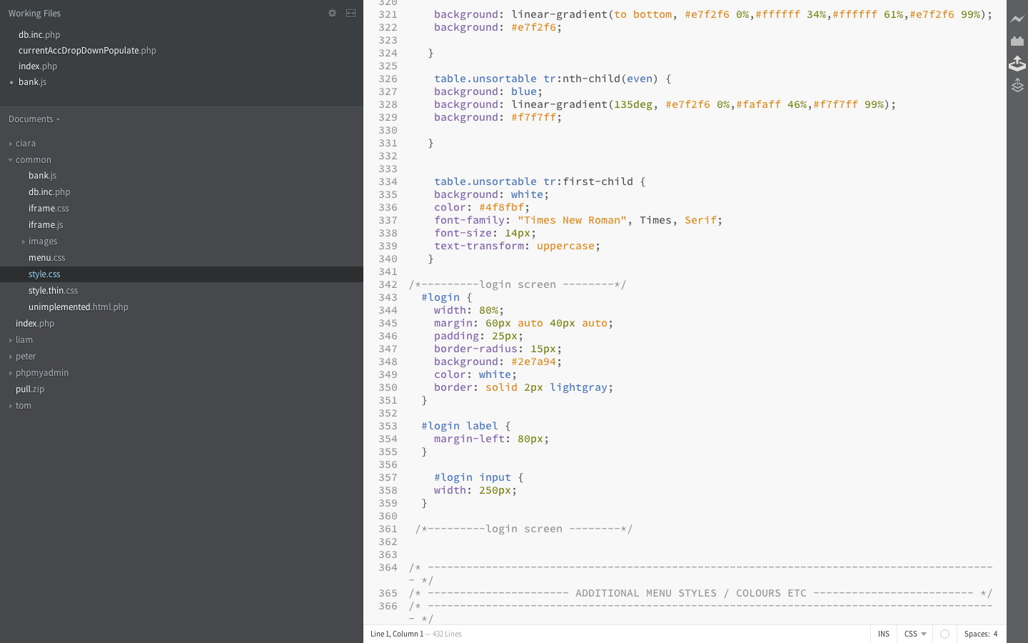

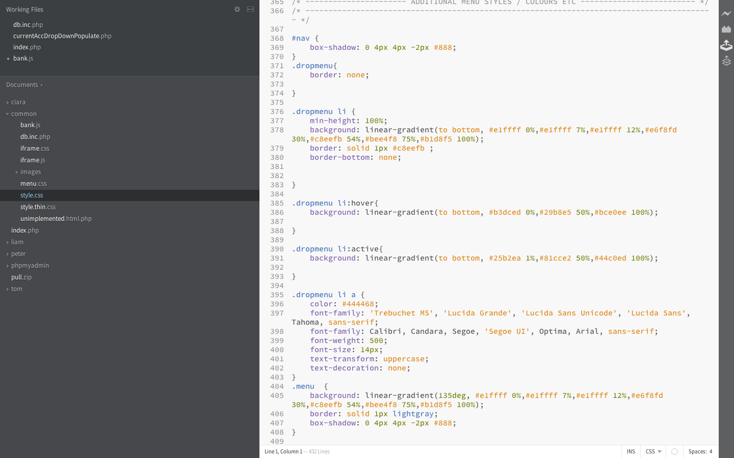

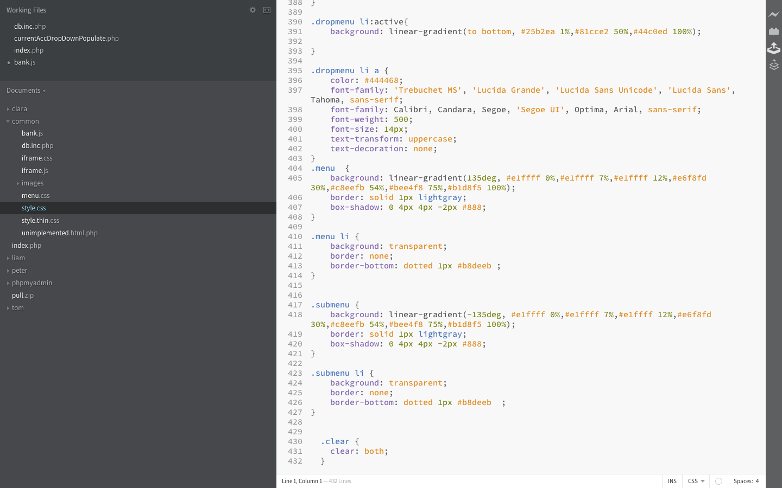

# common javascript

# Iframe.js

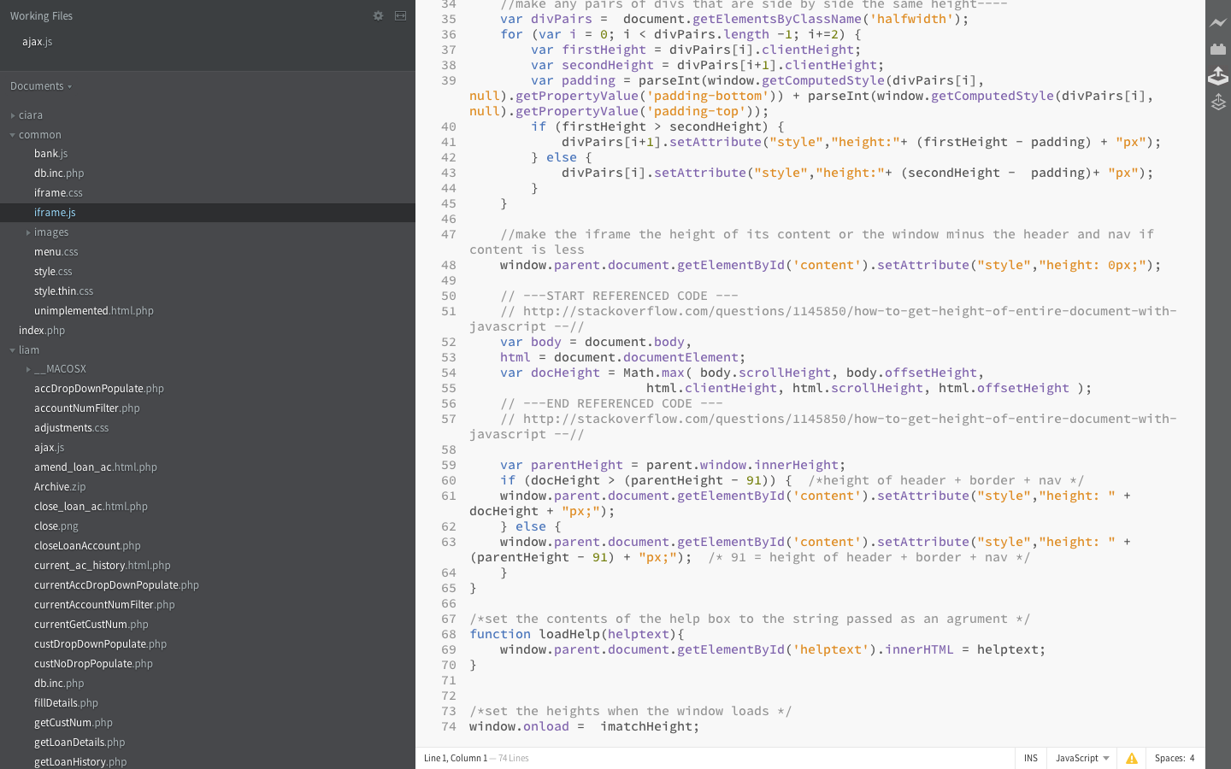

# individual work units (liam maloney)

general php files

## accDropDownPopulate.php

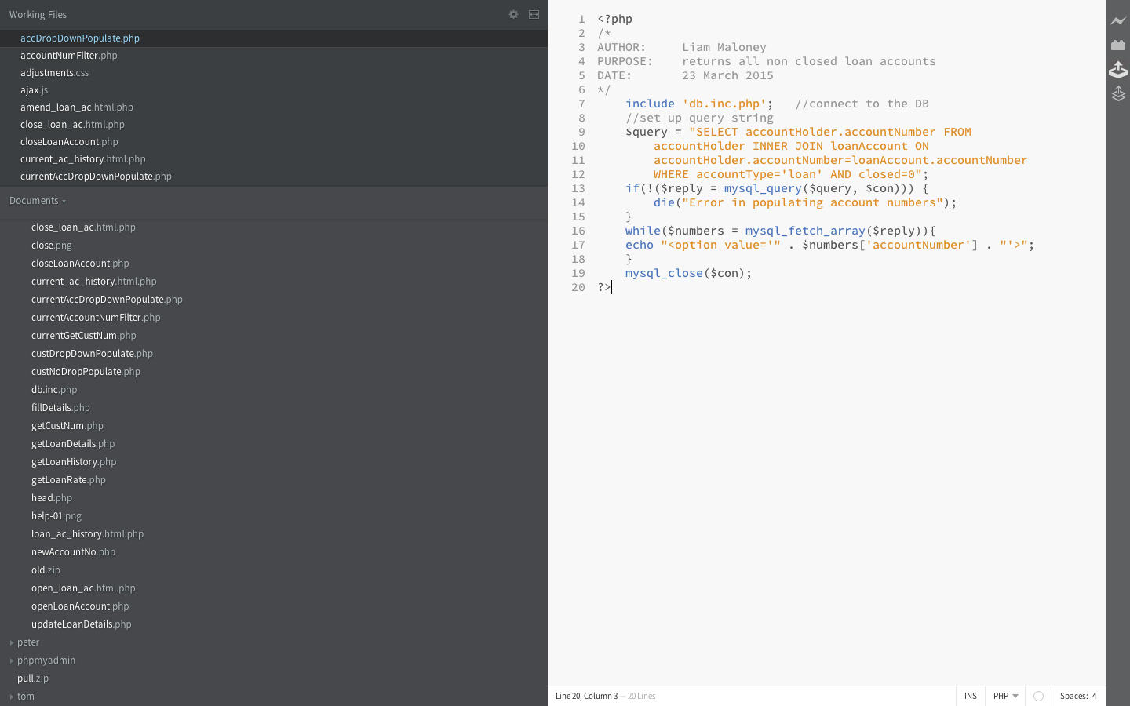

## 

## custDropDownPopulate.php

## custNoDropPopulate.php

## fillDetails.php

## getCustNum.php

## getLoanRate.php

## getLoanHistory.php

## accountNumFilter.php

## currentAccountNumFilter.php

## getLoanDetails.php

individual style sheet

## adjustments.css

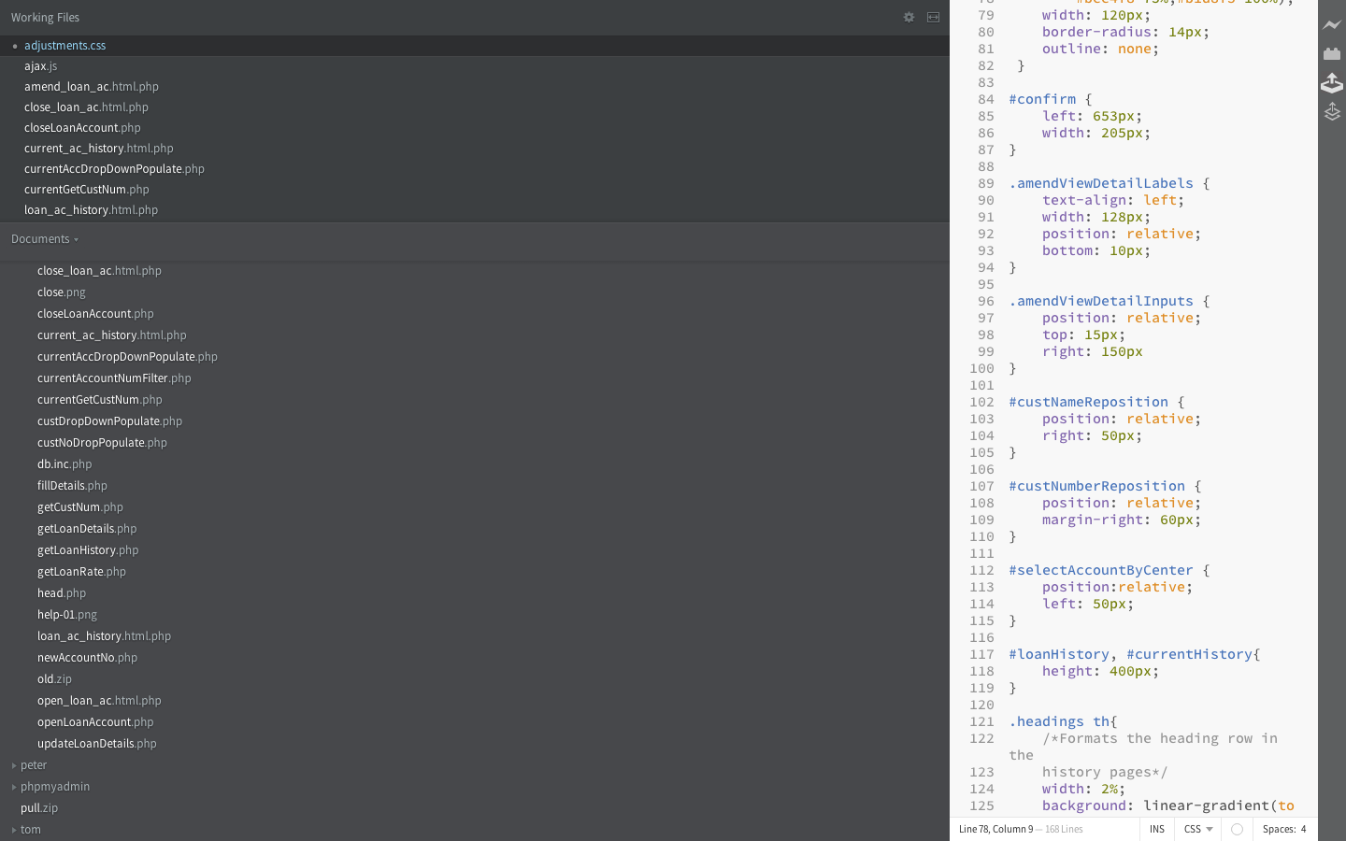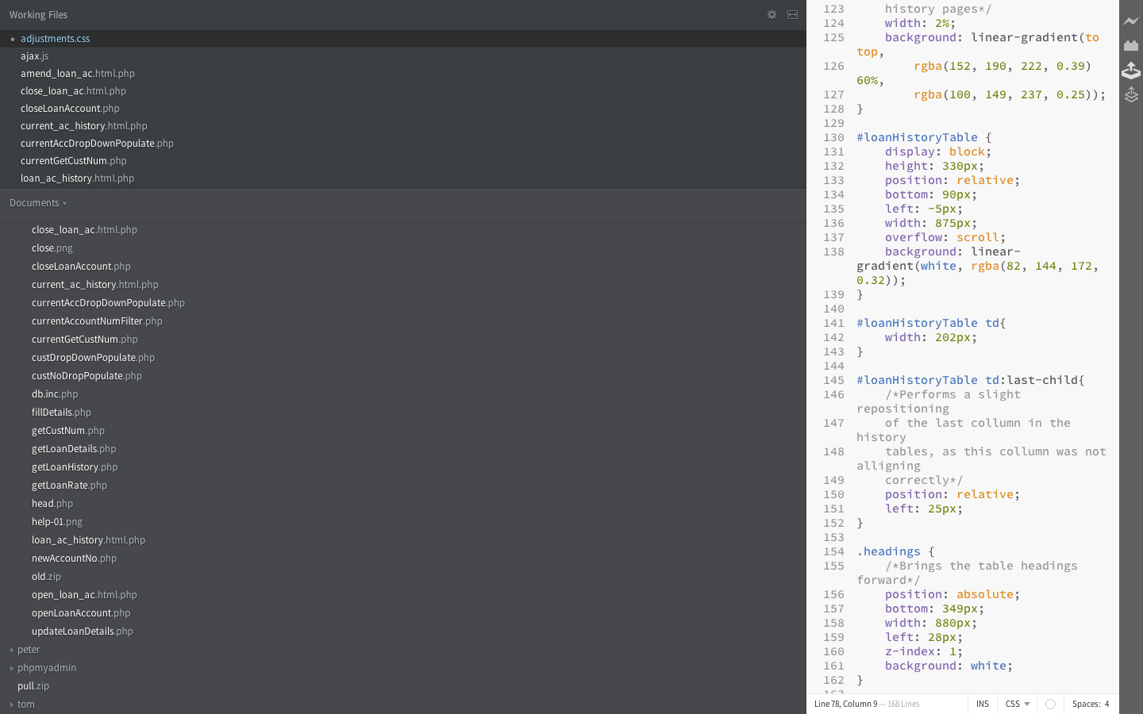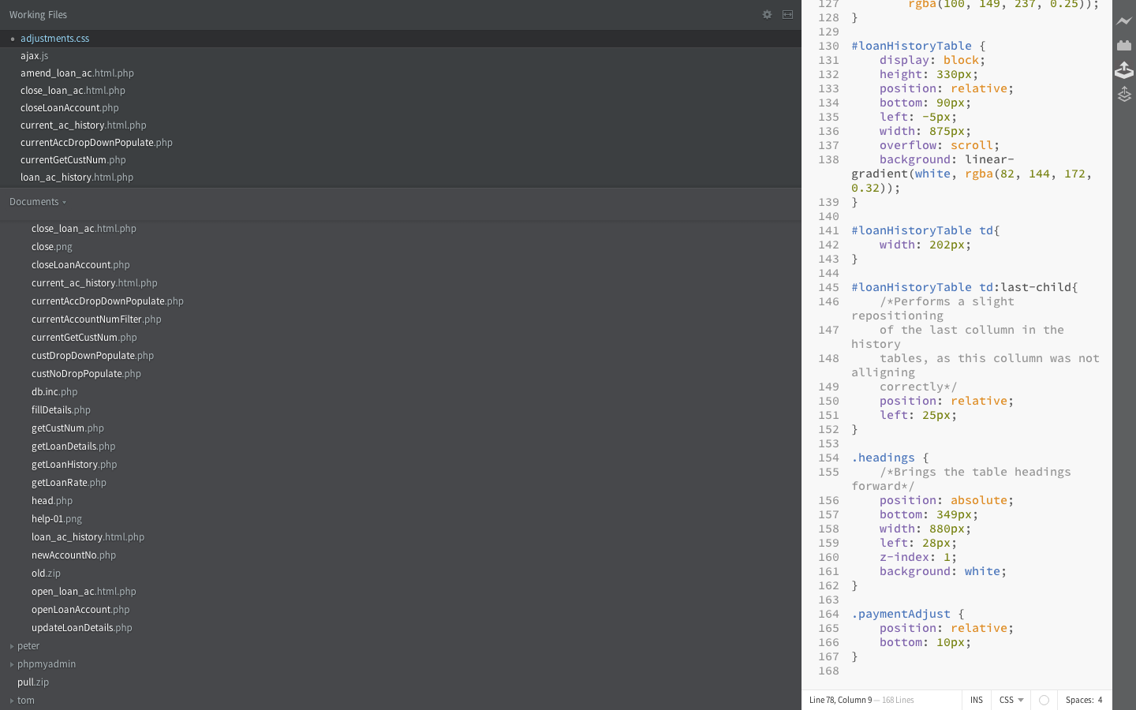

open a loan account

## Screen

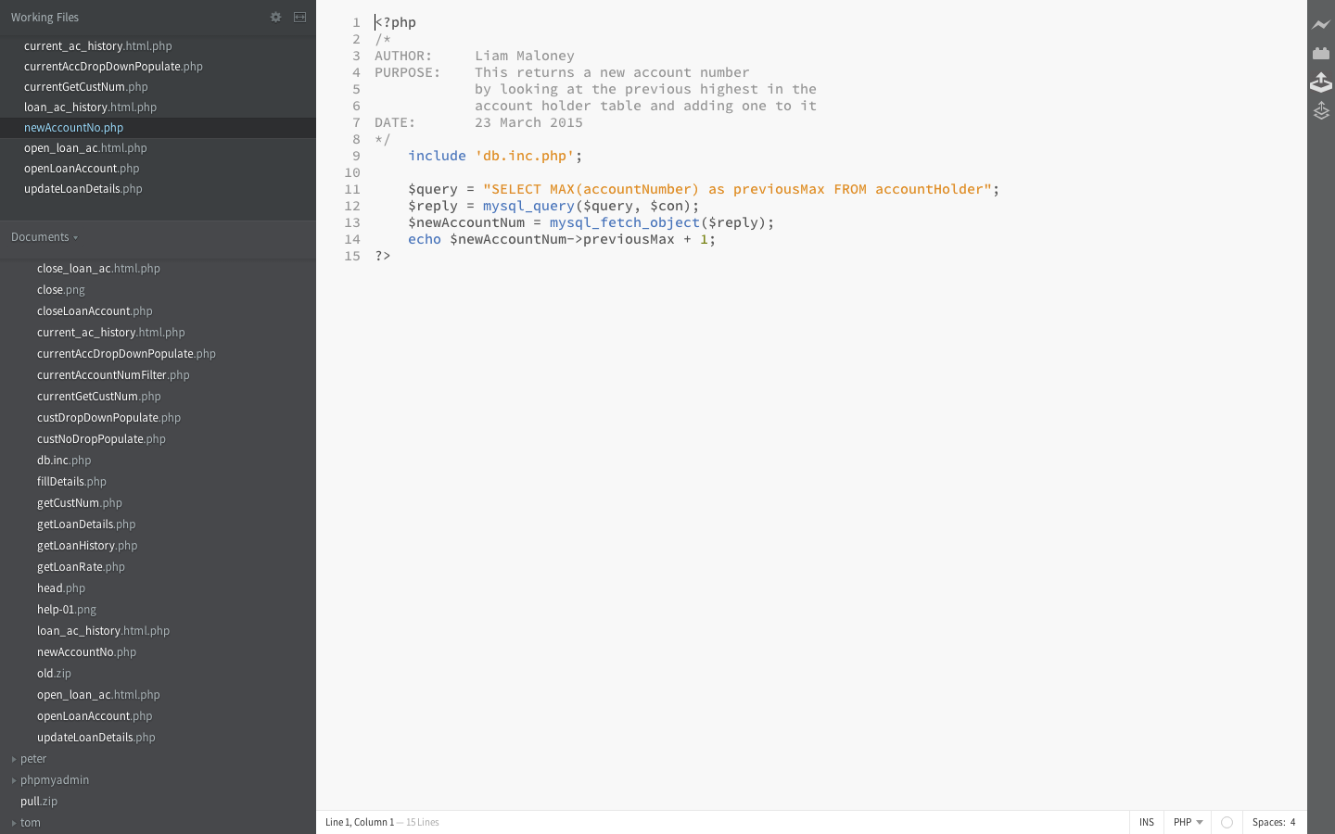

## newAccountNo.php

## openLoanAccount.php

## open_loan_ac.html.php

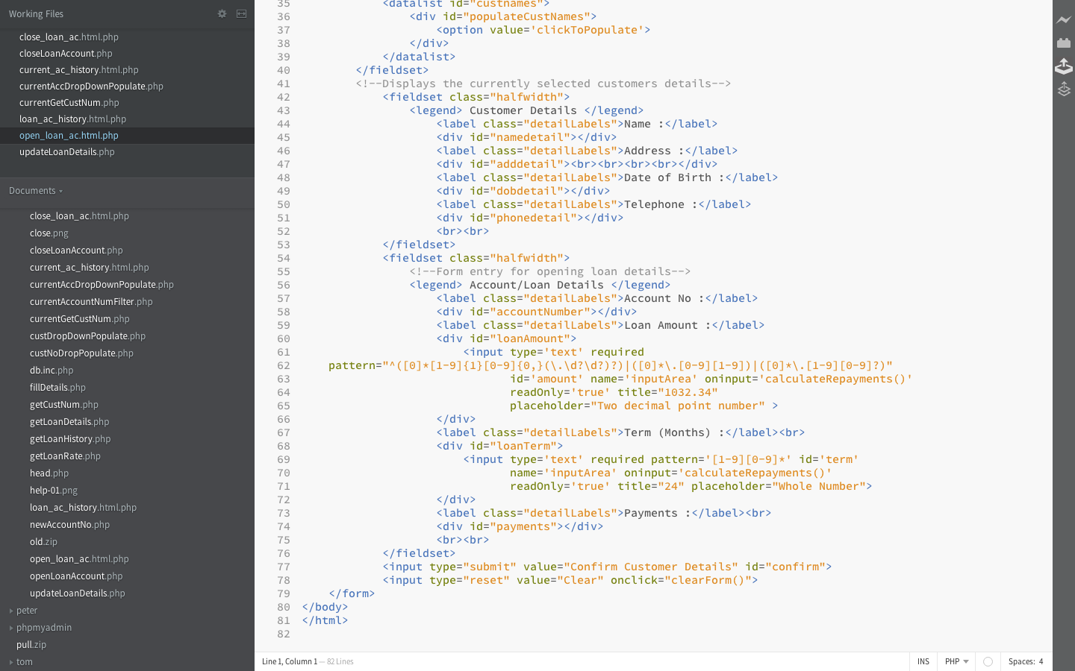

close a loan account

## Screen

## closeLoanAccount.php

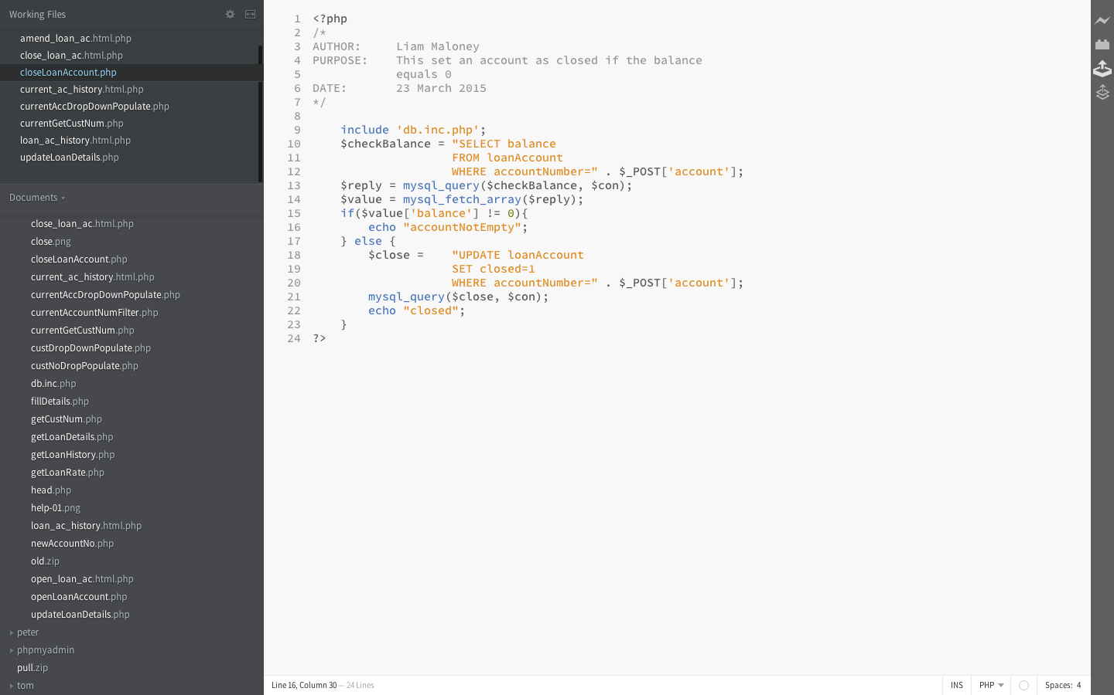

## close_loan_account.html.php

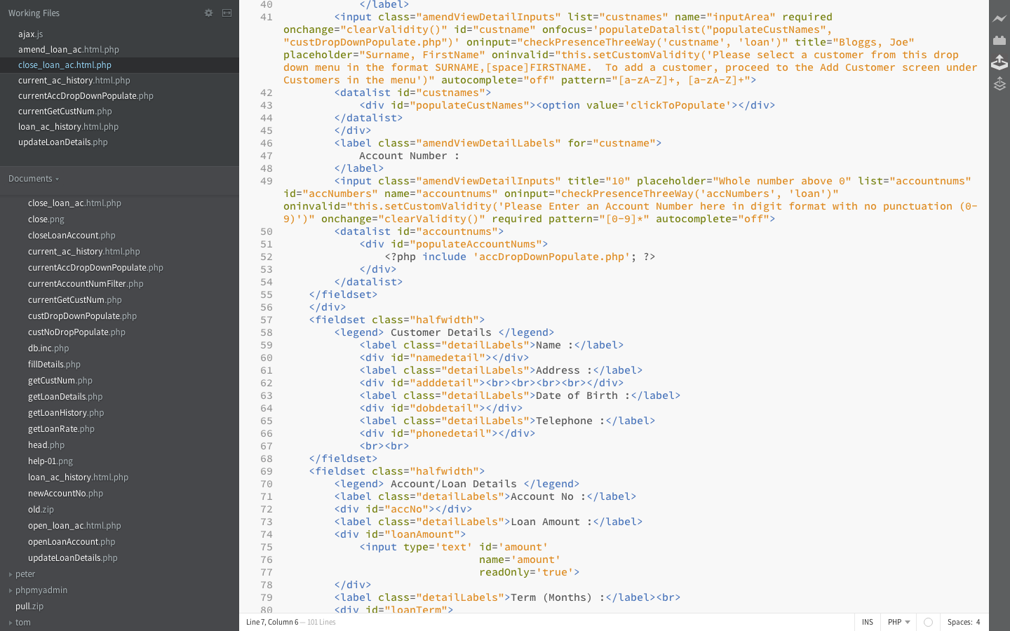

Amend loan account

## Screen

## updateLoanDetails.php

## 

## 

## amend_loan_ac.html.php

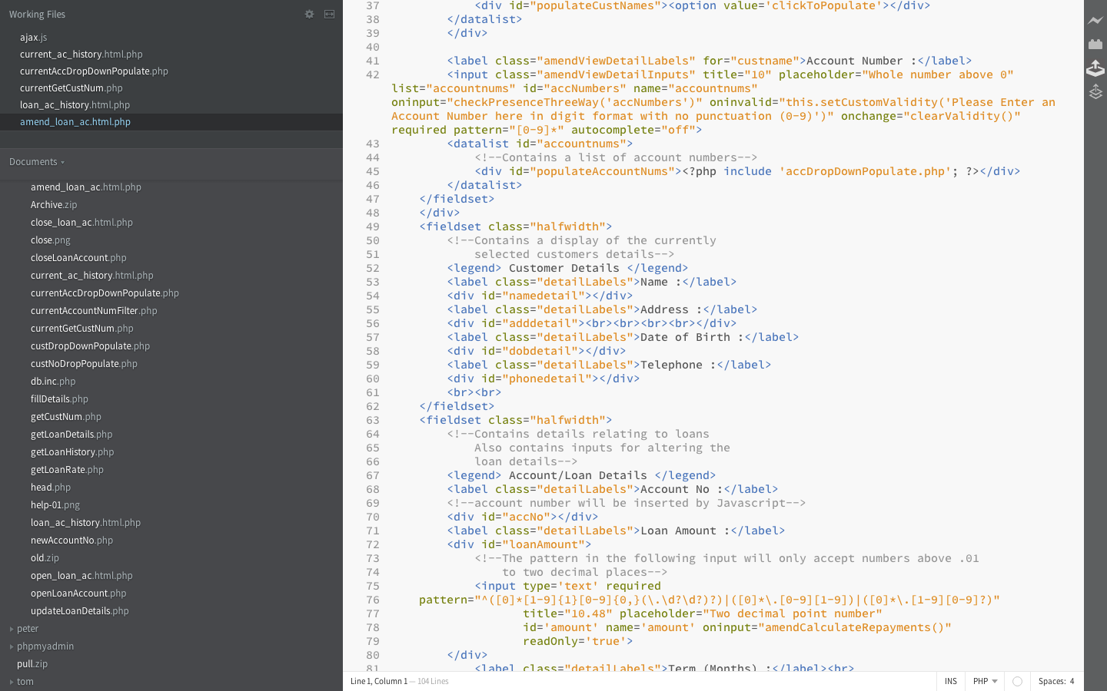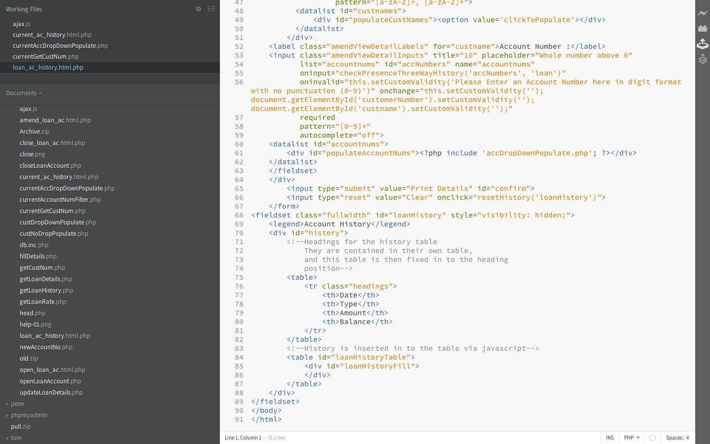

loan account history

## Screen

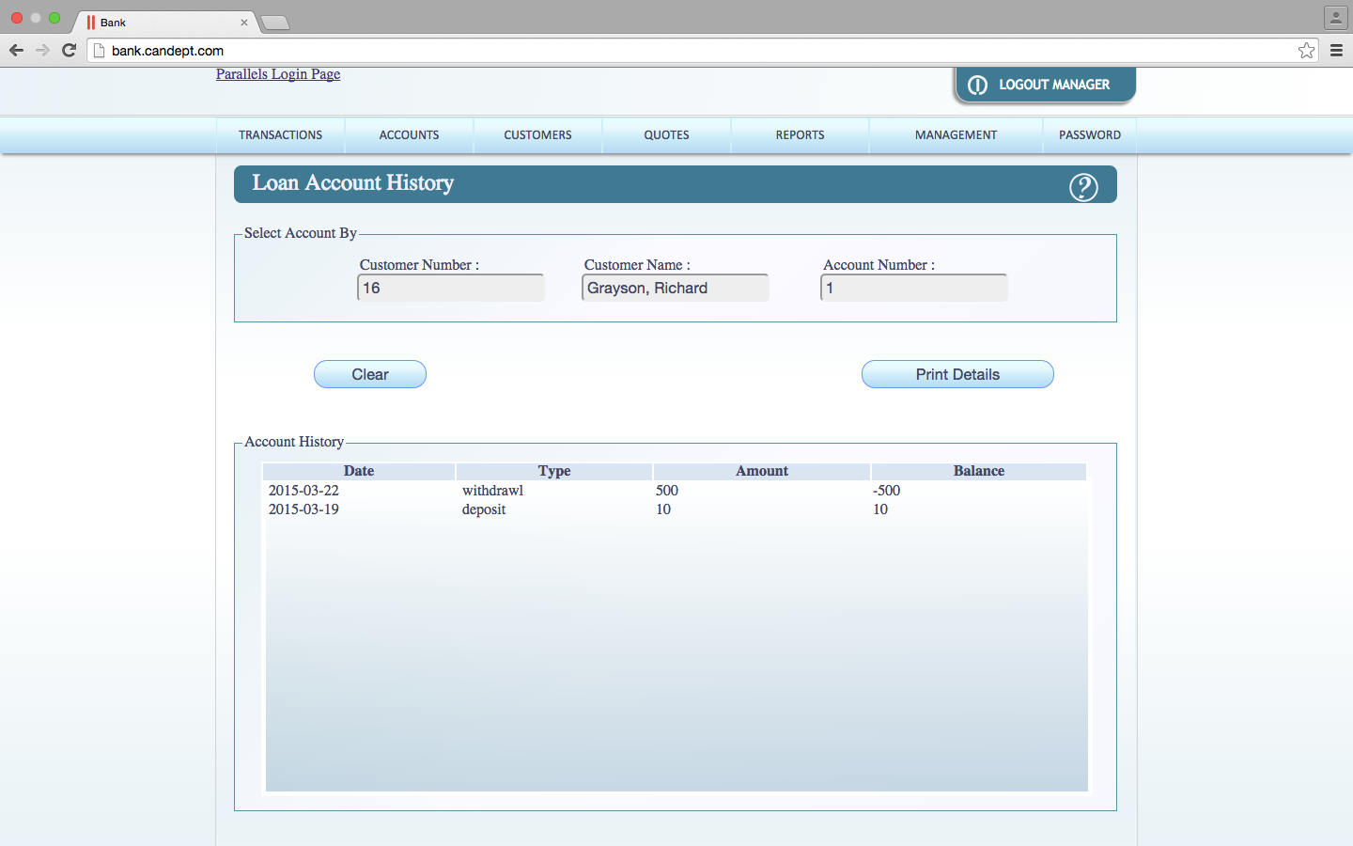

## loan_ac_history.html.php

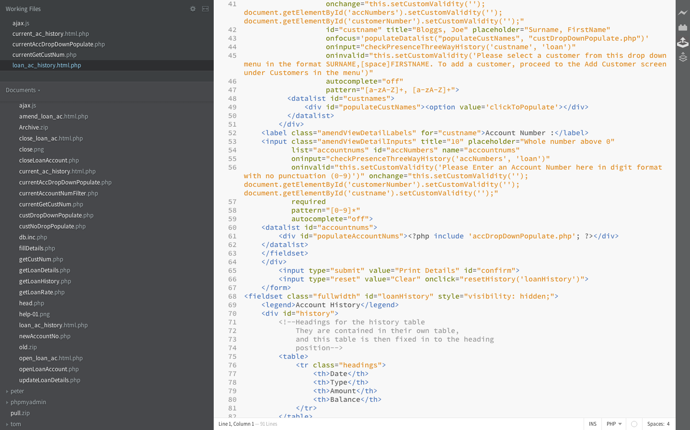

current account history

## Screen

## currentAccDropDownPopulate.php

## currentGetCustNum.php

## current_ac_history.html.php

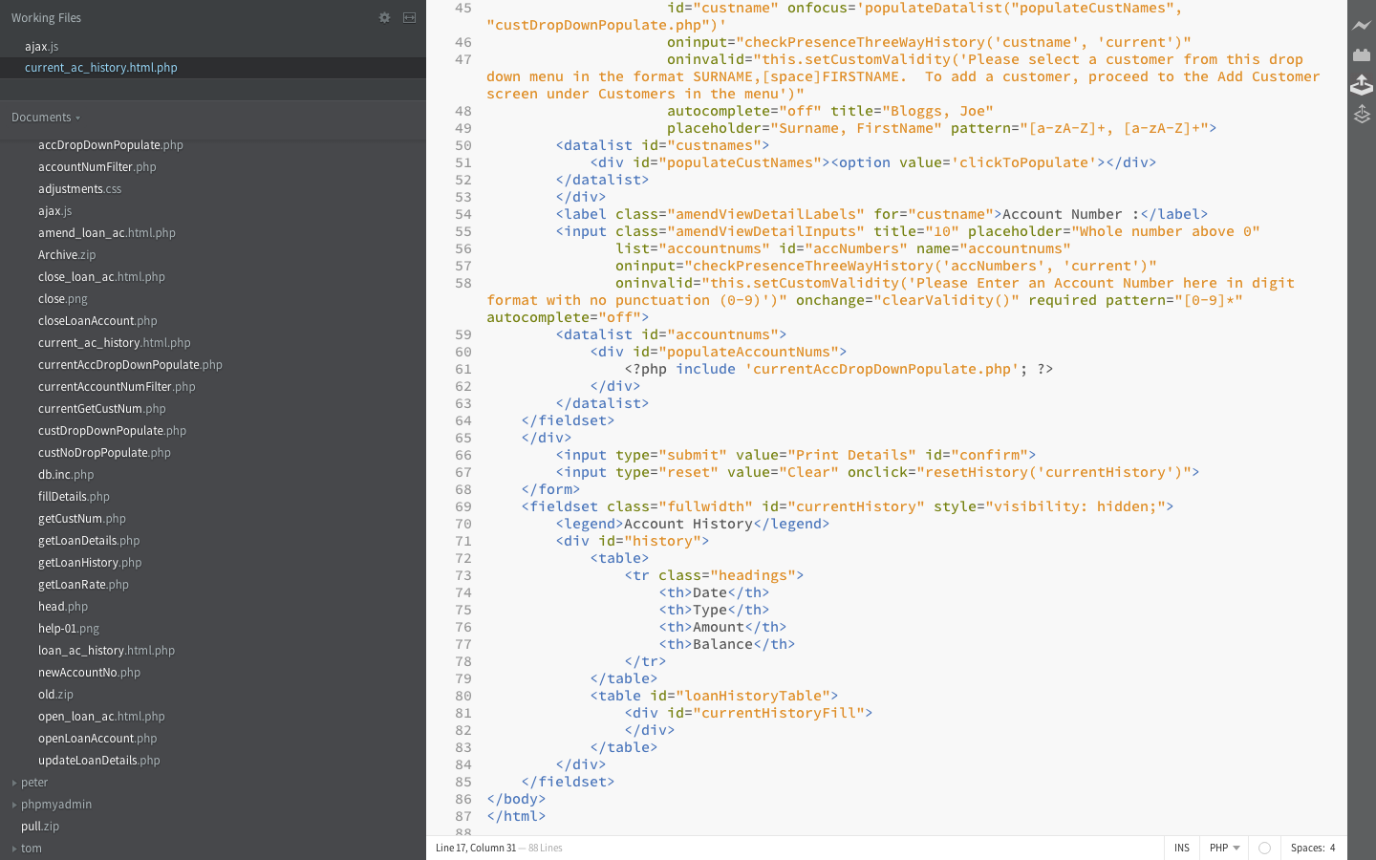

javascript

## ajax.js

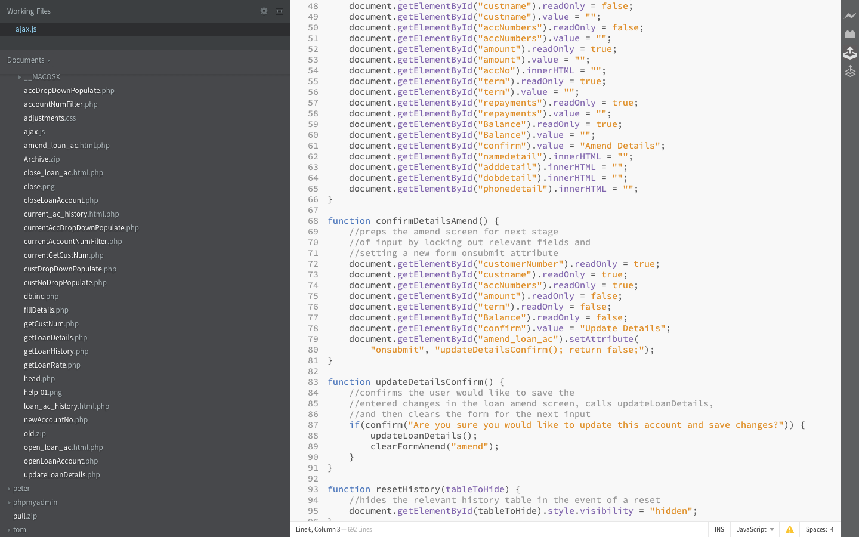

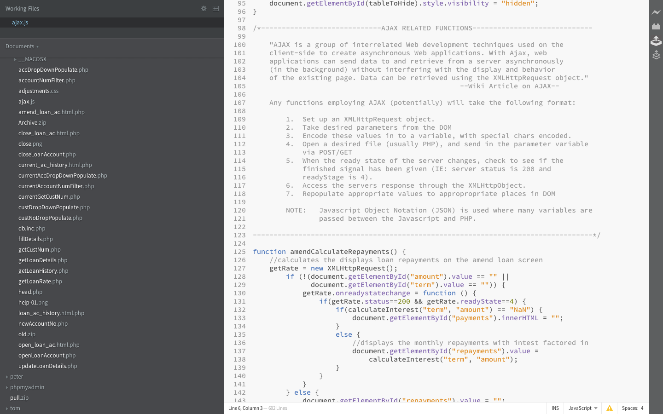

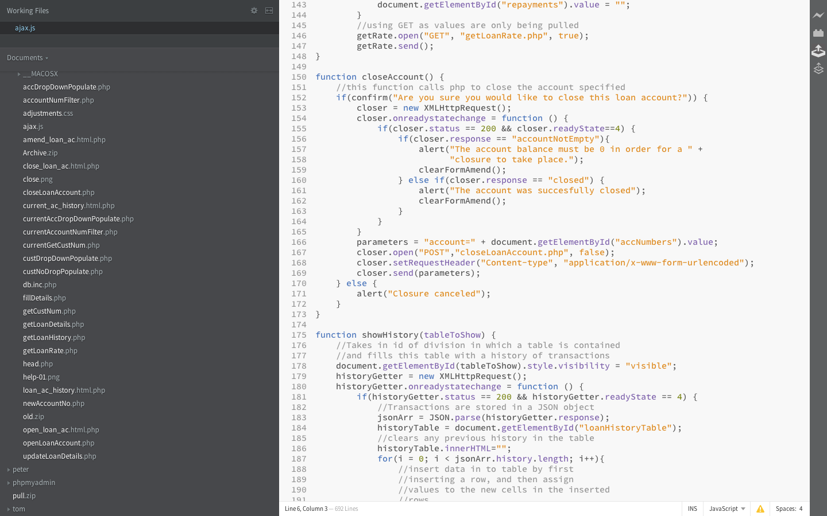

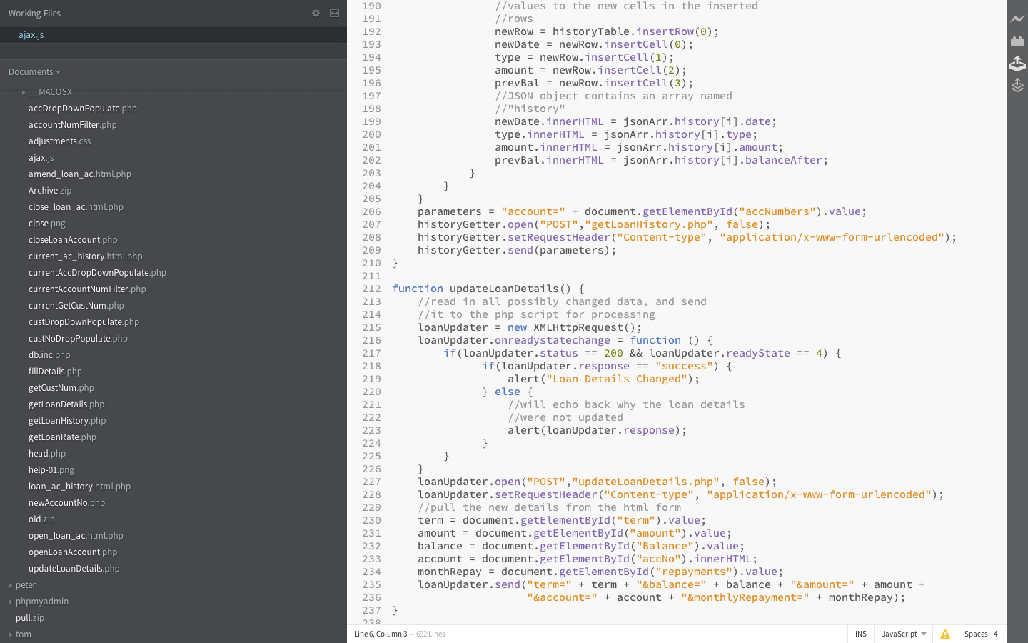

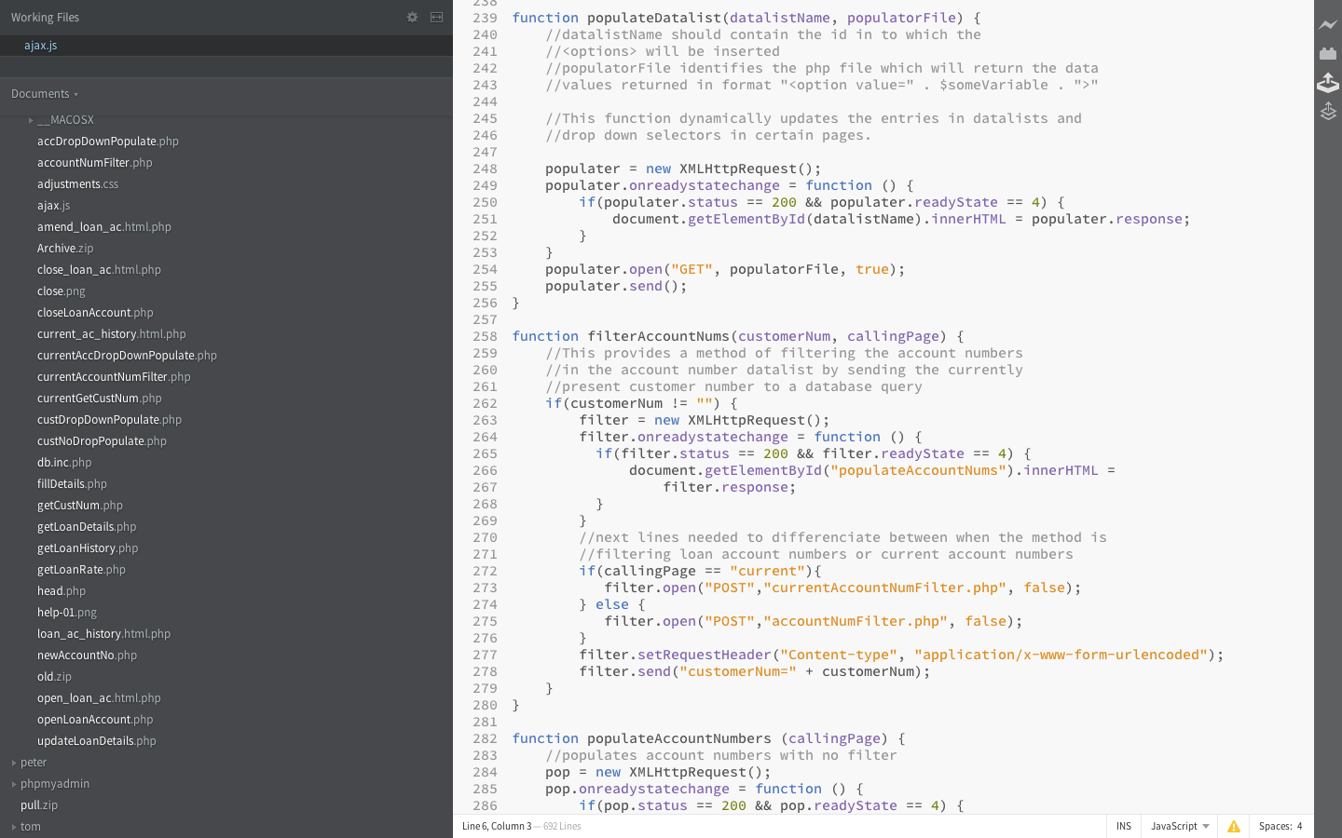

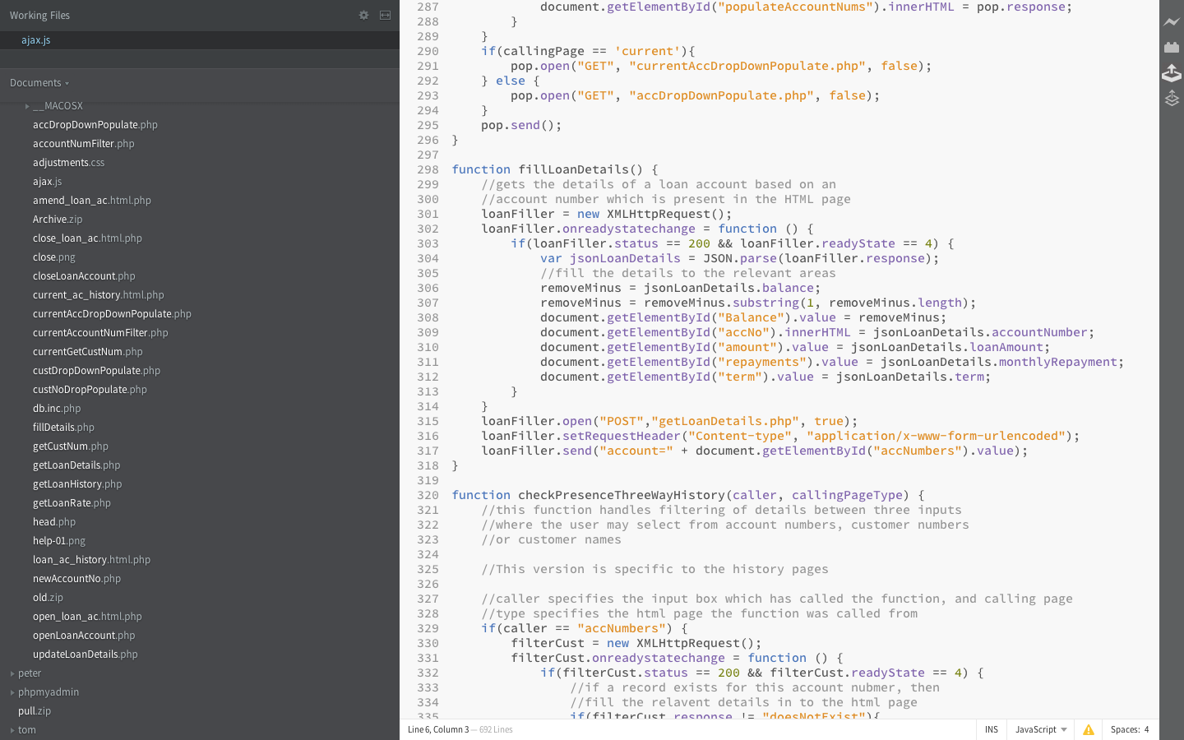

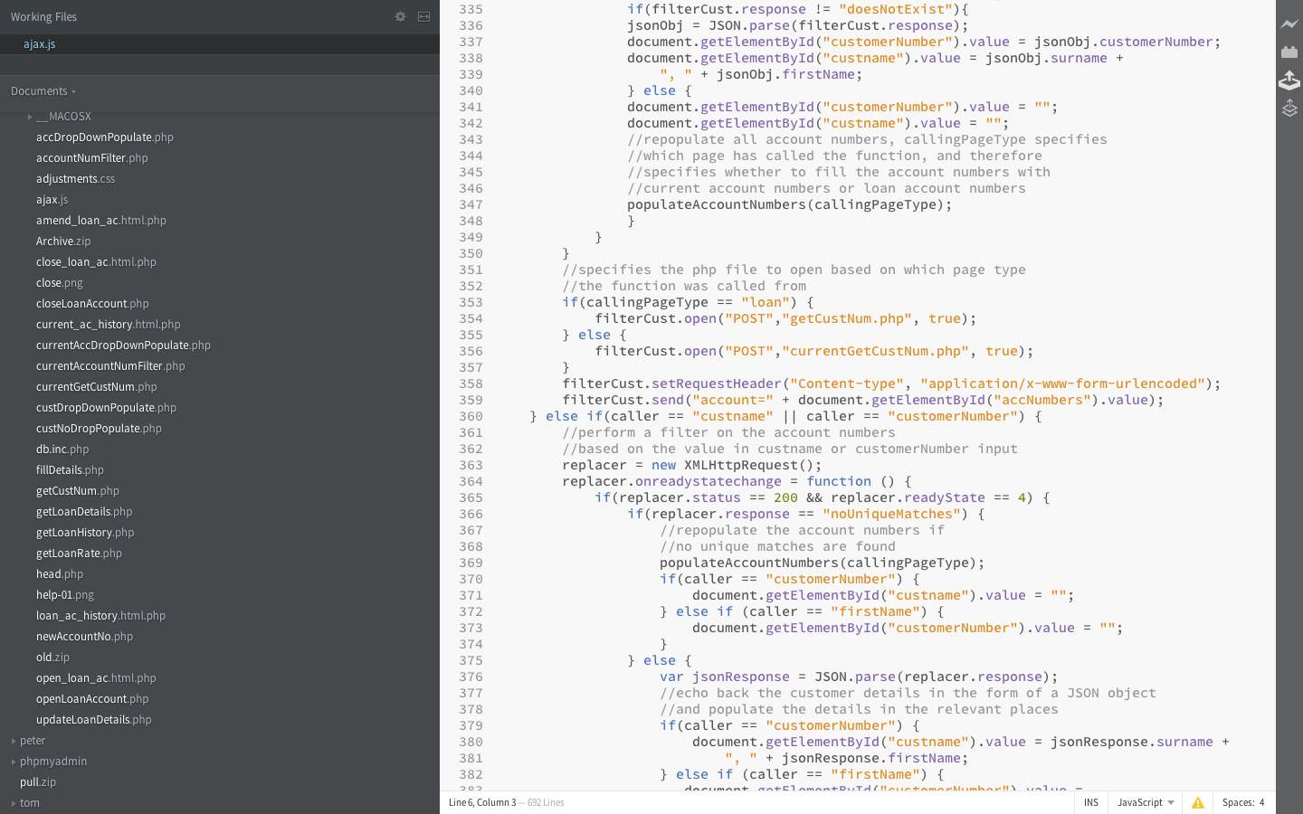

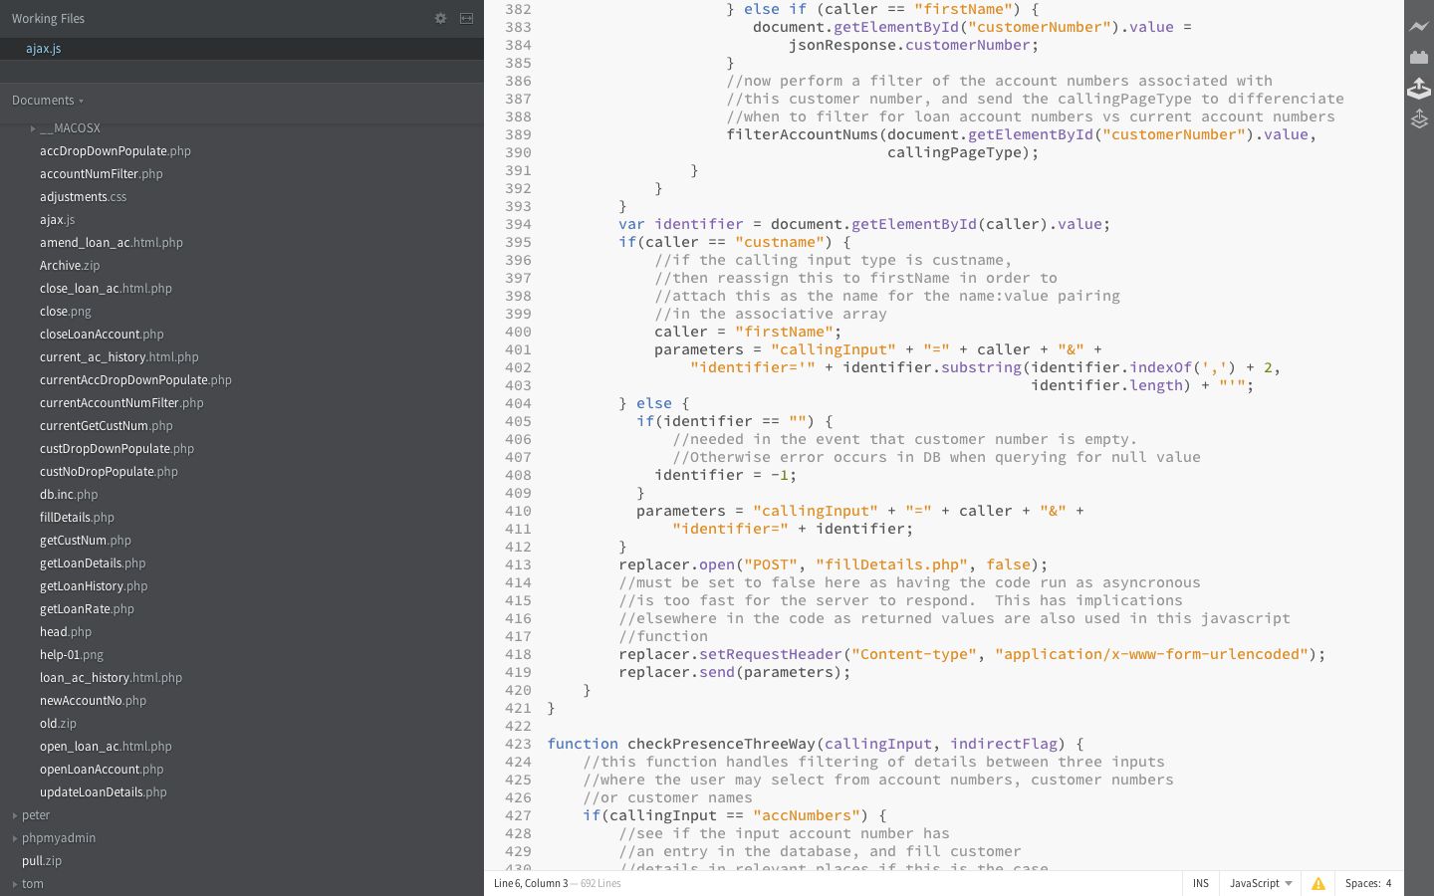

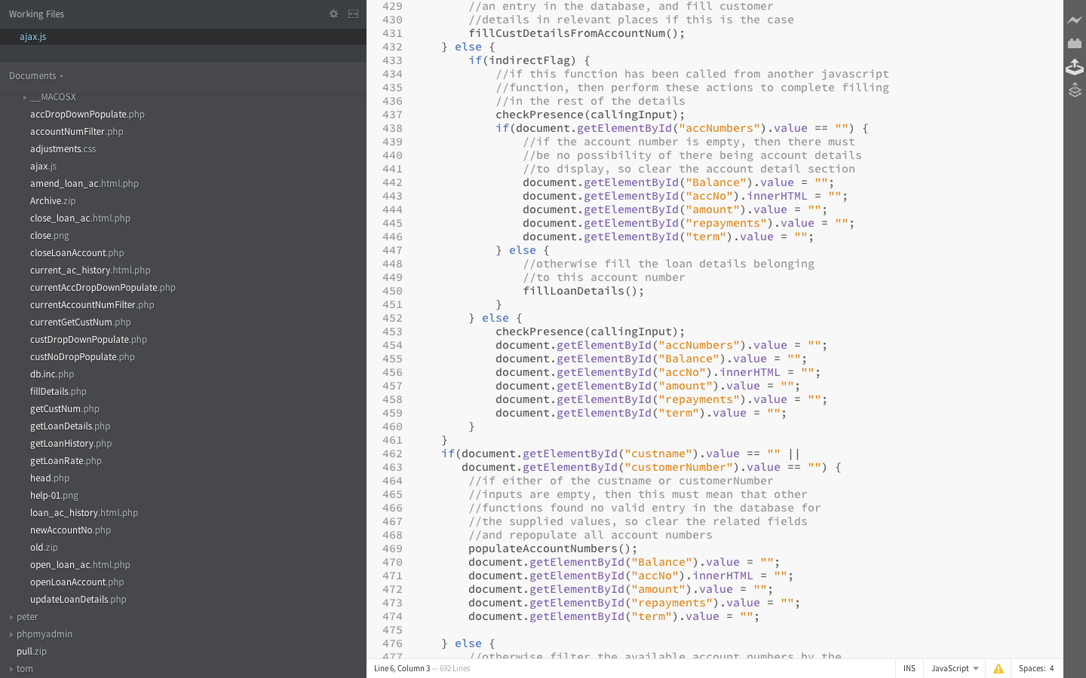

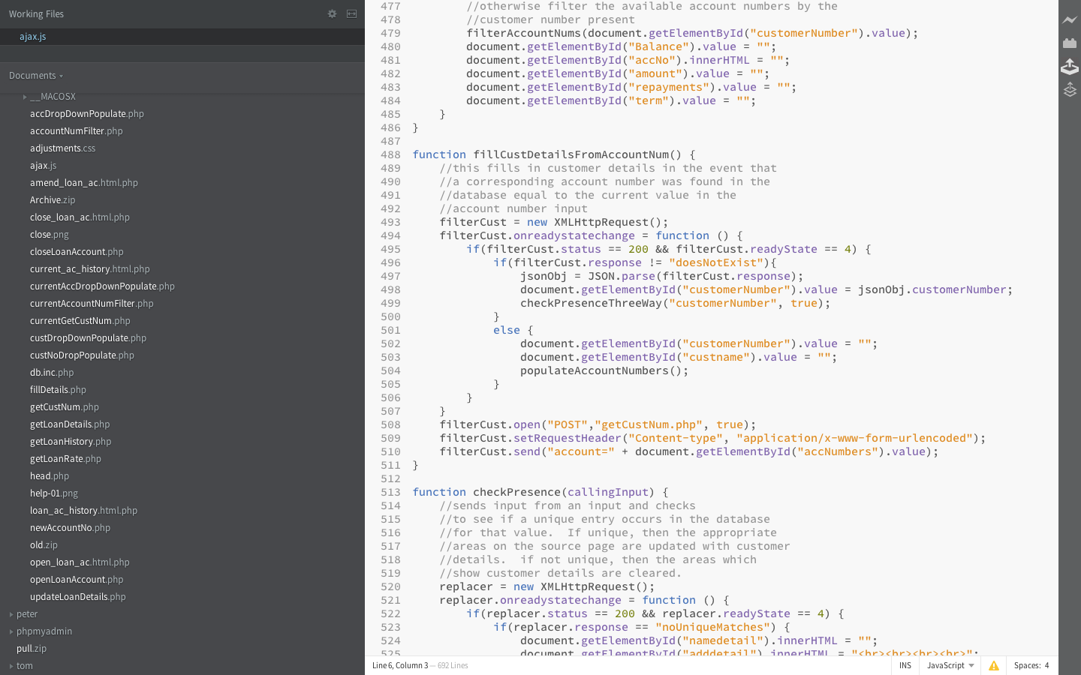

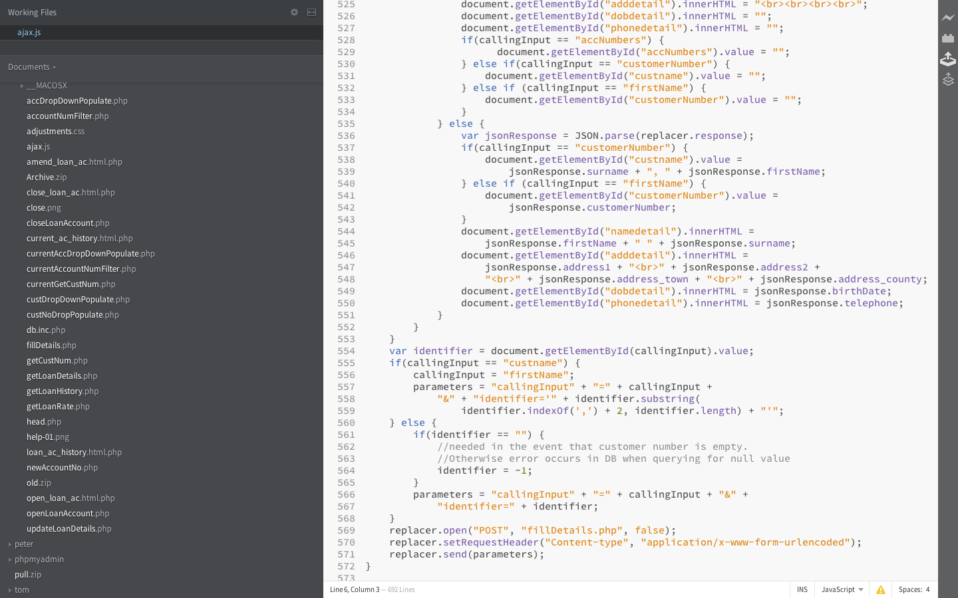

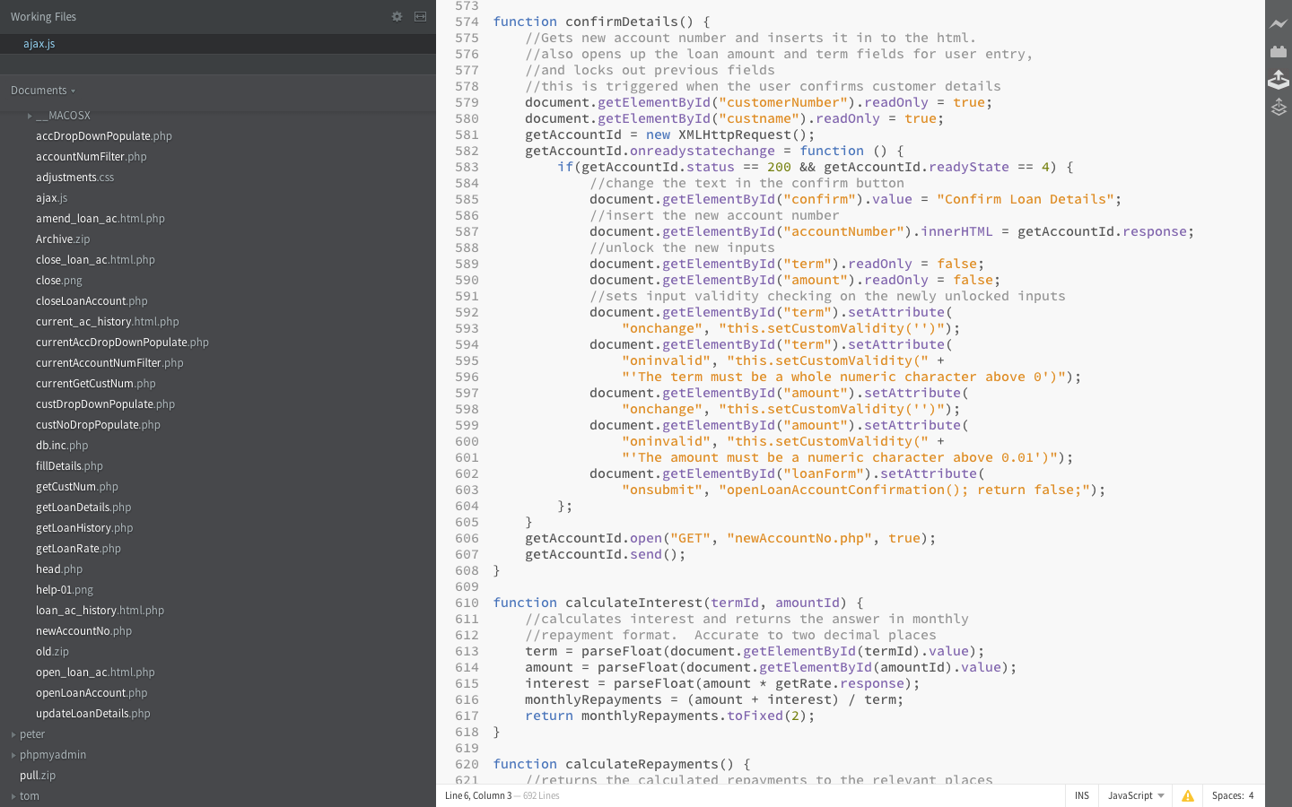

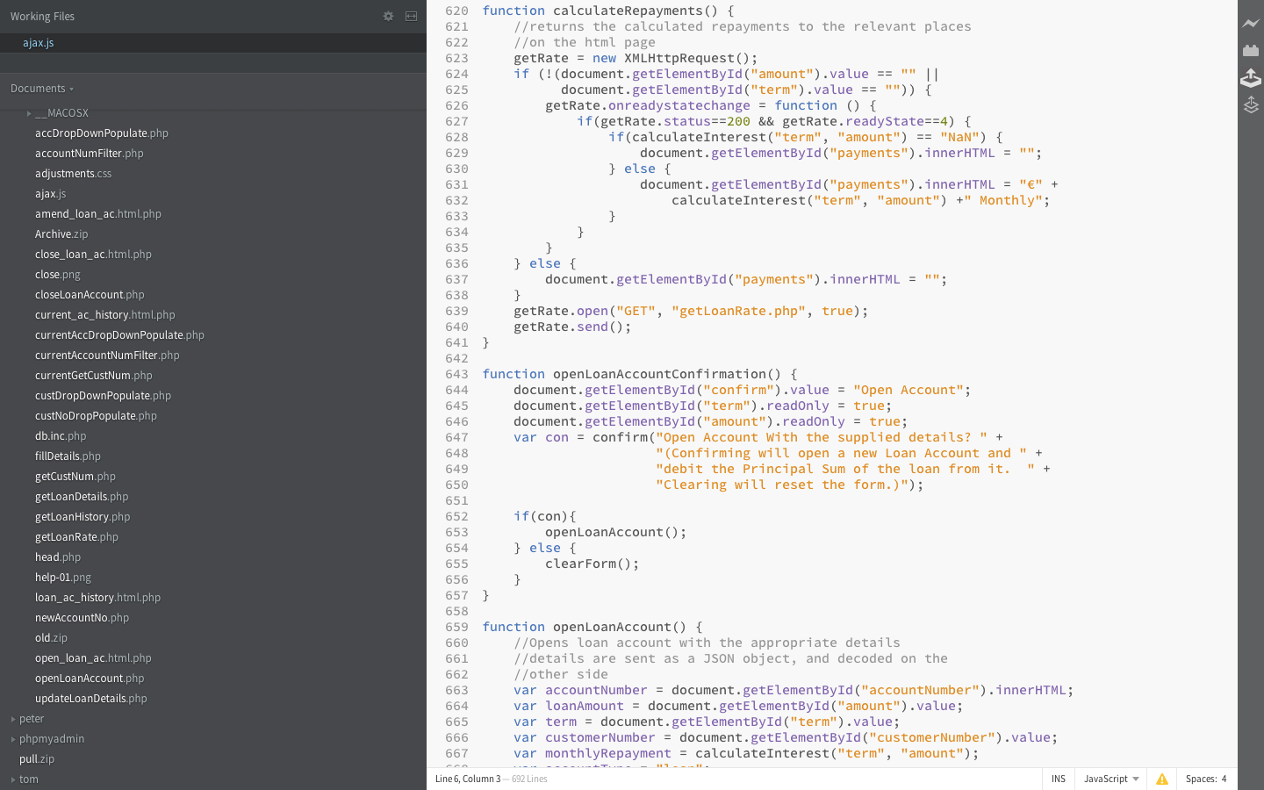

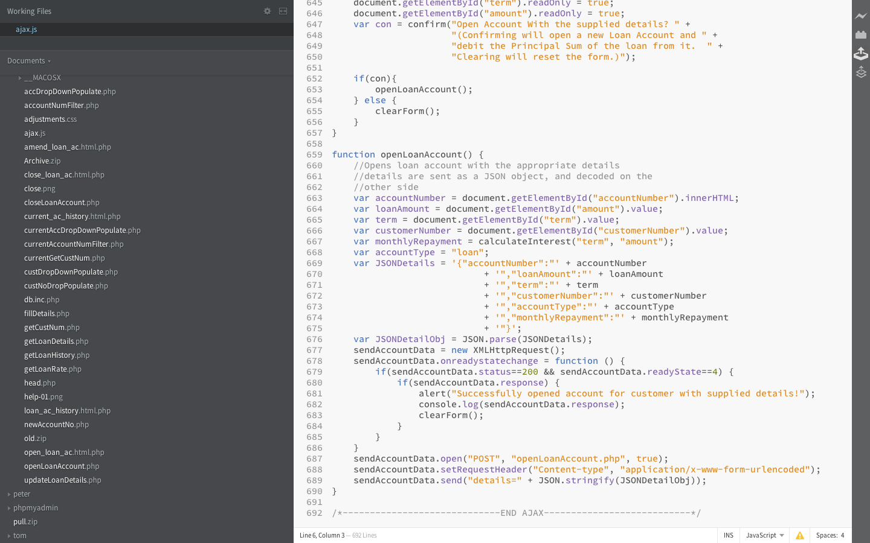

# individual work units (tom anderson)

Lodgement Screen

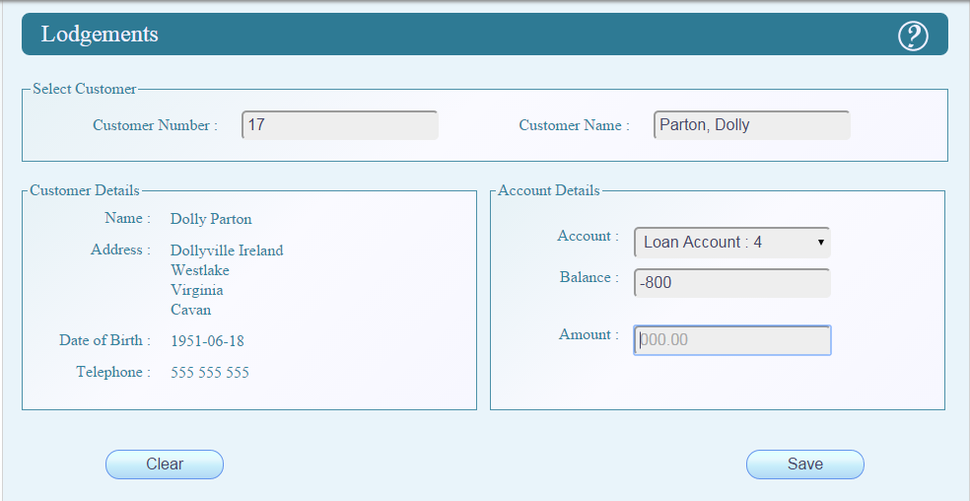

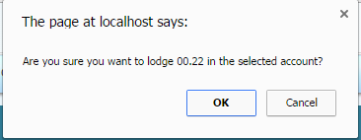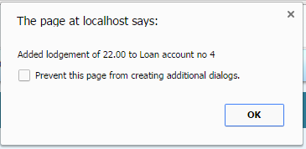

## lodgements.html.php

<?php

/*

* File Produced By: Tom Anderson - C00174844 - 2015

* Purpose:

*/

**include** "verify_user.php";

$_SESSION['helptext'] = "To make a lodgement:<br><br>".

"Select the customer by name or number<br><br>".

"Select the appropriate account.<br><br>".

"Enter the amount and confirm when prompted.<br><br>";

**include** 'head.php';

?>

<form name=**"lodgements"** id=**"lodgements"** method=**"post"** onsubmit=**"return confirmCheck()"** action=**"lodgements.php"** >

<h2>**Lodgements** <img src=**"../common/images/help-01.png"** alt=**"Help"** id=**"helpbtn"** onmousedown=**"frameToggleHelp() "** ></h2><?php

?>

<fieldset class=**"fullwidth"**>

<legend>**Select Customer**</legend>

<label for=**"selectnumber"**>**Customer Number :**</label>

<?php

**include** 'cust_no_datalist.php';

?>

<label for=**"selectname"**>**Customer Name :**</label>

<?php

**include** 'cust_name_datalist.php';

?>

</fieldset>

<fieldset class=**"halfwidth"**>

<legend>**Customer Details** </legend>

<label >**Name :**</label>

<div id=**"normalname"** name=**"normalname"** ><br /></div>

<label >**Address :**</label>

<div id=**"address"** name=**"address"** /><br /><br /><br /><br /></div>

<label >**Date of Birth :**</label>

<div type=**"date"** id=**"dob"** name=**"dob"** ><br /></div>

<label >**Telephone :**</label>

<div id=**"phone"** name=**"phone"**><br /></div>

</fieldset>

<fieldset class=**"halfwidth"**>

<legend> **Account Details** </legend>

<br />

<label for=**"actypelist"**>**Account :**</label>

<?php

**include** "accountlist.php";

?>

<br />

<label for=**"balance"** >**Balance :**</label>

<input type=**"text"** id=**"balance"** name=**"balance"** disabled /><br /><br />

<label for=**"amount"**>**Amount :**</label>

<input type=**"text"** id=**"amount"** name=**"amount"** disabled required pattern=**"[0-9]+[.][0-9]{2}"** placeholder=**"000.00"** title=**"Please enter the value in euro and cent e.g 25.33, 33.00, or 0.25"** oninput=**"activateForm()"**><br /><br />

</fieldset>

<input type=**"submit"** name=**"submit"** id=**"submit"** value=**"Save"** disabled></input>

<input type=**"reset"** name=**"clear"** value=**"Clear"** onclick=**"resetForm()"**></input>

</form>

<script>

***function*** populate**(**index**)**

**{** //Check where the index came from and use the appropriate array

***if*** **(** noarray**[**index**]** **!==** undefined **&&** index **==** noarray**[**index**].**id**)** **{**

***var*** details **=** noarray**[**index**];**

**}** ***else*** ***if*** **(** namearray**[**index**]** **!==** undefined **&&** index **==** namearray**[**index**].**sname **+** ", " **+** namearray**[**index**].**fname **){**

***var*** details **=** namearray**[**index**];**

//clear all the boxes and quit if the index is invalid

**}** ***else*** **{**

document.getElementById**(**"selectnumber"**).**value **=** ""**;**

document.getElementById**(**"selectname"**).**value **=** ""**;**

document.getElementById**(**"normalname"**).**innerHTML **=** "<br />"**;**

document.getElementById**(**"address"**).**innerHTML **=** "<br /><br /><br /><br />"**;**

document.getElementById**(**"dob"**).**innerHTML **=** "<br />"**;**

document.getElementById**(**"phone"**).**innerHTML **=** "<br />"**;**

***return*** 0**;**

**}**

//set all the outputs to the values related to the selected item

document.getElementById**(**"normalname"**).**innerHTML **=** details.normalname**;**

document.getElementById**(**"address"**).**innerHTML **=** details.address**;**

document.getElementById**(**"dob"**).**innerHTML **=** details.dob**;**

document.getElementById**(**"phone"**).**innerHTML **=** details.phone**;**

***try*** **{**

document.getElementById**(**"myemail"**).**innerHTML **=** details.email**;**

document.getElementById**(**"occupation"**).**innerHTML **=** details.occupation**;**

document.getElementById**(**"salary"**).**innerHTML **=** details.salary**;**

document.getElementById**(**"guarantor"**).**innerHTML **=** details.guarantor**;**

**}** ***catch*** **(**error**)** **{**

**}**

document.getElementById**(**"selectnumber"**).**value **=** details.id**;**

document.getElementById**(**"selectname"**).**value **=** details.sname **+** ", " **+** details.fname**;**

filterAccounts**(**details.id**);**

imatchHeight**()** **;**

**}**

//display only the accounts belonging to the selected customer - enable the select box for accounts

***function*** filterAccounts **(**id**)** **{**

***var*** accountList **=** document.getElementById**(**"selectaccount"**);**

***for*** **(*var*** i **=** 1**;** i **<** accountList.options.length**;** i**++)** **{**

***var*** value **=** accountList.options**[**i**].**value**;**

***var*** details **=** value.split**(**'#'**);**

***if*** **(**details**[**0**]** **==** id**)** **{**

accountList.options**[**i**].**hidden **=** ***false*;**

**}** ***else*** **{**

accountList.options**[**i**].**hidden **=** ***true*;**

**}**

**}**

accountList.selectedIndex **=** 0**;**

accountList.disabled **=** ***false*;**

**}**

***function*** setAccount **(**index**)** **{**

***var*** accountList **=** document.getElementById**(**"selectaccount"**);**

***var*** value **=** accountList.options**[**index**].**value**;**

***var*** details **=** value.split**(**'#'**);**

***var*** balance **=** details**[**1**];**

document.getElementById**(**'balance'**).**value **=** balance**;**

document.getElementById**(**"selectnumber"**).**disabled **=** ***true*;**

document.getElementById**(**"selectname"**).**disabled **=** ***true*;**

document.getElementById**(**"amount"**).**disabled **=** ***false*;**

**}**

//stop the user from changing the account once they enter an amount and allow them to click the submit button

***function*** activateForm**()** **{**

document.getElementById**(**"selectaccount"**).**disabled **=** ***false*;**

document.getElementById**(**"submit"**).**disabled **=** ***false*;**

**}**

//reset the disabled atributes of the inputs and clear the display of customer details

***function*** resetForm**()** **{**

document.getElementById**(**"normalname"**).**innerHTML **=** "<br />"**;**

document.getElementById**(**"address"**).**innerHTML **=** "<br /><br /><br /><br />"**;**

document.getElementById**(**"dob"**).**innerHTML **=** "<br />"**;**

document.getElementById**(**"phone"**).**innerHTML **=** "<br />"**;**

document.getElementById**(**"selectaccount"**).**disabled **=** ***true*;**

document.getElementById**(**"submit"**).**disabled **=** ***true*;**

document.getElementById**(**"selectnumber"**).**disabled **=** ***false*;**

document.getElementById**(**"selectname"**).**disabled **=** ***false*;**

document.getElementById**(**"amount"**).**disabled **=** ***true*;**

**}**

//confirmation popup

***function*** confirmCheck**()**

**{** ***var*** response**;**

response **=** confirm**(**'Are you sure you want to lodge ' **+** document.getElementById**(**"amount"**).**value **+** ' in the selected account?'**);**

***return*** response**;**

**}**

</script>

<?php

**if** ( **ISSET**($_SESSION['returnMessage']) )

{

**echo** "<SCRIPT>alert(**$_SESSION**[returnMessage]);</SCRIPT>";

**unset**($_SESSION['returnMessage']);

}

?>

</body>

</html>

## lodgements.php

<?php

/*

* File Produced By: Tom Anderson - C00174844 - 2015

* Purpose:

*/

**session_start**();

date_default_timezone_set("Europe/Dublin");

**include** "verify_user.html.php";

**include** '../common/db.inc.php';

$accountDetails = strtok($_POST['selectaccount'],'#');

$customerId = $accountDetails;

$accountDetails = strtok('#');

$balance = $accountDetails;

$accountDetails = strtok('#');

$accountType = $accountDetails;

$accountDetails = strtok('#');

$accountNumber = $accountDetails;

$amount = $_POST['amount'];

$transactionType = "lodgement";

$balanceAfter = $balance + $amount;

$date = **date**('Y-m-d');

$sql = "SELECT max(transactionID) AS MAXNUM FROM transaction ;";

**if** (!$result = **mysql_query**($sql, $con))

{

**die** ('Error in querying the database, query 1 ' . **mysql_error**());

}

$rowcount = **mysql_affected_rows**();

**if** ($rowcount == 1)

{

$row= **mysql_fetch_array**($result);

$transactionId = $row['MAXNUM'] +1;

} **else**

{

$transactionId = 1;

}

$sql = "INSERT INTO transaction ( transactionID ,accountNumber, amount,balanceAfter,date, type)

VALUES ( **$transactionId**, **$accountNumber**,**$amount**,**$balanceAfter**,'**$date**','**$transactionType**')";

**if** (!$result == **mysql_query**($sql, $con))

{ **die** ('Error in querying the database, query 2 insert' . **mysql_error**());

} **else**

{

$_SESSION['returnMessage'] = "'Added lodgement of **$amount** to **$accountType** account no **$accountNumber**'";

}

$accountTable = **strtolower**($accountType)."Account";

$sql = "UPDATE **$accountTable**

SET balance = **$balanceAfter**

WHERE accountNumber = **$accountNumber**;";

**if** (!$result = **mysql_query**($sql, $con))

{

**die ('Error in querying the database, query 3 update balance' . mysql_error());**

**}**

**mysql_close($con);**

**header ("location: lodgements.html.php") ;**

**?>**

Add customer screen

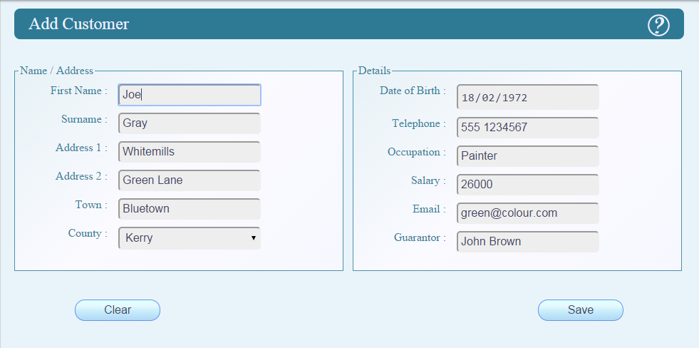

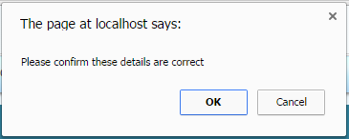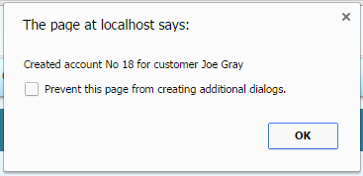

## addcustomer.html.php

<?php

/*

* File Produced By: Tom Anderson - C00174844 - 2015

* Purpose: To add a customer to the database

*/

**include** "verify_user.php";

/* set the help text */

$_SESSION['helptext'] = "To add a customer : <br //><br //> (1) Enter the appropriate details in the fields provided.<br //>".

"<br //>(2)When the details are entered click the Save button to save the customer and confirm that the details are correct when prompted.<br //>".

"<br //><br //>The Address 2 and Guarantor fields are optional, all other fields are required. The form may be reset at any time by clicking the clear button";

**include** 'head.php';

?>

<form name=**"add_customer"** id=**"add_customer"** method=**"post"** action=**"add_customer.php"** onsubmit=**"return confirm('Please confirm these details are correct')"** >

<h2>**Add Customer** <img src=**"../common/images/help-01.png"** alt=**"Help"** id=**"helpbtn"** onmousedown=**"frameToggleHelp()"** ></h2>

<fieldset class=**"halfwidth"**>

<legend> **Name / Address** </legend>

<label for=**"firstname"**>**First Name :**</label>

<input type=**"text"** name=**"firstname"** id=**"firstname"** required pattern=**"[a-zA-Z-]+"** title=**"Please use letters of the alphabet and hyphens only"** />

<label for=**"surname"**>**Surname :**</label>

<input type=**"text"** name=**"surname"** id=**"surname"** required pattern=**"[a-zA-Z -]+"** title=**"Please use letters of the alphabet, spaces and hyphens only"** />

<label for =**"address1"**>**Address 1 :**</label>

<input type=**"text"** id=**"address1"** name=**"address1"** pattern=**"[0-9a-zA-Z ,.-]+"** required title=**"Please use letters of the alphabet, numbers, spaces, full stops, and hyphens only"** /><br />

<label for =**"address2"**>**Address 2 :**</label>

<input type=**"text"**id=**"address2"** name=**"address2"** pattern=**"[a-zA-Z ,.-]+"** title=**"Please use letters of the alphabet, spaces, full stops, and hyphens only"** /><br />

<label for =**"town"**>**Town :**</label>

<input type=**"text"**id=**"town"** name=**"town"** pattern=**"[a-zA-Z .]+"**required title=**"Please use letters of the alphabet, spaces or full stops only"** /><br />

<label for =**"county"**>**County :**</label>

<select id=**"county"** name=**"county"** required title=**"Please select a county"**>

<option selected disabled hidden value=**''**></option>

<option value=**"Antrim"**>**Antrim**</option>

<option value=**"Armagh"**>**Armagh**</option>

<option value=**"Carlow"**>**Carlow**</option>

<option value=**"Cavan"**>**Cavan**</option>

<option value=**"Clare"**>**Clare**</option>

<option value=**"Cork"**>**Cork**</option>

<option value=**"Derry"**>**Derry**</option>

<option value=**"Donegal"**>**Donegal**</option>

<option value=**"Down"**>**Down**</option>

<option value=**"Dublin"**>**Dublin**</option>

<option value=**"Fermanagh"**>**Fermanagh**</option>

<option value=**"Galway"**>**Galway**</option>

<option value=**"Kerry"**>**Kerry**</option>

<option value=**"Kildare"**>**Kildare**</option>

<option value=**"Kilkenny"**>**Kilkenny**</option>

<option value=**"Laois"**>**Laois**</option>

<option value=**"Leitrim"**>**Leitrim**</option>

<option value=**"Limerick"**>**Limerick**</option>

<option value=**"Longford"**>**Longford**</option>

<option value=**"Louth"**>**Louth**</option>

<option value=**"Mayo"**>**Mayo**</option>

<option value=**"Meath"**>**Meath**</option>

<option value=**"Monaghan"**>**Monaghan**</option>

<option value=**"Offaly"**>**Offaly**</option>

<option value=**"Roscommon"**>**Roscommon**</option>

<option value=**"Sligo"**>**Sligo**</option>

<option value=**"Tipperary"**>**Tipperary**</option>

<option value=**"Tyrone"**>**Tyrone**</option>

<option value=**"Waterford"**>**Waterford**</option>

<option value=**"Westmeath"**>**Westmeath**</option>

<option value=**"Wexford"**>**Wexford**</option>

<option value=**"Wicklow"**>**Wicklow**</option>

</select>

</fieldset>

<!-- END HALF WIDTH ADDRESS-->

<fieldset class=**"halfwidth"**>

<legend> **Details** </legend>

<label for=**"dob"**>**Date of Birth :**</label>

<input type=**"date"** id=**"dob"** name=**"dob"** required onblur=**"checkDatePast(this.value)"**/><br />

<label for=**"phone"**>**Telephone :**</label>

<input type=**"text"**id=**"phone"** name=**"phone"** required pattern=**"[0-9 -]+"** title=**"Please use numbers, spaces, or hyphens only"**/><br />

<label for=**"occupation"**>**Occupation :**</label>

<input type=**"text"**id=**"occupation"** name=**"occupation"** required pattern=**"[a-zA-Z -]+"** title=**"Please use letters of the alphabet, spaces or hyphens only"** /><br />

<label for=**"salary"**>**Salary :**</label>

<input type=**"text"**id=**"salary"** name=**"salary"** required pattern=**"[0-9.]+"**/ title=**"Please use numbers only"** ><br />

<label for=**"myemail"**>**Email :**</label>

<input type=**"email"** id=**"myemail"** name=**"myemail"** required /><br />

<label for=**"guarantor"**>**Guarantor :**</label>

<input type=**"text"**id=**"guarantor"** name=**"guarantor"** pattern=**"[a-zA-Z -]+"** title=**"Please use letters of the alphabet, spaces or hyphens only"** /><br />

</fieldset>

<input type=**"reset"** name=**"clear"** value=**"Clear"**></input>

<input type=**"submit"** name=**"submit"** value=**"Save"**></input>

</form>

<?php

/* pop up a confirmation message when we successfully create an account */

**if** (**ISSET** ($_SESSION['accountNumber']))

{

**echo** "<script>alert('Created account No ". $_SESSION['accountNumber'] . " for customer " . $_SESSION['firstname']." ".$_SESSION['surname']."');</script>";

}

**unset**( $_SESSION['accountNumber']);

?>

</body>

</html>

## addcustomer.php

<?php

/*

File Produced By: Tom Anderson - C00174844 - 2015

Purpose: Sql queries to add a customer to the database

*/

**session_start**();

**include** '../common/db.inc.php';

$sql = "SELECT max(customerNumber) as MAXNUM FROM customer";

**if** (!$result = **mysql_query**($sql, $con))

{ **die** ('Error in querying the database, query 1' . **mysql_error**());

} $rowcount = **mysql_affected_rows**();

**if** ($rowcount = 1)

{

$row= **mysql_fetch_array**($result);

$_SESSION['accountNumber'] = $row['MAXNUM'] +1;

} **else**

{

$_SESSION['accountNumber'] = 1;

}

$_SESSION['firstname'] = $_POST['firstname'];

$_SESSION['surname'] = $_POST['surname'];

$sql = "INSERT INTO customer(customerNumber,

firstName, surname, address1, address2,

address_town, address_county, birthDate,

telephone, email, occupation, salary, guarantor)

VALUES( '**$_SESSION**[accountNumber]', '**$_POST**[firstname]',

'**$_POST**[surname]', '**$_POST**[address1]',

'**$_POST**[address2]', '**$_POST**[town]',

'**$_POST**[county]', '**$_POST**[dob]',

'**$_POST**[phone]', '**$_POST**[myemail]',

'**$_POST**[occupation]',

'**$_POST**[salary]', '**$_POST**[guarantor]');";

**if** (!$result = **mysql_query**($sql, $con))

{

**die** ('Error in querying the database, query 2' . **mysql_error**());

}

**mysql_close**($con);

header ("location: add_customer.html.php") ;

?>

Delete Customer Screen

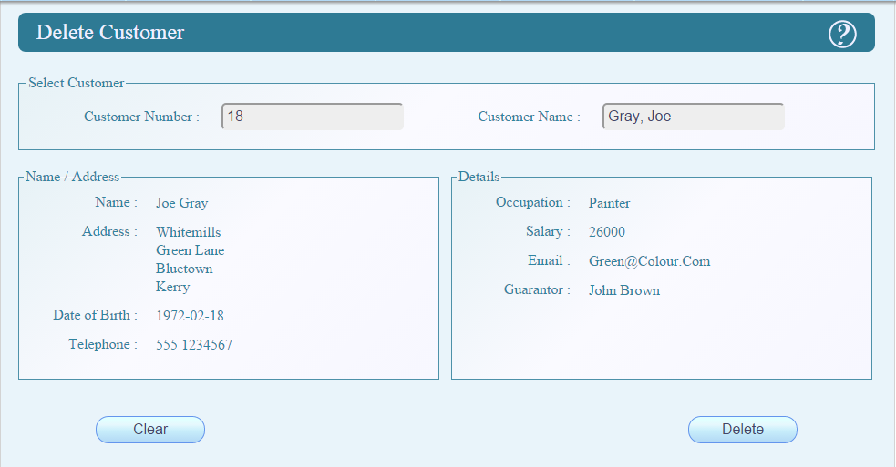

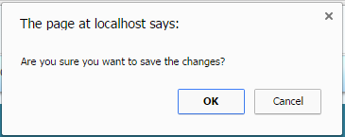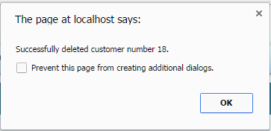

### delete_customer.html.php

<?php

/*

* File Produced By: Tom Anderson - C00174844 - 2015

* Purpose:

*/

**include** "../tom/verify_user.php";

$_SESSION['helptext'] = "To delete a customer :<br> Select the customer from the customer list or enter the customer name or number into the appropriate boxes.<br><br>".

"Click delete and confirm that the correct customer is selected when prompted.";

**include** 'head.php';

?>

<form name=**"delete_customer"** id=**"delete_customer"** method=**"post"** onsubmit=**"return confirmCheck()"** action=**"delete_customer.php"** >

<h2>**Delete Customer** <img src=**"../common/images/help-01.png"** alt=**"Help"** id=**"helpbtn"** onmousedown=**"frameToggleHelp() "** ></h2>

<fieldset class=**"fullwidth"**>

<legend>**Select Customer**</legend>

<label for=**"selectnumber"**>**Customer Number :**</label>

<?php

**include** 'cust_no_datalist.php';

?>

<label for=**"selectname"**>**Customer Name :**</label>

<?php

**include** 'cust_name_datalist.php';

?>

</fieldset>

<fieldset class=**"halfwidth"**>

<legend> **Name / Address** </legend>

<label >**Name :**</label>

<div id=**"normalname"** name=**"normalname"** ><br /></div>

<label >**Address :**</label>

<div id=**"address"** name=**"address"** /><br /><br /><br /><br /></div>

<label >**Date of Birth :**</label>

<div type=**"date"** id=**"dob"** name=**"dob"** ><br /></div>

<label >**Telephone :**</label>

<div id=**"phone"** name=**"phone"**><br /></div>

</fieldset>

<fieldset class=**"halfwidth"**>

<legend> **Details** </legend>

<label>**Occupation :**</label>

<div id=**"occupation"** name=**"occupation"** ><br /></div>

<label >**Salary :**</label>

<div id=**"salary"** name=**"salary"**><br /></div>

<label >**Email :**</label>

<div id=**"myemail"** name=**"myemail"**><br /></div>

<label >**Guarantor :**</label>

<div id=**"guarantor"** name=**"guarantor"**><br /></div>

</fieldset>

<input type=**"submit"** name=**"actionbtn"** id=**"actionbtn"** value=**"Delete"**></input>

<input type=**"reset"** name=**"clear"** value=**"Clear"** ></input>

</form>

<script>

***function*** populate**(**index**)**

**{** //Check where the index came from and use the appropriate array

***if*** **(** noarray**[**index**]** **!==** undefined **&&** index **==** noarray**[**index**].**id**)** **{**

***var*** details **=** noarray**[**index**];**

**}** ***else*** ***if*** **(** namearray**[**index**]** **!==** undefined **&&** index **==** namearray**[**index**].**sname **+** ", " **+** namearray**[**index**].**fname **){**

***var*** details **=** namearray**[**index**];**

//clear all the boxes and quit if the index is invalid

**}** ***else*** **{**

document.getElementById**(**"selectnumber"**).**value **=** ""**;**

document.getElementById**(**"selectname"**).**value **=** ""**;**

document.getElementById**(**"selectnumber"**).**value **=** ""**;**

document.getElementById**(**"fname"**).**value **=** ""**;**

document.getElementById**(**"sname"**).**value **=** ""**;**

document.getElementById**(**"address1"**).**value **=** ""**;**

document.getElementById**(**"address2"**).**value **=** ""**;**

document.getElementById**(**"town"**).**value **=** ""**;**

document.getElementById**(**"county"**).**value **=** ""**;**

document.getElementById**(**"dob"**).**value **=** ""**;**

document.getElementById**(**"phone"**).**value **=** ""**;**

document.getElementById**(**"myemail"**).**value **=** ""**;**

document.getElementById**(**"occupation"**).**value **=** ""**;**

document.getElementById**(**"salary"**).**value **=** ""**;**

document.getElementById**(**"guarantor"**).**value **=** ""**;**

imatchHeight**()** **;**

***return*** 1**;**

**}**

//set all the outputs to the values related to the selected item

***try*** **{**

document.getElementById**(**"normalname"**).**innerHTML **=** details.normalname**;**

document.getElementById**(**"address"**).**innerHTML **=** details.address**;**

document.getElementById**(**"dob"**).**innerHTML **=** details.dob**;**

document.getElementById**(**"phone"**).**innerHTML **=** details.phone**;**

**}** ***catch*** **(**error**){**

document.getElementById**(**"fname"**).**value **=** details.fname**;**

document.getElementById**(**"sname"**).**value **=** details.sname**;**

document.getElementById**(**"address1"**).**value **=** details.address1**;**

document.getElementById**(**"address2"**).**value **=** details.address2**;**

document.getElementById**(**"town"**).**value **=** details.town**;**

document.getElementById**(**"county"**).**value **=** details.county**;**

document.getElementById**(**"dob"**).**value **=** details.dob**;**

document.getElementById**(**"phone"**).**value **=** details.phone**;**

document.getElementById**(**"myemail"**).**value **=** details.email**;**

document.getElementById**(**"occupation"**).**value **=** details.occupation**;**

document.getElementById**(**"salary"**).**value **=** details.salary**;**

document.getElementById**(**"guarantor"**).**value **=** details.guarantor**;**

document.getElementById**(**"selectnumber"**).**value **=** details.id**;**

document.getElementById**(**"selectname"**).**value **=** details.sname **+** ", " **+** details.fname**;**

imatchHeight**()** **;**

***return*** 0**;**

**}**

***try*** **{**

document.getElementById**(**"myemail"**).**innerHTML **=** details.email**;**

document.getElementById**(**"occupation"**).**innerHTML **=** details.occupation**;**

document.getElementById**(**"salary"**).**innerHTML **=** details.salary**;**

document.getElementById**(**"guarantor"**).**innerHTML **=** details.guarantor**;**

**}** ***catch*** **(**error**)** **{**

**}**

document.getElementById**(**"selectnumber"**).**value **=** details.id**;**

document.getElementById**(**"selectname"**).**value **=** details.sname **+** ", " **+** details.fname**;**

imatchHeight**()** **;**

**}**

//confirmation popup

***function*** confirmCheck**()**

**{** ***var*** response**;**

response **=** confirm**(**'Are you sure you want to save the changes?'**);**

***return*** response**;**

**}**

</script>

<?php

**if** ( **ISSET**($_SESSION['returnMessage']) )

{

**echo** "<SCRIPT>alert(**$_SESSION**[returnMessage]);</SCRIPT>";

**unset**($_SESSION['returnMessage']);

}

?>

</body>

</html>

### delete_customer.php

<?php

/*

* File Produced By: Tom Anderson - C00174844 - 2015

* Purpose:

*/

**session_start**();

**include** "verify_user.html.php";

**include** '../common/db.inc.php';

$sql = "SELECT accountHolder.accountNumber as number, accountHolder.accountType as type

FROM accountHolder INNER JOIN

(SELECT accountNumber, closed FROM `loanaccount` where closed != 1

UNION

SELECT accountNumber, closed FROM `currentaccount` where closed != 1

UNION

SELECT accountNumber, closed FROM `loanaccount` where closed != 1) as accounts

ON accountHolder.accountNumber = accounts.accountNumber

where accountHolder.customerNumber = '**$_POST**[selectnumber]'

ORDER BY accountHolder.accountNumber;";

**if** (!$result = **mysql_query**($sql, $con))

{

**die** ('Error in querying the database, query 1' . **mysql_error**());

}

**if** ( **mysql_affected_rows**() != 0)

{

$_SESSION['returnMessage'] = '"Cannot delete customer with the following open accounts,\\n';

**while** ($row = **mysql_fetch_array**($result))

{

$_SESSION['returnMessage'] = $_SESSION['returnMessage']."**$row**[type] acccount Number : **$row**[number]\\n";

}

$_SESSION['returnMessage'] = $_SESSION['returnMessage'].'"';

} **else**

{

$sql = "UPDATE customer

SET `deleted` = '1'

WHERE customerNumber = '**$_POST**[selectnumber]'";

**if** (!$result = **mysql_query**($sql, $con))

{

**die** ('Error in querying the database, query 2' . **mysql_error**());

} **else**

{

$_SESSION['returnMessage'] = "'Successfully deleted customer number **$_POST**[selectnumber].'";

}

}

**mysql_close**($con);

header ("location: delete_customer.html.php") ;

?>

Amend Customer Screen

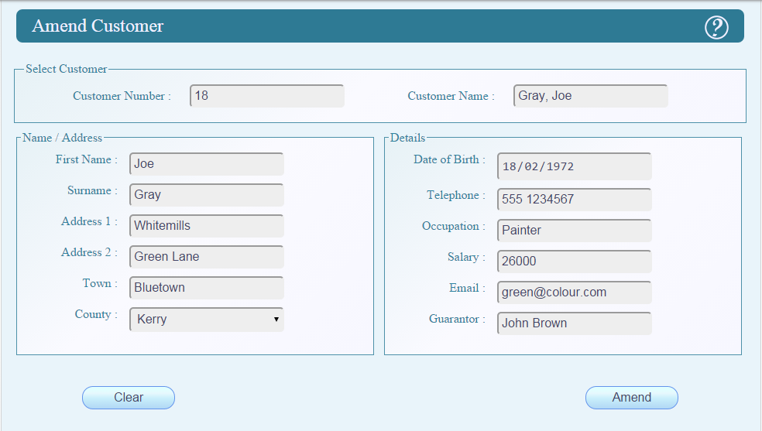

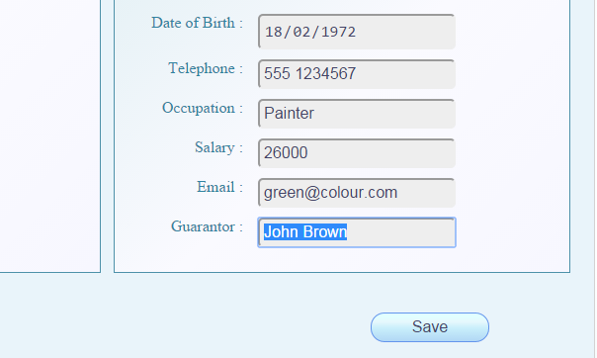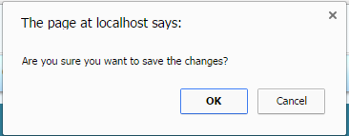

## amend_custome.html.php

<?php

/*

* File Produced By: Tom Anderson - C00174844 - 2015

* Purpose:

*/

**include** "verify_user.php";

$_SESSION['helptext'] = "To View or Edit a customer record : <br><br>".

"Enter or select the customer name or number from the appropriate select customer box<br><br>".

"Click Amend when the correct customer is selected. <br><br>".

"Edit the details and click save, check the record and confirm when prompted.";

**include** 'head.php';

?>

<form name=**"amend_customer"** id=**"amend_customer"** method=**"post"** onsubmit=**"return confirmCheck()"** action=**"amend_customer.php"** >

<h2>**Amend Customer** <img src=**"../common/images/help-01.png"** alt=**"Help"** id=**"helpbtn"** onmousedown=**"frameToggleHelp() "** ></h2>

<fieldset class=**"fullwidth$"**>

<legend>**Select Customer**</legend>

<label for=**"selectnumber"**>**Customer Number :**</label>

<?php

**include** 'cust_no_datalist.php';

?>

<label for=**"selectname"**>**Customer Name :**</label>

<?php

**include** 'cust_name_datalist.php';

?>

</fieldset>

<fieldset class=**"halfwidth"**>

<legend> **Name / Address** </legend>

<label for=**"fname"**>**First Name :**</label>

<input type=**"text"**id=**"fname"** name=**"fname"** required disabled pattern=[a-zA-Z -]+**" title="**Please use letters of the alphabet, spaces and hyphens only" /><br />

<label for=**"sname"**>**Surname :**</label>

<input type=**"text"** name=**"sname"** id=**"sname"** required disabled pattern=[a-zA-Z -]+**" title="**Please use letters of the alphabet, spaces and hyphens only" />

<label for =**"address1"**>**Address 1 :**</label>

<input type=**"text"** id=**"address1"** name=**"address1"** pattern=**"[0-9a-zA-Z ,.-]+"** required disabled title=**"Please use letters of the alphabet, numbers, spaces, full stops, and hyphens only"** /><br />

<label for =**"address2"**>**Address 2 :**</label>

<input type=**"text"**id=**"address2"** name=**"address2"** disabled pattern=**"[a-zA-Z ,.-]+"** title=**"Please use letters of the alphabet, spaces, full stops, and hyphens only"** /><br />

<label for =**"town"**>**Town :**</label>

<input type=**"text"**id=**"town"** name=**"town"** pattern=**"[a-zA-Z .]+"** required disabled title=**"Please use letters of the alphabet, spaces or full stops only"** /><br />

<label for =**"county"**>**County :**</label>

<select id=**"county"** name=**"county"** required title=**"Please select a county"** disabled >

<option selected disabled hidden value=**''**></option>

<option value=**"Antrim"**>**Antrim**</option>

<option value=**"Armagh"**>**Armagh**</option>

<option value=**"Carlow"**>**Carlow**</option>

<option value=**"Cavan"**>**Cavan**</option>

<option value=**"Clare"**>**Clare**</option>

<option value=**"Cork"**>**Cork**</option>

<option value=**"Derry"**>**Derry**</option>

<option value=**"Donegal"**>**Donegal**</option>

<option value=**"Down"**>**Down**</option>

<option value=**"Dublin"**>**Dublin**</option>

<option value=**"Fermanagh"**>**Fermanagh**</option>

<option value=**"Galway"**>**Galway**</option>

<option value=**"Kerry"**>**Kerry**</option>

<option value=**"Kildare"**>**Kildare**</option>

<option value=**"Kilkenny"**>**Kilkenny**</option>

<option value=**"Laois"**>**Laois**</option>

<option value=**"Leitrim"**>**Leitrim**</option>

<option value=**"Limerick"**>**Limerick**</option>

<option value=**"Longford"**>**Longford**</option>

<option value=**"Louth"**>**Louth**</option>

<option value=**"Mayo"**>**Mayo**</option>

<option value=**"Meath"**>**Meath**</option>

<option value=**"Monaghan"**>**Monaghan**</option>

<option value=**"Offaly"**>**Offaly**</option>

<option value=**"Roscommon"**>**Roscommon**</option>

<option value=**"Sligo"**>**Sligo**</option>

<option value=**"Tipperary"**>**Tipperary**</option>

<option value=**"Tyrone"**>**Tyrone**</option>

<option value=**"Waterford"**>**Waterford**</option>

<option value=**"Westmeath"**>**Westmeath**</option>

<option value=**"Wexford"**>**Wexford**</option>

<option value=**"Wicklow"**>**Wicklow**</option>

</select>

</fieldset>

<fieldset class=**"halfwidth"**>

<legend> **Details** </legend>

<label for=**"dob"**>**Date of Birth :**</label>

<input type=**"date"** id=**"dob"** name=**"dob"** required disabled onblur=**"checkDatePast(this.value)"**/><br />

<label for=**"phone"**>**Telephone :**</label>

<input type=**"text"**id=**"phone"** name=**"phone"** required disabled pattern=**"[0-9 -]+"** title=**"Please use numbers, spaces, or hyphens only"**/><br />

<label for=**"occupation"**>**Occupation :**</label>

<input type=**"text"**id=**"occupation"** name=**"occupation"** required disabled pattern=**"[a-zA-Z -]+"** title=**"Please use letters of the alphabet, spaces or hyphens only"** /><br />

<label for=**"salary"**>**Salary :**</label>

<input type=**"text"**id=**"salary"** name=**"salary"** required disabled pattern=**"[0-9.]+"**/ title=**"Please use numbers only"** ><br />

<label for=**"myemail"**>**Email :**</label>

<input type=**"email"** id=**"myemail"** name=**"myemail"** disabled required /><br />

<label for=**"guarantor"**>**Guarantor :**</label>

<input type=**"text"**id=**"guarantor"** name=**"guarantor"** disabled pattern=**"[a-zA-Z -]+"** title=**"Please use letters of the alphabet, spaces or hyphens only"** /><br />

</fieldset>

<input type=**"button"** name=**"actionbtn"** id=**"actionbtn"** value=**"Amend"** onclick=**"unLock()"**></input>

<input type=**"reset"** name=**"clear"** value=**"Clear"** onclick=**"lock()"** ></input>

</form>

<script>

***function*** populate**(**index**)**

**{** //Check where the index came from and use the appropriate array

***if*** **(** noarray**[**index**]** **!==** undefined **&&** index **==** noarray**[**index**].**id**)** **{**

***var*** details **=** noarray**[**index**];**

**}** ***else*** ***if*** **(** namearray**[**index**]** **!==** undefined **&&** index **==** namearray**[**index**].**sname **+** ", " **+** namearray**[**index**].**fname **){**

***var*** details **=** namearray**[**index**];**

//clear all the boxes and quit if the index is invalid

**}** ***else*** **{**

document.getElementById**(**"selectnumber"**).**value **=** ""**;**

document.getElementById**(**"selectname"**).**value **=** ""**;**

document.getElementById**(**"selectnumber"**).**value **=** ""**;**

document.getElementById**(**"fname"**).**value **=** ""**;**

document.getElementById**(**"sname"**).**value **=** ""**;**

document.getElementById**(**"address1"**).**value **=** ""**;**

document.getElementById**(**"address2"**).**value **=** ""**;**

document.getElementById**(**"town"**).**value **=** ""**;**

document.getElementById**(**"county"**).**value **=** ""**;**

document.getElementById**(**"dob"**).**value **=** ""**;**

document.getElementById**(**"phone"**).**value **=** ""**;**

document.getElementById**(**"myemail"**).**value **=** ""**;**

document.getElementById**(**"occupation"**).**value **=** ""**;**

document.getElementById**(**"salary"**).**value **=** ""**;**

document.getElementById**(**"guarantor"**).**value **=** ""**;**

imatchHeight**()** **;**

***return*** 1**;**

**}**

//set all the outputs to the values related to the selected item

***try*** **{**

document.getElementById**(**"normalname"**).**innerHTML **=** details.normalname**;**

document.getElementById**(**"address"**).**innerHTML **=** details.address**;**

document.getElementById**(**"dob"**).**innerHTML **=** details.dob**;**

document.getElementById**(**"phone"**).**innerHTML **=** details.phone**;**

**}** ***catch*** **(**error**){**

document.getElementById**(**"fname"**).**value **=** details.fname**;**

document.getElementById**(**"sname"**).**value **=** details.sname**;**

document.getElementById**(**"address1"**).**value **=** details.address1**;**

document.getElementById**(**"address2"**).**value **=** details.address2**;**

document.getElementById**(**"town"**).**value **=** details.town**;**

document.getElementById**(**"county"**).**value **=** details.county**;**

document.getElementById**(**"dob"**).**value **=** details.dob**;**

document.getElementById**(**"phone"**).**value **=** details.phone**;**

document.getElementById**(**"myemail"**).**value **=** details.email**;**

document.getElementById**(**"occupation"**).**value **=** details.occupation**;**

document.getElementById**(**"salary"**).**value **=** details.salary**;**

document.getElementById**(**"guarantor"**).**value **=** details.guarantor**;**

document.getElementById**(**"selectnumber"**).**value **=** details.id**;**

document.getElementById**(**"selectname"**).**value **=** details.sname **+** ", " **+** details.fname**;**

imatchHeight**()** **;**

***return*** 0**;**

**}**

***try*** **{**

document.getElementById**(**"myemail"**).**innerHTML **=** details.email**;**

document.getElementById**(**"occupation"**).**innerHTML **=** details.occupation**;**

document.getElementById**(**"salary"**).**innerHTML **=** details.salary**;**

document.getElementById**(**"guarantor"**).**innerHTML **=** details.guarantor**;**

**}** ***catch*** **(**error**)** **{**

**}**

document.getElementById**(**"selectnumber"**).**value **=** details.id**;**

document.getElementById**(**"selectname"**).**value **=** details.sname **+** ", " **+** details.fname**;**

imatchHeight**()** **;**

**}**

//confirmation popup

***function*** confirmCheck**()**

**{** ***var*** response**;**

response **=** confirm**(**'Are you sure you want to save the changes?'**);**

***return*** response**;**

**}**

//function to unlock the read only inputs or submit the form if they have already been unlocked

***function*** unLock**()**

**{** //only run this if we have a valid account selected

***if*** **(**document.getElementById**(**"fname"**).**text **!=** ""**)** **{**

//if we have already changed the button text to save - change type to submit and the form will submit

***if*** **(**document.getElementById**(**"actionbtn"**).**value **==** "Save"**)** **{**

document.getElementById**(**"selectnumber"**).**disabled **=** ***false*;**

document.getElementById**(**"actionbtn"**).**type **=** "submit"**;**

//otherwise allow user to edit the values - stop user from selecting another customer - and change the button text to save

**}** ***else*** **{**

document.getElementById**(**"fname"**).**disabled **=** ***false*;**

document.getElementById**(**"sname"**).**disabled **=** ***false*;**

document.getElementById**(**"address1"**).**disabled **=** ***false*;**

document.getElementById**(**"address2"**).**disabled **=** ***false*;**

document.getElementById**(**"town"**).**disabled **=** ***false*;**

document.getElementById**(**"county"**).**disabled **=** ***false*;**

document.getElementById**(**"dob"**).**disabled **=** ***false*;**

document.getElementById**(**"phone"**).**disabled **=** ***false*;**

document.getElementById**(**"myemail"**).**disabled **=** ***false*;**

document.getElementById**(**"occupation"**).**disabled **=** ***false*;**

document.getElementById**(**"salary"**).**disabled **=** ***false*;**

document.getElementById**(**"guarantor"**).**disabled **=** ***false*;**

document.getElementById**(**"selectnumber"**).**disabled **=** ***true*;**

document.getElementById**(**"selectname"**).**disabled **=** ***true*;**

document.getElementById**(**"actionbtn"**).**value **=** "Save"**;**

document.getElementById**(**"actionbtn"**).**type **=** "button"**;**

**}**

**}}**

//function to reset the writeable config of the inputs and the action button when we clear the form

***function*** lock**()** **{**

document.getElementById**(**"fname"**).**disabled **=** ***true*;**

document.getElementById**(**"sname"**).**disabled **=** ***true*;**

document.getElementById**(**"address1"**).**disabled **=** ***true*;**

document.getElementById**(**"address2"**).**disabled **=** ***true*;**

document.getElementById**(**"town"**).**disabled **=** ***true*;**

document.getElementById**(**"county"**).**disabled **=*true*;**

document.getElementById**(**"dob"**).**disabled **=** ***true*;**

document.getElementById**(**"phone"**).**disabled **=*true*;**

document.getElementById**(**"myemail"**).**disabled **=*true*;**

document.getElementById**(**"occupation"**).**disabled **=*true*;**

document.getElementById**(**"salary"**).**disabled **=** ***true*;**

document.getElementById**(**"guarantor"**).**disabled **=** ***true*;**

document.getElementById**(**"selectnumber"**).**disabled **=** ***false*;**

document.getElementById**(**"selectname"**).**disabled **=** ***false*;**

document.getElementById**(**"actionbtn"**).**value **=** "Amend"**;**

document.getElementById**(**"actionbtn"**).**type **=** "button"**;**

**}**

//confirmation popup

***function*** confirmCheck**()**

**{** ***var*** response**;**

response **=** confirm**(**'Are you sure you want to save the changes?'**);**

***return*** response**;**

**}**

</script>

</body>

</html>

## amendcustomer.php

<?php

/*

* File Produced By: Tom Anderson - C00174844 - 2015

* Purpose:

*/

**include** "verify_user.html.php";

**include** '../common/db.inc.php';

$sql = "UPDATE customer

SET firstName = '**$_POST**[fname]', surname = '**$_POST**[sname]',address1 = '**$_POST**[address1]',

address2 = '**$_POST**[address2]', address_town = '**$_POST**[town]', address_county = '**$_POST**[county]',email = '**$_POST**[myemail]',birthDate = '**$_POST**[dob]' ,

telephone = '**$_POST**[phone]', occupation = '**$_POST**[occupation]',

salary = '**$_POST**[salary]',guarantor = '**$_POST**[guarantor]'

WHERE customerNumber = '**$_POST**[selectnumber]'";

**if** (!$result = **mysql_query**($sql, $con))

{

**die** ('Error in querying the database, query 1' . **mysql_error**());

}

**mysql_close**($con);

header ("location: amend_customer.html.php") ;

?>

Start Up / Login Page

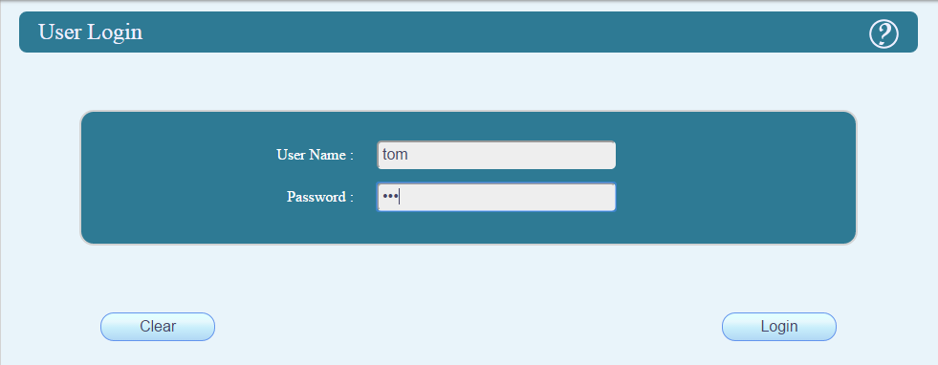

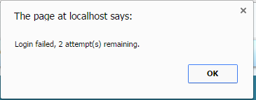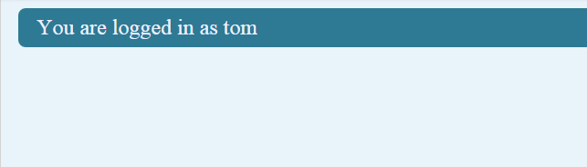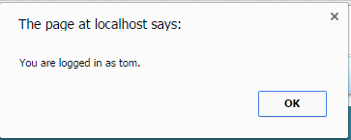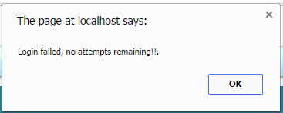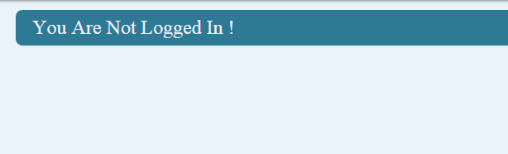

## login.html.php

<?php

/*

* File Produced By: Tom Anderson - C00174844 - 2015

* Purpose:

*/

**session_start**();

$_SESSION['helptext'] = "Enter a valid username and password combination.<br>You have up to three attempts.<br>";

**include** 'head.php';

?>

<form name=**"userlogin"** id=**"userlogin"** method=**"post"** action=**"login.php"** >

<h2>**User Login** <img src=**"../common/images/help-01.png"** alt=**"Help"** id=**"helpbtn"** onmousedown=**"frameToggleHelp()"**></h2>

<fieldset id=**"login"**>

<label for=**"username"**>**User Name :**</label>

<input type=**"text"** id=**"username"** name=**"username"** required title=**"Please enter a valid username using upper and/or lowercase letters and spaces only"** pattern=**"[a-zA-Z ]+"** /><br />

<label for=**"password"**>**Password :**</label>

<input type=**"password"** name=**"password"** id=**"sname"** required title=**"Please enter your password** /><br />

</fieldset>

<input type=**"submit"** name=**"submit"** id=**"submit"** value=**"Login"** input>

<input type=**"reset"** name=**"clear"** value=**"Clear"** ></input>

</form>

<?php

**if** ( **ISSET**($_SESSION['returnMessage']) )

{

**echo** "<SCRIPT>alert(**$_SESSION**[returnMessage]);</SCRIPT>";

**unset**($_SESSION['returnMessage']);

}

?>

</body>

</html>

## login.php

<?php

/*

* File Produced By: Tom Anderson - C00174844 - 2015

* Purpose:

*/

**session_start**();

**include** '../common/db.inc.php';

**if** (! **ISSET**($_SESSION["attempts"]))

{ $_SESSION["attempts"] = 3;

}$_SESSION["attempts"]--;

$sql = "SELECT password , userName

FROM password

WHERE userName = '**$_POST**[username]'";

**if** (!$result = **mysql_query**($sql, $con))

{ **die** ('Error in querying the database, query 1' . **mysql_error**());

}

**if** (**mysql_affected_rows**() == 1 )

{

$result = **mysql_fetch_array**($result);

**if** ($result['password'] == $_POST['password'])

{

$_SESSION["username"] = $result['userName'];

**unset** ($_SESSION["attempts"]);

$_SESSION['returnMessage'] = "'You are logged in as **$_SESSION**[username].'";

header("Location: default.html.php");

**exit**;

}

}

**if** ($_SESSION["attempts"] <= 0)

{

**UNSET**($_SESSION['attempts']);

$_SESSION['returnMessage'] = "'Login failed, no attempts remaining!!.'";

header("Location: logout.html.php");

**exit**();

}

$_SESSION['returnMessage'] = "'Login failed, **$_SESSION**[attempts] attempt(s) remaining.'";

header("Location: login.html.php");

?>

### logout.html.php

<?php

/*

* File Produced By: Tom Anderson - C00174844 - 2015

* Purpose:

*/

**session_start**();

$_SESSION['helptext'] = 'You are not logged in, please refresh your browser or select a menu item to continue';

**include** 'head.php';

?>

<script>

***var*** target **=** window.parent.document.getElementById**(**'logout'**);**

target.innerHTML **=** ""

target.hidden **=** ***true*;**

</script>

<form name=**""** id=**""** method=**""** action=**""** onsubmit=**""**>

<h2>**You Are Not Logged In !** <img src=**"../common/images/help-01.png"** alt=**"Help"** id=**"helpbtn"** onmousedown=**"frameToggleHelp() "** /></h2>

</form>

</body>

<?php

**if** ( **ISSET**($_SESSION['returnMessage']) )

{

**echo** "<SCRIPT>alert(**$_SESSION**[returnMessage]);</SCRIPT>";

**unset**($_SESSION['returnMessage']);

}

session_destroy();

?>

</html>

## default.html.php

<?php

/*

* File Produced By: Tom Anderson - C00174844 - 2015

* Purpose:

*/

**include** 'verify_user.php';

$_SESSION['helptext'] = "Select an option from the menu or log out!";

**include** 'head.php';

?>

<script>

***var*** target **=** window.parent.document.getElementById**(**'logout'**);**

target.innerHTML **=** "Logout <?php **echo** $_SESSION['username']; ?> <img src='./common/images/logout.png' alt='logout' >"

target.hidden **=** ***false*;**

</script>

<form name=**""** id=**""** method=**""** action=**""** onsubmit=**""**>

<h2>**You are logged in as** <?php **echo** $_SESSION['username']; ?><img src=**"../common/images/help-01.png"** alt=**"Help"** id=**"helpbtn"** onmousedown=**"frameToggleHelp() "** ></h2>

</form>

</body>

<?php

**if** ( **ISSET**($_SESSION['returnMessage']) )

{

**echo** "<SCRIPT>alert(**$_SESSION**[returnMessage]);</SCRIPT>";

**unset**($_SESSION['returnMessage']);

}

?>

</html>

Change Password Screen

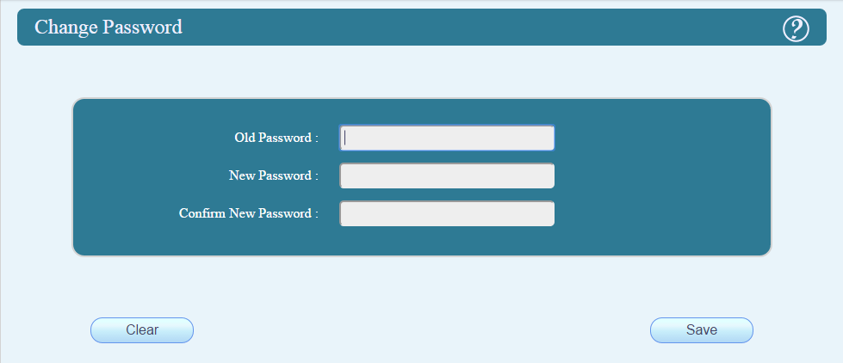

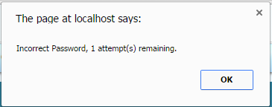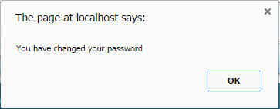

## password.html.php

<?php

/*

* File Produced By: Tom Anderson - C00174844 - 2015

* Purpose: To change the users password

*/

**include** "../tom/verify_user.php";

$_SESSION['helptext'] = 'To change your password: <br><br>Enter your existing password.<br><br>Enter the new password<br><br>Re-enter the new password<br><br>Click the submit button';

**include** 'head.php';

?>

<script>

***function*** check**()** **{**

***var*** input **=** document.getElementById**(**'confirmpass'**);**

***if*** **(**input.value **!=** document.getElementById**(**'newpass'**).**value**)** **{**

input.setCustomValidity**(**'The passwords do not match.'**);**

***return*** ***false*;**

**}** ***else*** **{**

input.setCustomValidity**(**''**);**

***return*** ***true*;**

**}**

**}**

</script>

<form name=**"epass"** id=**"pass"** method=**"post"** action=**"changepass.php"** onsubmit = **"return check()"** >

<h2>**Change Password** <img src=**"../common/images/help-01.png"** alt=**"Help"** id=**"helpbtn"** onmousedown=**"frameToggleHelp()"**></h2>

<fieldset id=**"login"**>

<label for=**"oldpass"**>**Old Password :**</label>

<input type=**"password"** name=**"oldpass"** id=**"oldpass"** required title=**"Please enter your password"** /><br />

<label for=**"newpass"**>**New Password :**</label>

<input type=**"password"** name=**"newpass"** id=**"newpass"** title=**"Please enter the new password"** /><br />

<label for=**"confirmpass"**>**Confirm New Password :**</label>

<input type=**"password"** name=**"confirmpass"** id=**"confirmpass"** title=**"Please repeat your new password"** oninput=**"check()"** /><br />

</fieldset>

<input type=**"submit"** name=**"submit"** id=**"submit"** value=**"Save"** input>

<input type=**"reset"** name=**"clear"** value=**"Clear"** ></input>

</form>

<?php

**if** ( **ISSET**($_SESSION['returnMessage']) )

{

**echo** "<SCRIPT>alert(**$_SESSION**[returnMessage]);</SCRIPT>";

**unset**($_SESSION['returnMessage']);

}

?>

</body>

</html>

## changepass.php

<?php

/*

* File Produced By: Tom Anderson - C00174844 - 2015

* Purpose:

*/

**session_start**();

**include** '../common/db.inc.php';

**if** (! **ISSET**($_SESSION["passattempts"]))

{

$_SESSION["passattempts"] = 3;

}

$_SESSION["passattempts"]--;

$sql = "SELECT password

FROM password

WHERE userName = '**$_SESSION**[username]'";

**if** (!$result = **mysql_query**($sql, $con))

{

**die** ('Error in querying the database, query 1' . **mysql_error**());

}

$result = **mysql_fetch_array**($result);

**if** ($result['password'] == $_POST['oldpass'])

{

**unset** ($_SESSION["passattempts"]);

$sql = "UPDATE password SET password = '**$_POST**[newpass]'

WHERE userName = '**$_SESSION**[username]'";

**if** (!$result = **mysql_query**($sql, $con))

{

**die** ('Error in querying the database, query 2' . **mysql_error**());

}

$_SESSION['returnMessage'] = "'You have changed your password'";

header("Location: default.html.php");

**exit**;

}

**if** ($_SESSION["passattempts"] <= 0)

{

**UNSET**($_SESSION['passattempts']);

$_SESSION['returnMessage'] = "'Login failed, no attempts remaining!!.'";

header("Location: logout.html.php");

**exit**();

}

$_SESSION['returnMessage'] = "'Incorrect Password, **$_SESSION**[passattempts] attempt(s) remaining.'";

header("Location: password.html.php");

?>

Included Files

## accountlist.php

<?php

/*

* File Produced By: Tom Anderson - C00174844 - 2015

* Purpose:

*/

**session_start**();

$_SESSION['helptext'] = "Enter a valid username and password combination.<br>You have up to three attempts.<br>";

**include** 'head.php';

?>

<form name=**"userlogin"** id=**"userlogin"** method=**"post"** action=**"login.php"** >

<h2>**User Login** <img src=**"../common/images/help-01.png"** alt=**"Help"** id=**"helpbtn"** onmousedown=**"frameToggleHelp()"**></h2>

<fieldset id=**"login"**>

<label for=**"username"**>**User Name :**</label>

<input type=**"text"** id=**"username"** name=**"username"** required title=**"Please enter a valid username using upper and/or lowercase letters and spaces only"** pattern=**"[a-zA-Z ]+"** /><br />

<label for=**"password"**>**Password :**</label>

<input type=**"password"** name=**"password"** id=**"sname"** required title=**"Please enter your password using upper and/or lowercase letters and numbers"** pattern=**"[a-zA-Z0-9 ]+"** /><br />

</fieldset>

<input type=**"submit"** name=**"submit"** id=**"submit"** value=**"Login"** input>

<input type=**"reset"** name=**"clear"** value=**"Clear"** ></input>

</form>

<?php

**if** ( **ISSET**($_SESSION['returnMessage']) )

{

**echo** "<SCRIPT>alert(**$_SESSION**[returnMessage]);</SCRIPT>";

**unset**($_SESSION['returnMessage']);

}

?>

</body>

</html>

## cust_no_datalist.php

<?php

/*

* File Produced By: Tom Anderson - C00174844 - 2015

* Purpose:

*/

**include** '../common/db.inc.php';

$sql = "SELECT * FROM `customer`

WHERE `deleted` = 0

ORDER BY customerNumber";

**if** (!$result = **mysql_query** ($sql, $con))

{

**die** ('Error in querying the database' . **mysql_error**());

}

**echo** "<script>var noarray = new Array();</script><input name='selectnumber' id='selectnumber' list='custnumbers' oninput='populate(this.value)'></input>";

**echo** "<option selected disabled hidden value=''></option><datalist id='custnumbers' >";

**while** ($row = **mysql_fetch_array**($result))

{

$dob = $row['birthDate'];

$birthDate = **date**("Y-m-d", strtotime($dob));

**echo** "<script>

noarray['**$row**[customerNumber]'] = {'id': '**$row**[customerNumber]','fname': '**$row**[firstName]','sname': '**$row**[surname]','address1': '**$row**[address1]','address2': '**$row**[address2]','town': '**$row**[address_town]','county': '**$row**[address_county]','dob': '**$birthDate**','phone': '**$row**[telephone]','email':'**$row**[email]','occupation': '**$row**[occupation]','salary': '**$row**[salary]','guarantor': '**$row**[guarantor]' };

noarray['**$row**[customerNumber]'] = {'id': '**$row**[customerNumber]','fname': '**$row**[firstName]','sname': '**$row**[surname]','address1': '**$row**[address1]','address2': '**$row**[address2]','town': '**$row**[address_town]','county': '**$row**[address_county]','dob': '**$birthDate**','phone': '**$row**[telephone]','email':'**$row**[email]','occupation': '**$row**[occupation]','salary': '**$row**[salary]','guarantor': '**$row**[guarantor]', 'normalname': '**$row**[firstName]'+' '+'**$row**[surname]',

'address': '**$row**[address1]<br />**$row**[address2]<br />**$row**[address_town]<br />**$row**[address_county]' };

</script>";

**echo** "<option value = '**$row**[customerNumber]'></option>";

}

**echo** "</datalist>";

**mysql_close**($con);

?>

## cust_name_datalist.php

<?php

/*

* File Produced By: Tom Anderson - C00174844 - 2015

* Purpose:

*/

**include** '../common/db.inc.php';

$sql = "SELECT * FROM `customer` WHERE `deleted` = 0 ORDER BY surname";

**if** (!$result = **mysql_query** ($sql, $con))

{

**die** ('Error in querying the database' . **mysql_error**());

}

**echo** "<script>var namearray = new Array();</script><input name='selectname' id='selectname' list='custnames' onblur='populate(this.value)'></input>";

**echo** "<option selected disabled hidden value=''></option><datalist id='custnames' >";

**while** ($row = **mysql_fetch_array**($result))

{

$dob = $row['birthDate'];

$birthDate = **date**("Y-m-d", strtotime($dob));

**echo** "<script>

namearray['**$row**[surname], **$row**[firstName]'] = {'id': '**$row**[customerNumber]','fname': '**$row**[firstName]','sname': '**$row**[surname]','address1': '**$row**[address1]','address2': '**$row**[address2]','town': '**$row**[address_town]','county': '**$row**[address_county]','dob': '**$birthDate**','phone': '**$row**[telephone]','email':'**$row**[email]','occupation': '**$row**[occupation]','salary': '**$row**[salary]','guarantor': '**$row**[guarantor]', 'normalname': '**$row**[firstName]'+' '+'**$row**[surname]',

'address': '**$row**[address1]<br />**$row**[address2]<br />**$row**[address_town]<br />**$row**[address_county]'};

</script>";

**echo** "<option value ='**$row**[surname], **$row**[firstName]'></option>";

}

**echo** "</datalist>";

**mysql_close**($con);

?>

## head.php

<!DOCTYPE HTML>

<!--

File Produced By: Tom Anderson - C00174844 - 2015

Purpose: To include common elements at the beginning of some pages / files

-->

<html>

<head>

<script type=**"text/javascript"** src=**"../common/iframe.js"**></script>

<script type=**"text/javascript"** src=**"tom.js"**></script>

<link rel=**"stylesheet"** href=**"../common/style.css"**>

<link rel=**"stylesheet"** href=**"../common/iframe.css"**>

</head>

<!-- This code V sends the text that is set as a php session variable to our help form -->

<body onmousedown=**"ihideMenu()"** <?php **echo** "onload='loadHelp(\"**$_SESSION**[helptext]\")'"; ?> >

# individual work units (ciara mcmahon)

HELP SCREEN SHOT

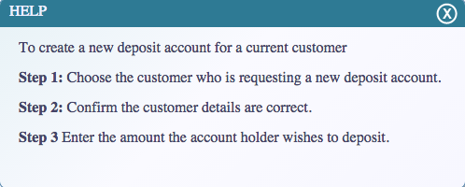

Open Deposit

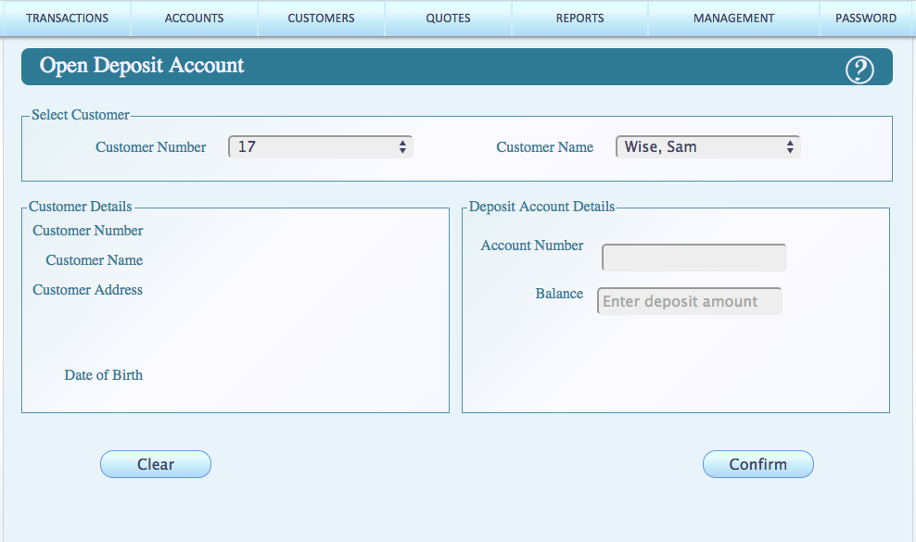

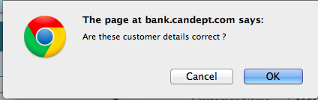

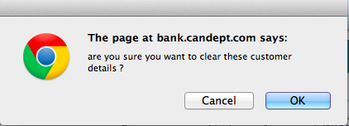

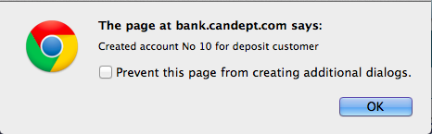



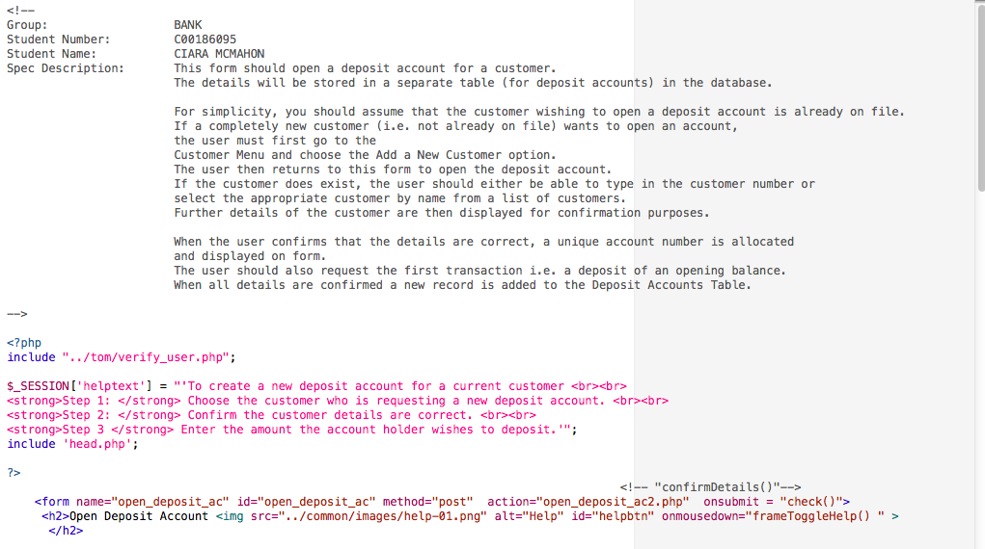

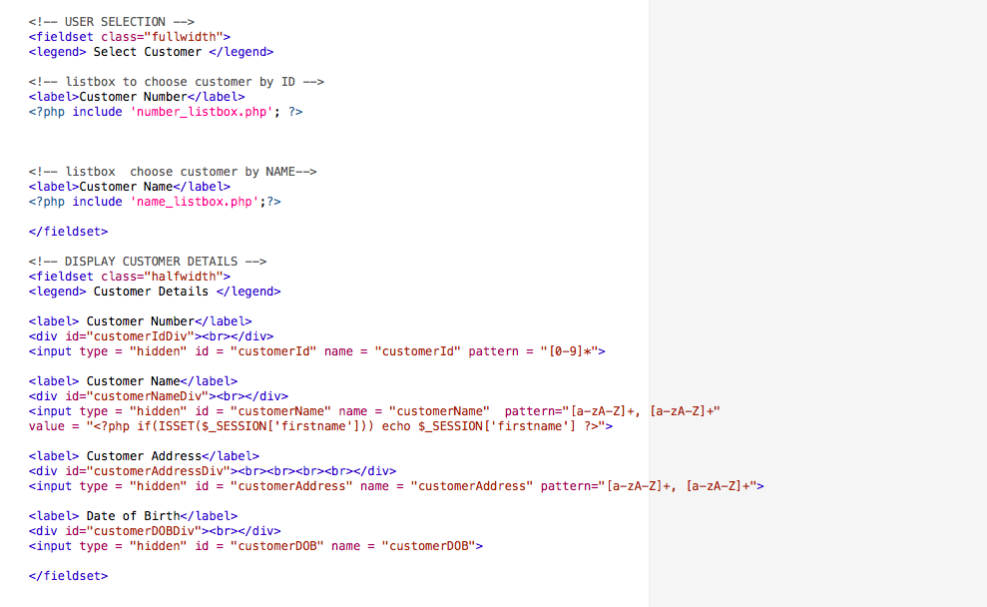

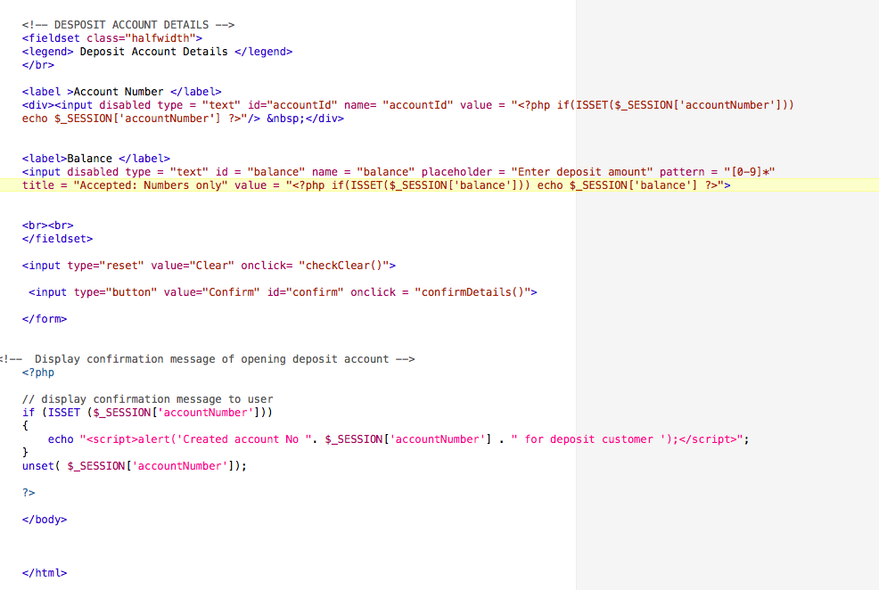

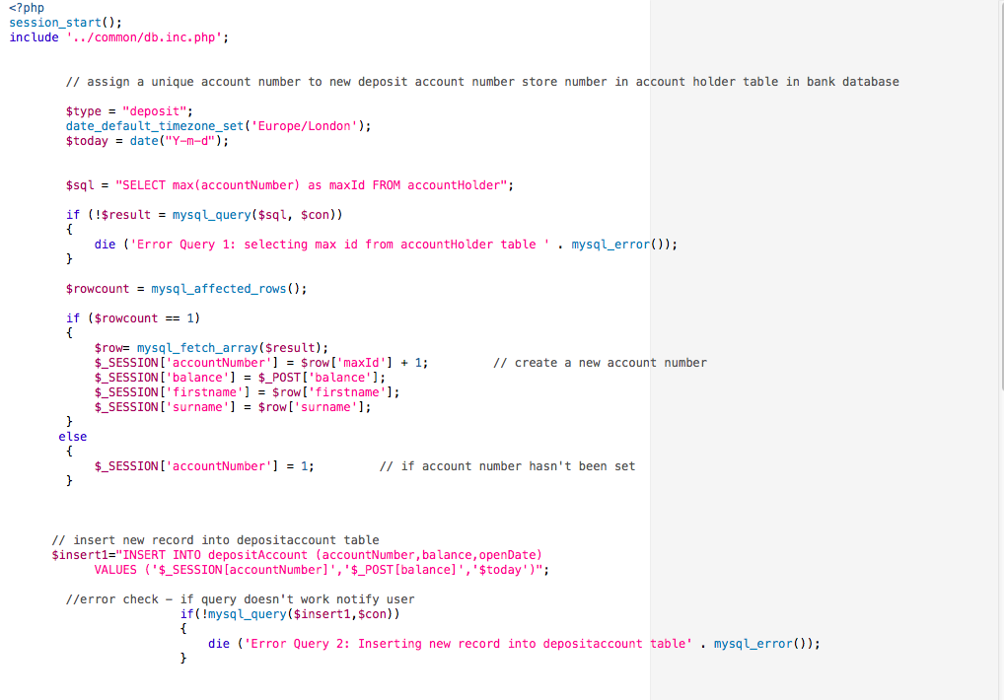

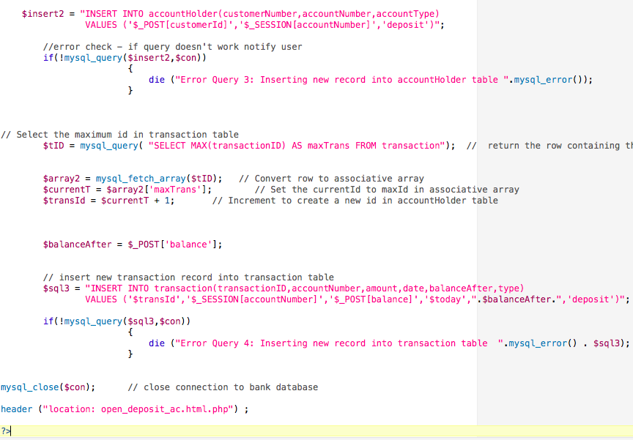

Close Deposit

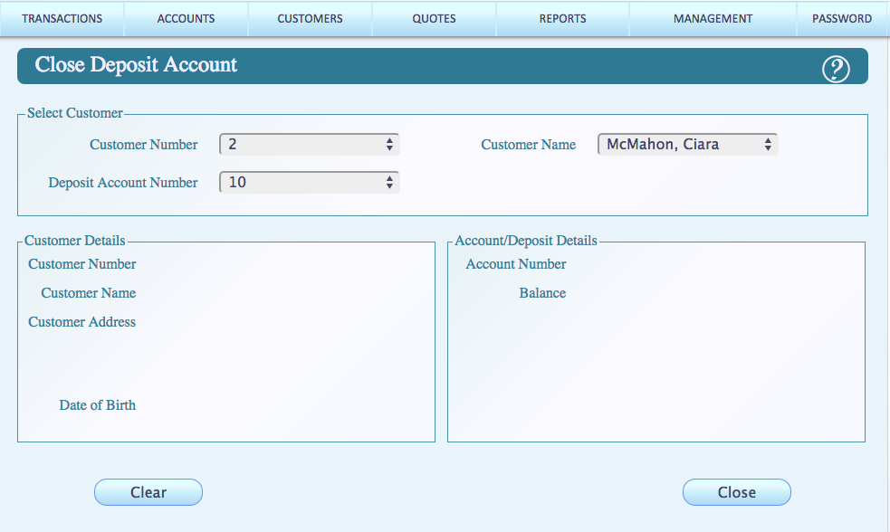

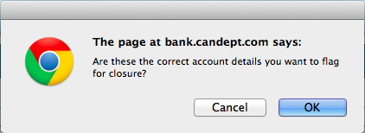

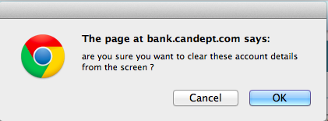

Close Deposit Code

HTML FORM

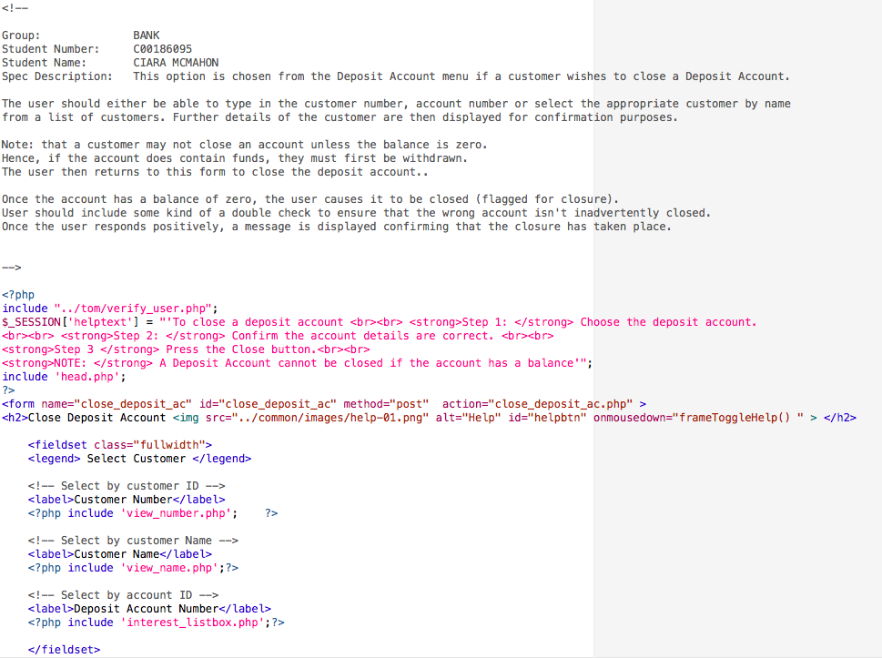

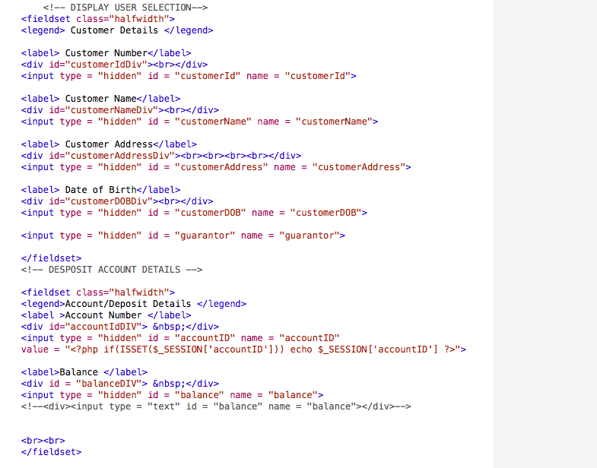

PHP CODE

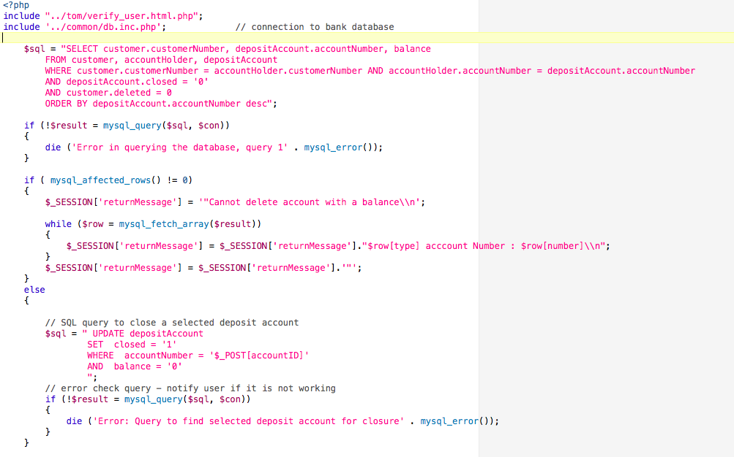

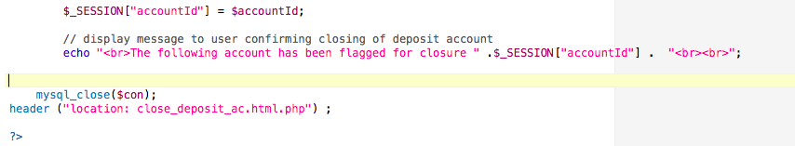

VIEW DEPOSIT

SCREENS

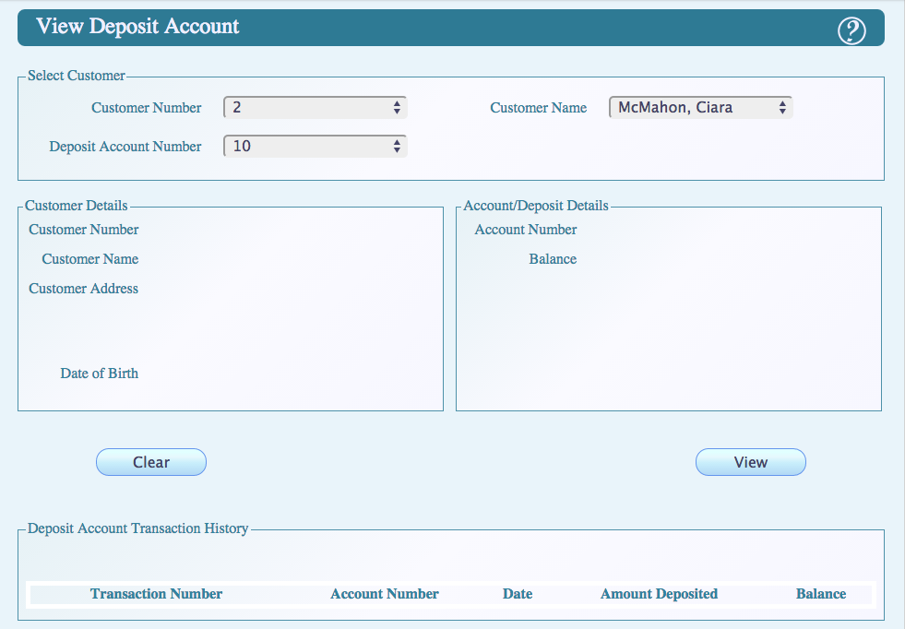

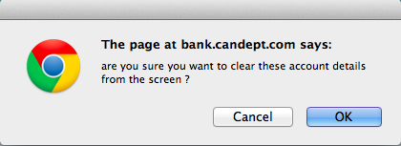

HTML CODE

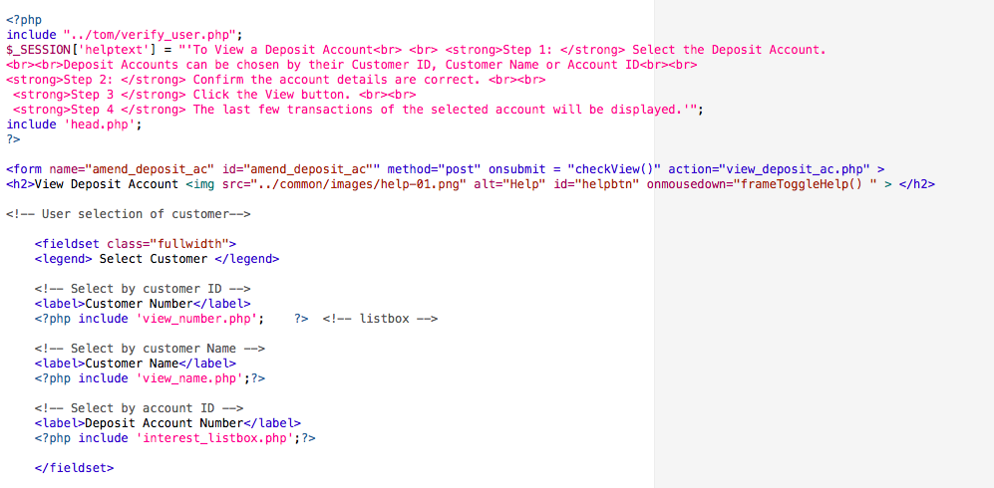

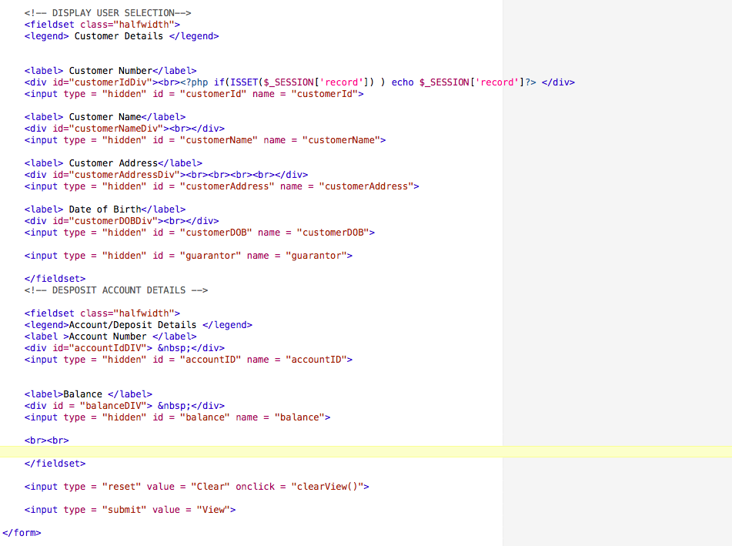

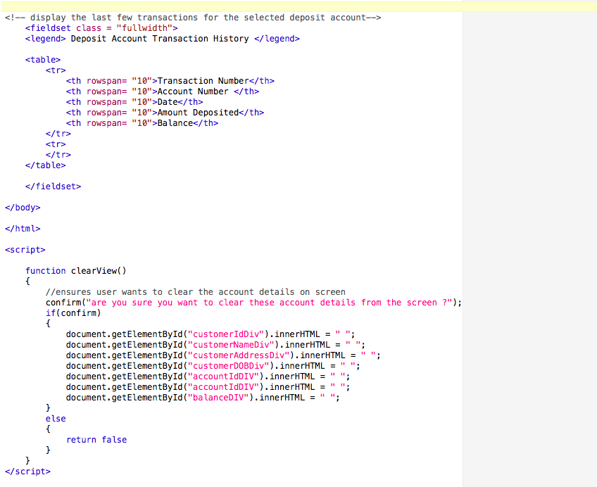

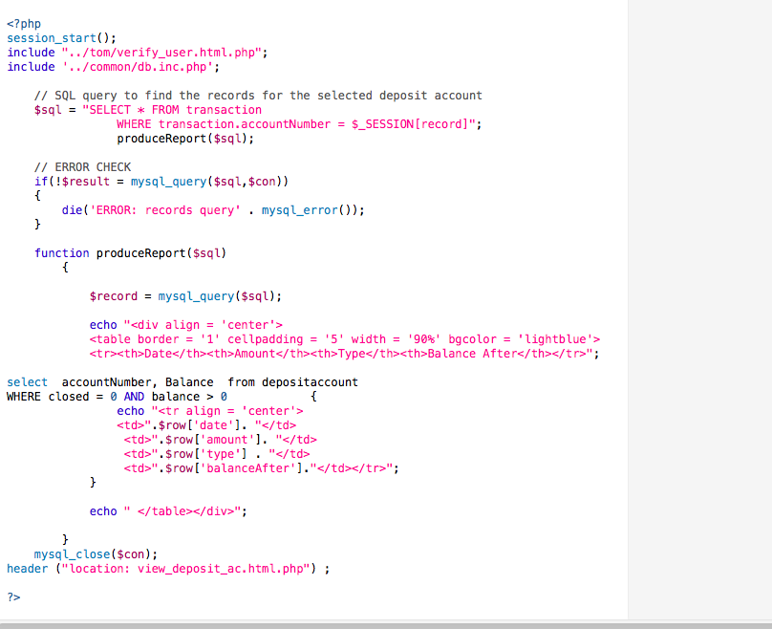

DEPOSIT HISTORY

SCREENS

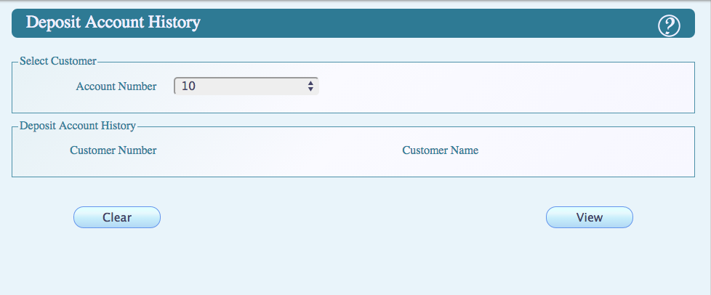

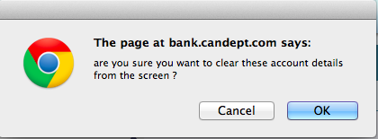

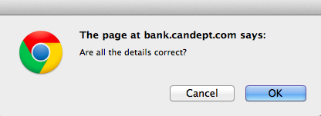

CODE

HTML FORM

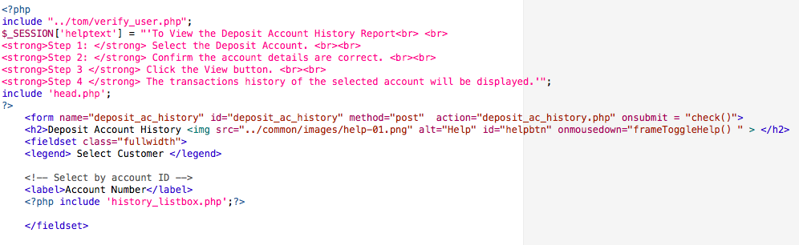

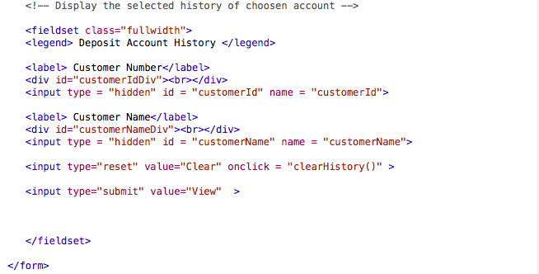

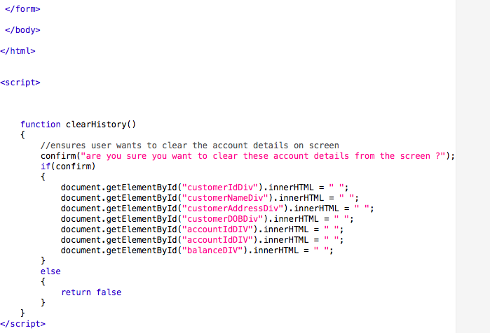

PHP CODE

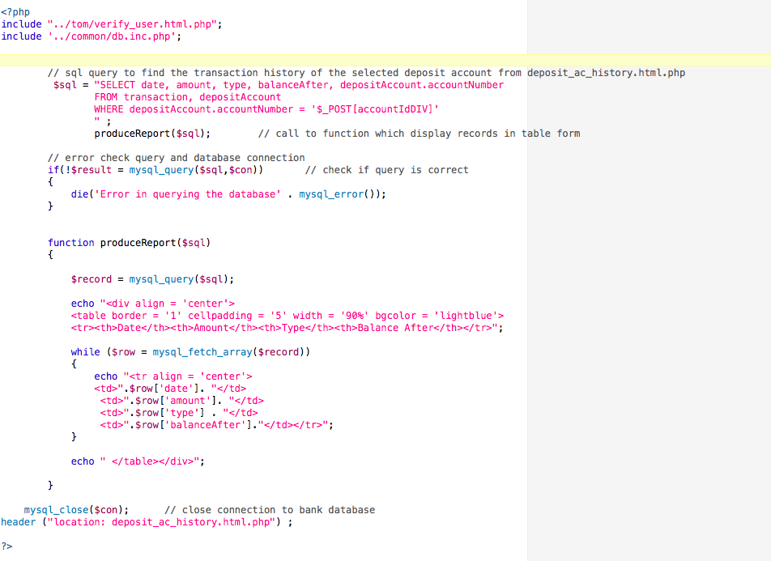

CALCULATE DEPOSIT INTEREST S

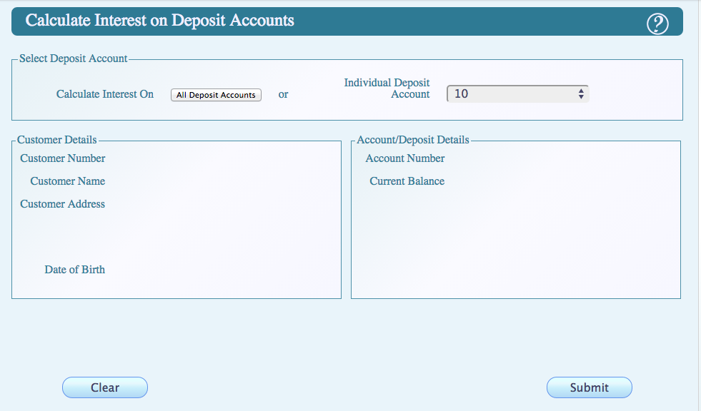

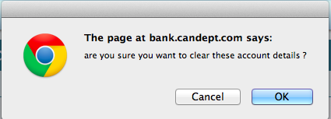

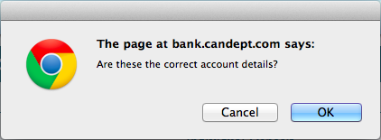

CODE

HTML FORM

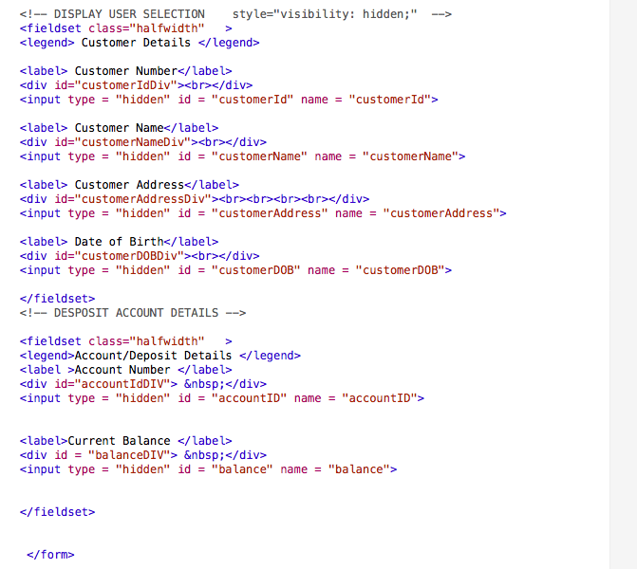

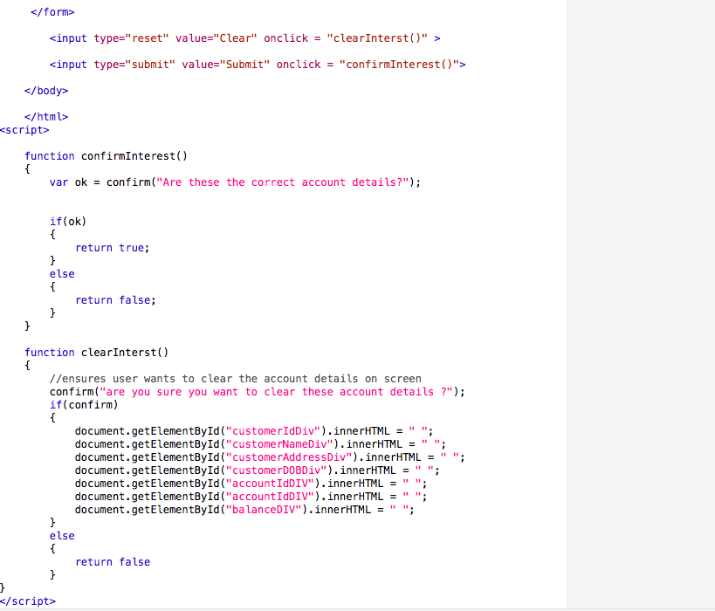

PHP CODE

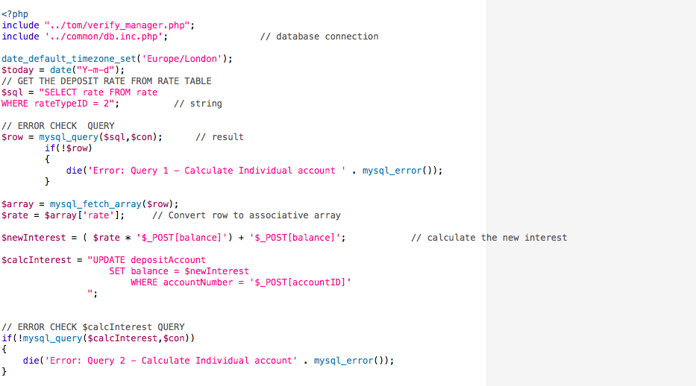

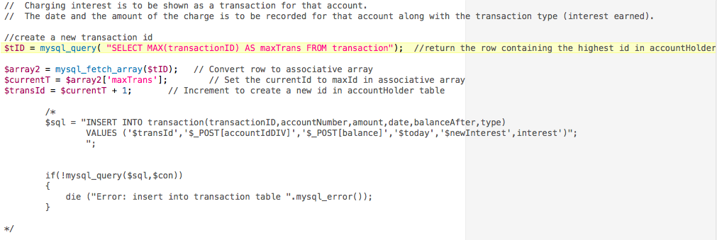

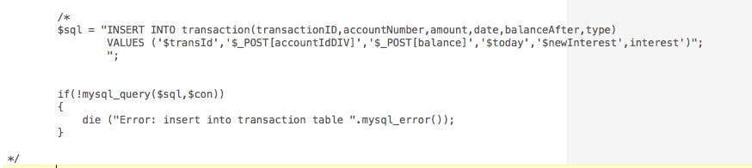

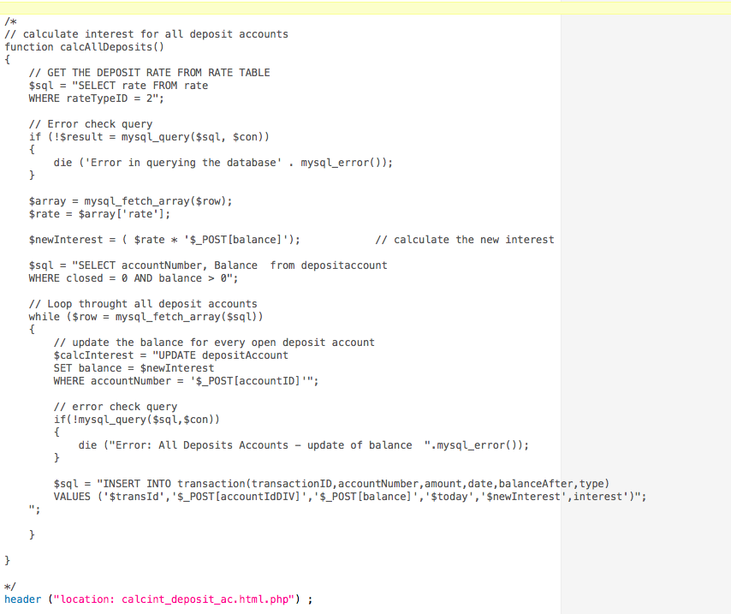

VIEW DEPOSIT

SCREEN



CODE

HTML FORM







PHP CODE



LIST BOX CODE

ACCOUNT LISTBOX

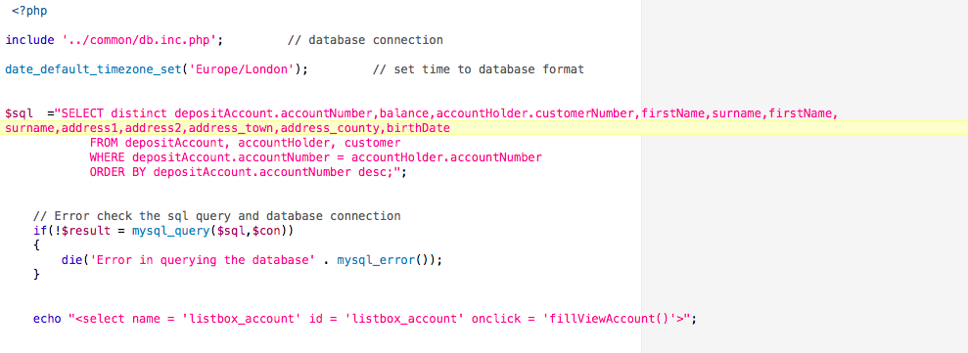

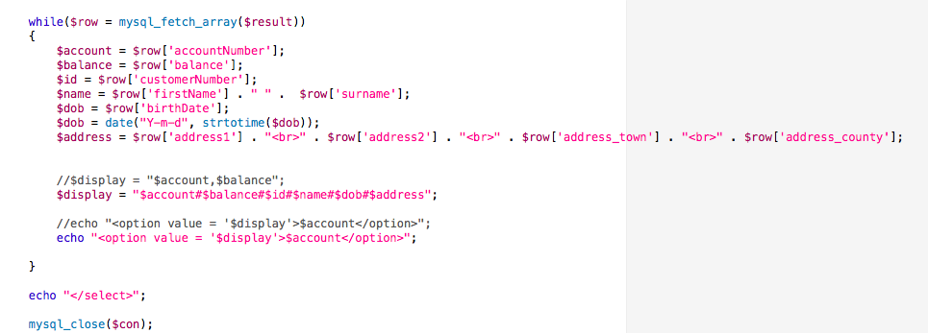

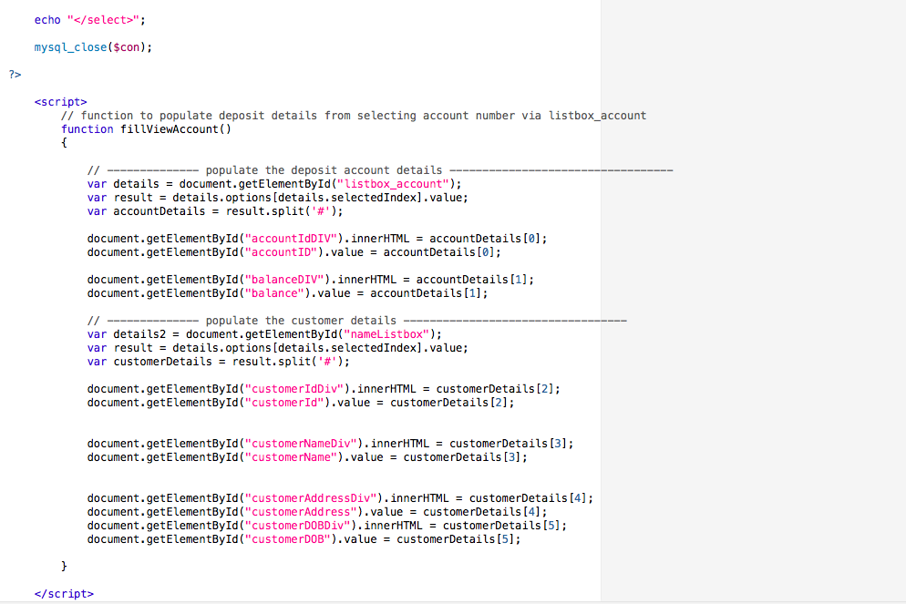

HISTORY LISTBOX

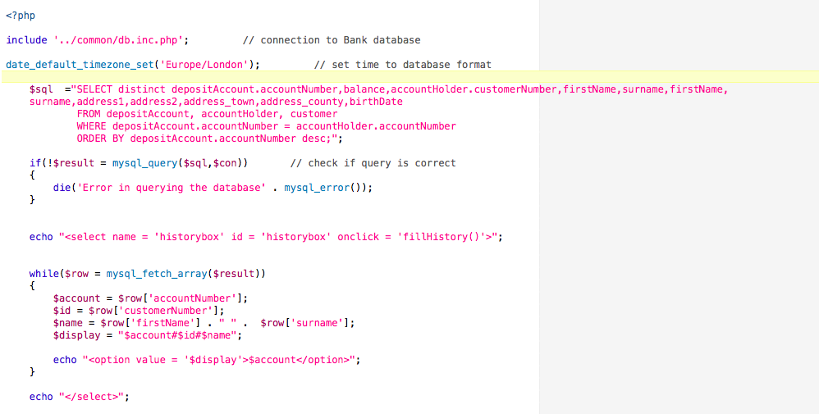

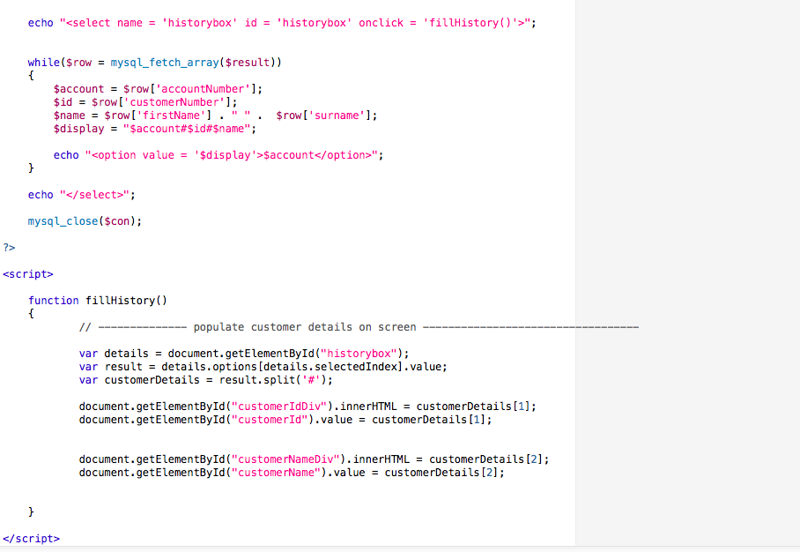

INTEREST LIST BOX

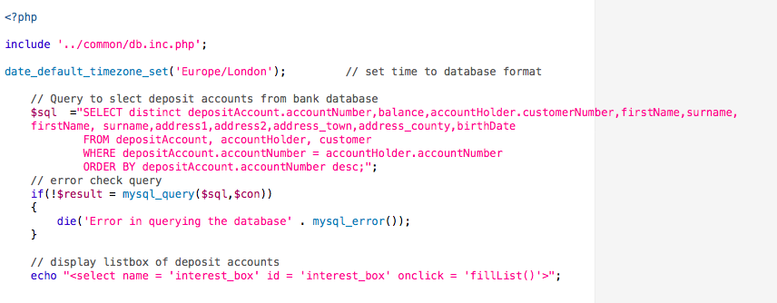

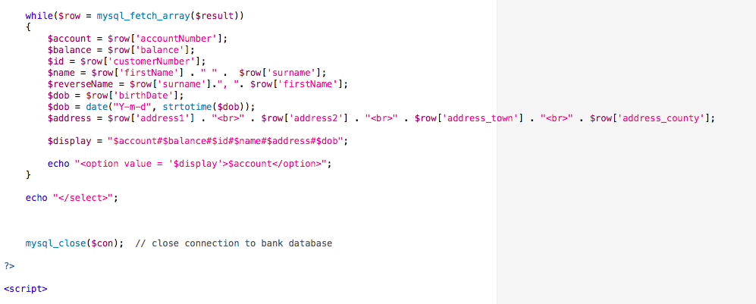

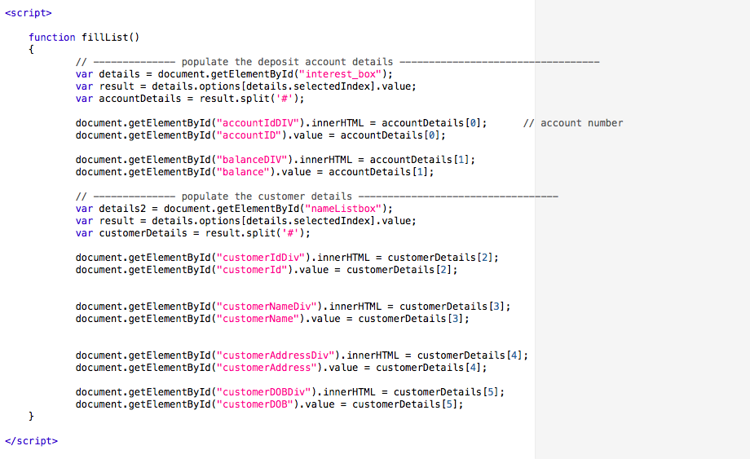

NAME LISTBOX

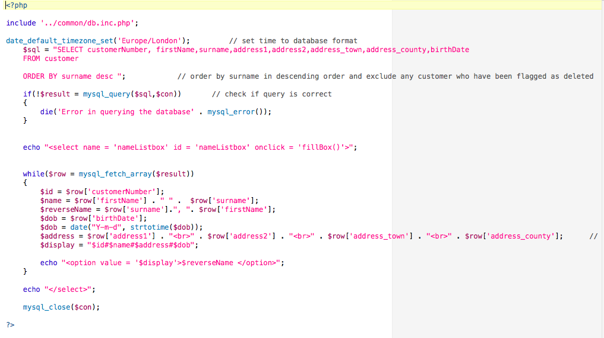

NUMBER LISTBOX

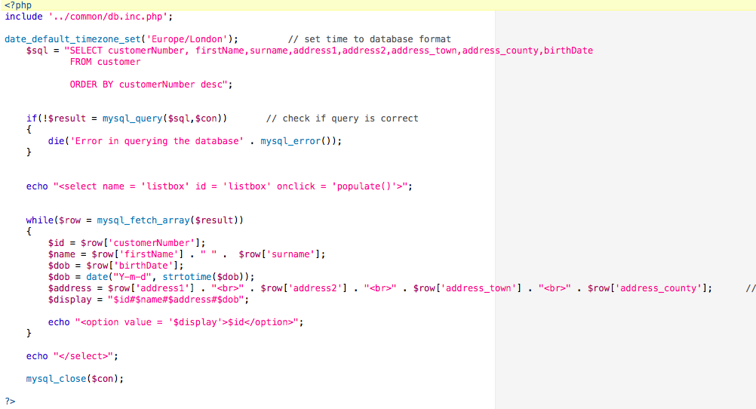

VIEW NUMBER LISTBOX

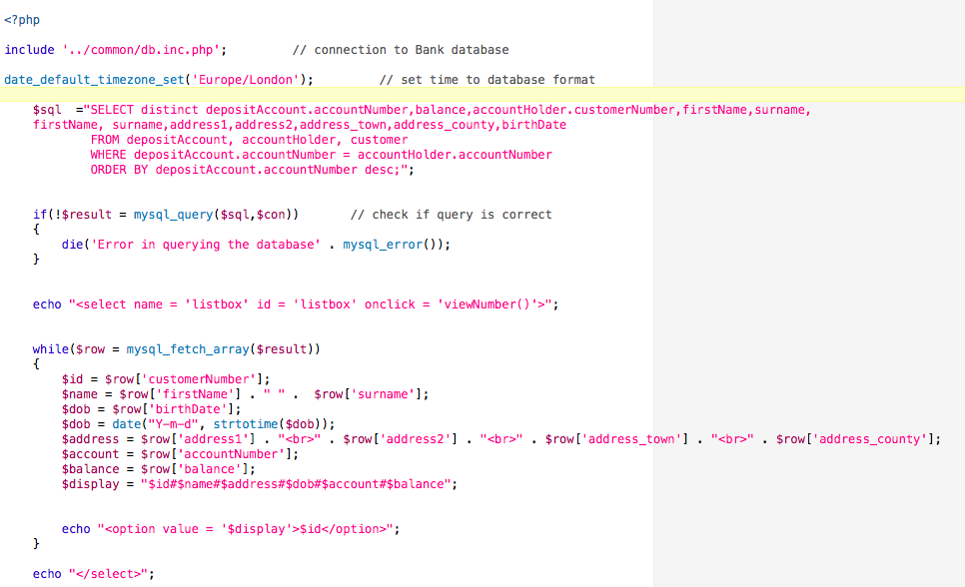

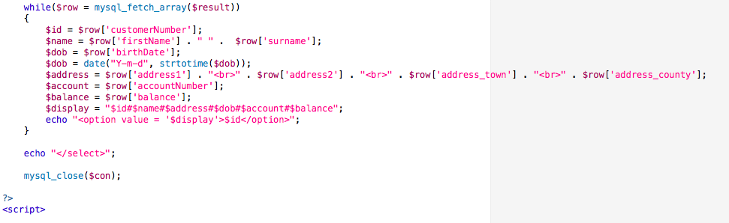

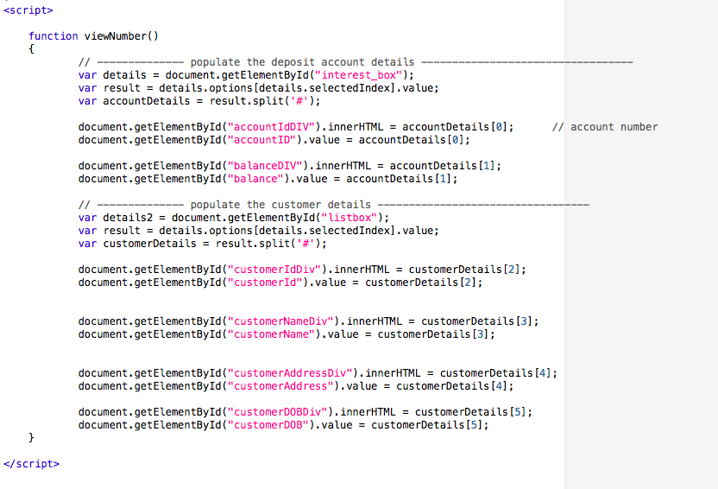

VIEW NAME LISTBOX

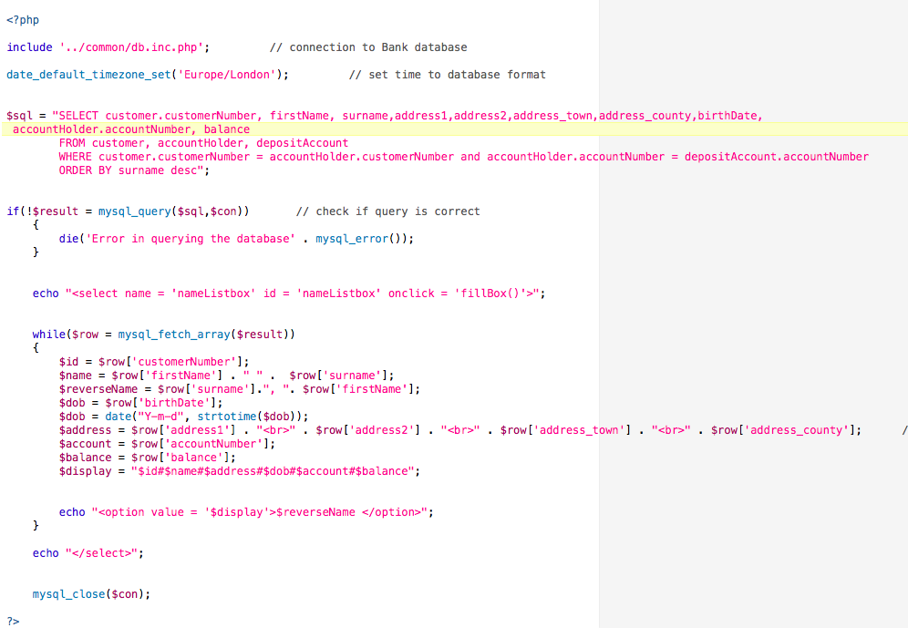

JAVASCRIPT CODE

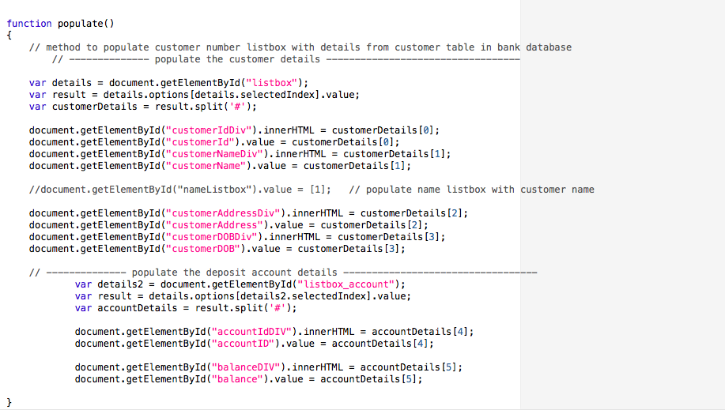

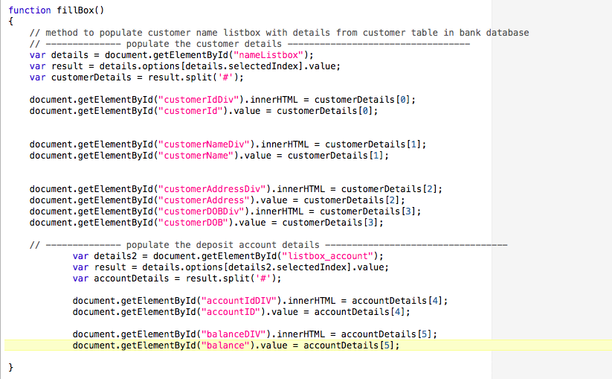

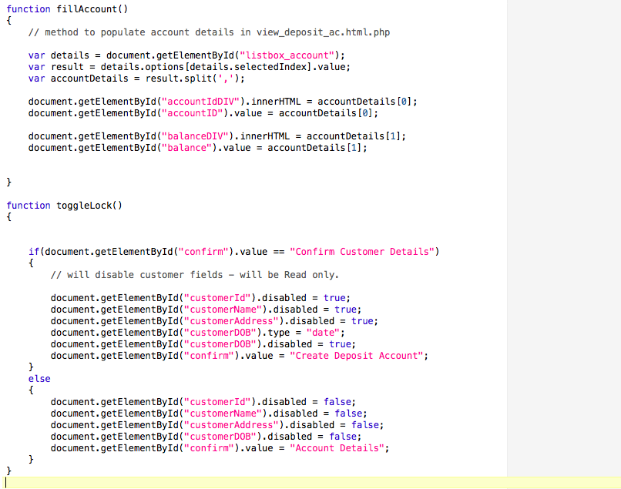

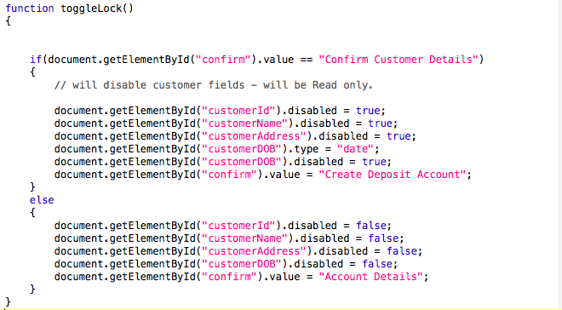

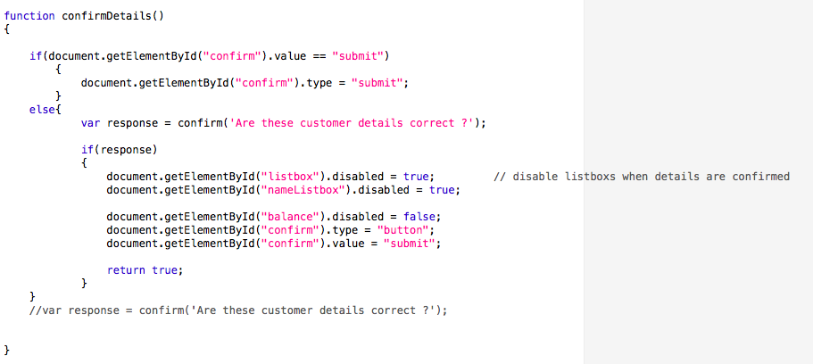

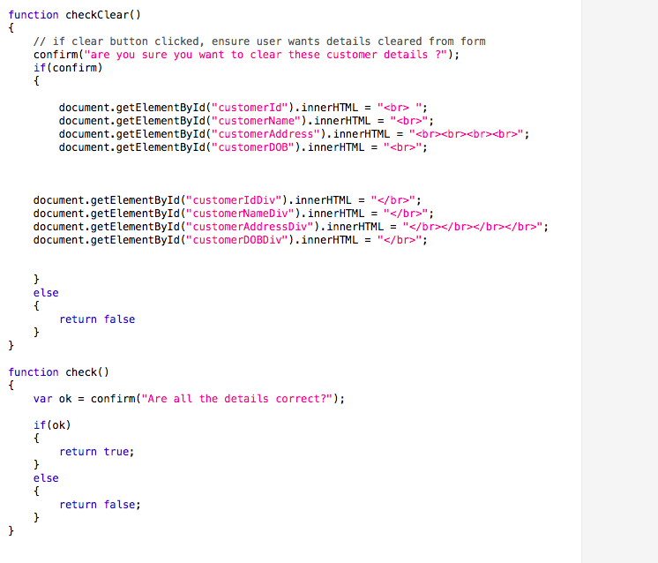

HEAD.PHP

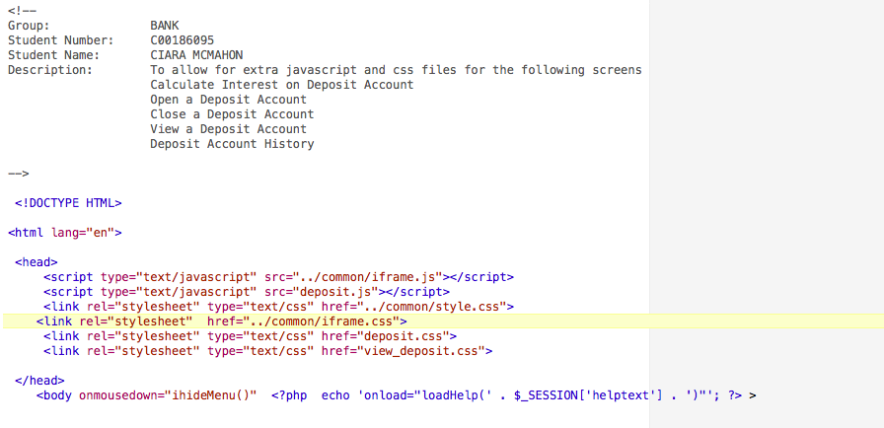

# individual work units (PETER ELLIOTT)

Amend Current Form

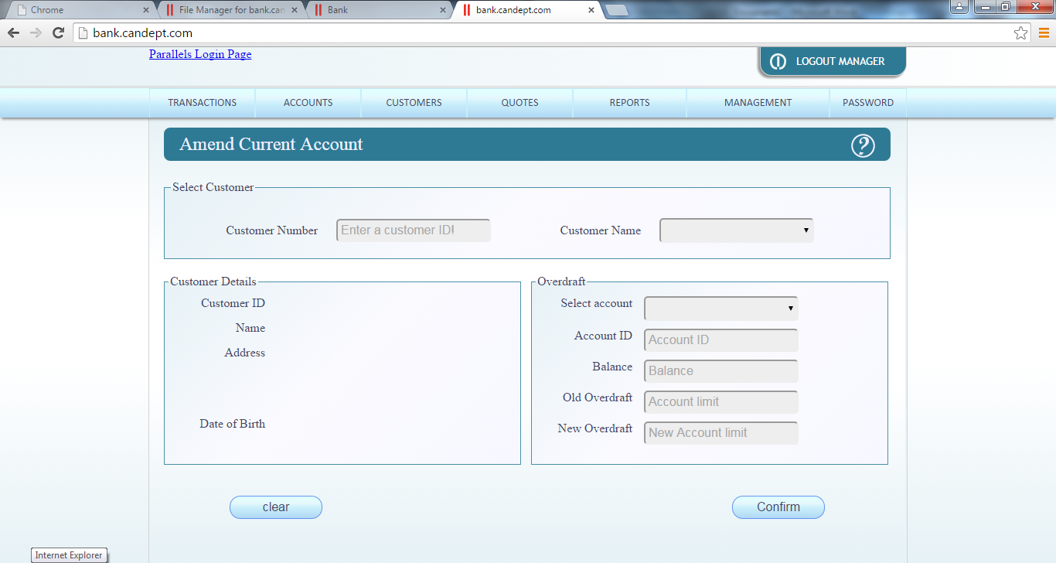

Amend_current_ac.html.php

<?php

**include** "../tom/verify_user.php";

$_SESSION['helptext'] = "' To amend a current account please do the following</b></br></br>Step 1:Select the customer to which the account will be updated select the Customer Number or by selecting the Customer name from the list of customer provided once selected the details will display</br></br> Step 2: Once the correct customer is selected enter the new overdraft limit for the customer ‘s account then click confirm to update the account’";

**include** 'head.php';

?>

<form name=**"amend_current_ac"** id=**"amend_current_ac"** method=**"post"** action=**"amend_current.php"** onsubmit=**"return myUpdate()"**>

<h2>**Amend Current Account** <img src=**"../common/images/help-01.png"** alt=**"Help"** id=**"helpbtn"** onmousedown=**"frameToggleHelp() "** ></h2>

<fieldset class=**"fullwidth"**><!--boarder-->

<legend>**Select Customer**</legend></br><!--text in the boarder-->

<label for=**"UserID"**>**Customer Number**</label>

<input type=**"text"** id=**"UserID"** name=**"UserID"** placeholder=**"Enter a customer ID!"** pattern=**"[0-9]+"** oninput=**"pop(this)"** title=**"User ID's are positive integers"** required>

<!-- above is to enter customer ID while below is a few spaces to seperate the textbox and listbox-->

<label for=**"listbox"**>**Customer Name**</label>

<?php **include** 'Customers.php'; ?>

</fieldset>

<fieldset class=**"halfwidth"**><!--again a boarder-->

<!--the divs are used to display details the breaks are to stop the div from messing up the alinement's of the labels-->

<legend>**Customer Details**</legend><!--the divs are used to display details the breaks are to stop the div from messing up the alinement's of the labels-->

<label>**Customer ID** </label><div id=**"CustomerID"** name=**"CustomerID"**>*&nbsp;*</div><br>

<label>**Name** </label><div id=**"CustomerName"** name=**"CustomerName"**>*&nbsp;*</div><br>

<label>**Address** </label><div id=**"Home"** name=**"Home"**>*&nbsp;*<br></br></br></br></div>

<label>**Date of Birth** </label><div id=**"DOB"** name=**"DOB"**>*&nbsp;*</div><br>

</fieldset>

<fieldset class=**"halfwidth"**>

<legend>**Overdraft**</legend>

<label>**Select account**</label>

<?php **include** 'accounts.php'?>

<label>**Account ID**</label>

<input type=**"text"** id=**"AccID"** name=**"AccID"** placeholder=**"Account ID"** disabled></input >

<label>**Balance** </label>

<input type=**"text"** id=**"Balance"** name=**"Balance"** placeholder=**"Balance"** disabled></input >

<label>**Old Overdraft**</label>

<input type=**"text"** id=**"Limit"** name=**"Limit"** placeholder=**"Account limit"** pattern=**"[0-9]+"** disabled title=**"Whole positive integer values "** required></input >

<label>**New Overdraft**</label>

<input type=**"text"** id=**"NewLimit"** name=**"NewLimit"** placeholder=**"New Account limit"** pattern=**"[0-9]+"** title=**"Whole positive integer values "** required></input >

</fieldset>

<input type=**"submit"** id=**"Confirm"** name=**"Confirm"** value=**"Confirm"**>

<input type=**"reset"** id=**"clear"** name=**"clear"** value=**"clear"** onclick=**"clean()"**>

</form>

</body>

</html>

Amend_current.php

<?php

**include** 'db.inc.php';

//update the current acount overdraft limit where acount number selected customer acount

$sql = "UPDATE currentAccount

SET overdraftLimit = '**$_POST**[NewLimit]'

Where accountNumber = '**$_POST**[AccountID]' AND closed = 0";

**if** (!$result = **mysql_query**($sql, $con))

{

**die** ('Error unable to update current account ' . **mysql_error**());

}

**mysql_close**($con);

header("location: amend_current_ac.html.php") ;

?>

Charge interest rates

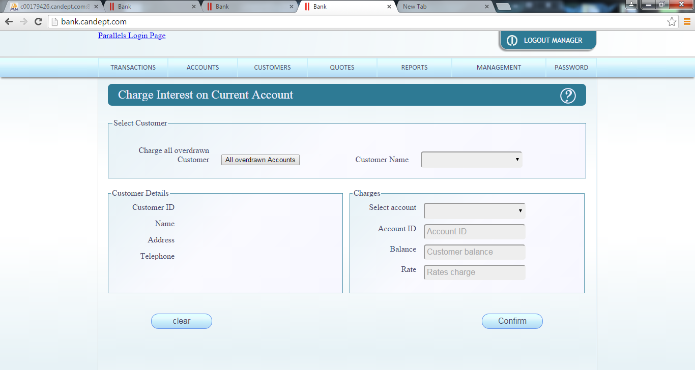

chargeint_current_ac.html

<?php

**include** "../tom/verify_manager.php";

$_SESSION['helptext'] = "'This is the help text that is specific to the Charge Interest on Current Account form'";

**include** 'head.php';

?>

<form name=**"chargeint_current_ac"** id=**"chargeint_current_ac"" method="**post" action=**"chargeint_current_ac.php"** onsubmit=**"return Chargedrates()"**>

<h2>**Charge Interest on Current Account** <img src=**"../common/images/help-01.png"** alt=**"Help"** id=**"helpbtn"** onmousedown=**"frameToggleHelp() "** ></h2>

<fieldset class=**"fullwidth"**><!--boarder-->

<legend>**Select Customer**</legend></br><!--text in the boarder-->

<label>**Charge all overdrawn Customer**</label>

<button type=**"button"** id=**"Overdrawns"** value=**"Overdrawns"** onclick=**"calcAllDeposits()"**>**All overdrawn Accounts**</button>

<!-- above is to enter customer ID while below is a few spaces to seperate the textbox and listbox-->

*&nbsp;&nbsp;&nbsp;&nbsp;*

<label for=**"listbox"**>**Customer Name**</label>

<?php **include** 'charge_customers.php'; ?>

</fieldset>

<fieldset class=**"halfwidth"**><!--again a boarder-->

<legend>**Customer Details**</legend><!--the divs are used to display details the breaks are to stop the div from messing up the alinement's of the labels-->

<label>**Customer ID** </label><div id=**"CustomerID"** name=**"CustomerID"**>*&nbsp;*</div><br>

<label>**Name** </label><div id=**"CustomerName"** name=**"CustomerName"**>*&nbsp;*</div><br>

<label>**Address** </label><div id=**"CustomerAddress"** name=**"CustomerAddress"**>*&nbsp;*</div></br></br></br>

<label>**Telephone** </label><div id=**"CustomerPhone"** name=**"CustomerPhone"**>*&nbsp;*</div>

</fieldset>

<fieldset class=**"halfwidth"**>

<legend>**Charges**</legend>

<label>**Select account**</label>

<?php **include** 'charge_account.php'?>

<label>**Account ID**</label>

<input type=**"text"** id=**"AccountID"** name=**"AccountID"** placeholder=**"Account ID"** readonly>

<label>**Balance** </label>

<input type=**"text"** id=**"Balance"** name=**"Balance"** placeholder=**"Customer balance"** readonly>

<label>**Rate**</label>

<input type=**"text"** id=**"IntRates"** name=**"IntRates"** placeholder=**"Rates charge"** readonly required title=**"Please chose a Customer and account"**>

</fieldset>

<input type=**"submit"** id=**"Confirm"** name=**"Confirm"** value=**"Confirm"** >

<input type=**"reset"** id=**"clear"** name=**"clear"** value=**"clear"** onclick=**"Tidy()"**><!--the method empty is used to clear the divs-->

</form>

</body>

</html>

chargeint_current_ac.php

<?php

date_default_timezone_set('Europe/London');

**include** '../common/db.inc.php';

$sql = "SELECT max(transactionID) as Max

FROM transaction";

**if** (!$result = **mysql_query**($sql, $con))

{

**die** ('Error unable to create transaction for account ' . **mysql_error**());

}

$Rowcounter = **mysql_affected_rows**();

**if**($Rowcounter == 1)

{

$Row= **mysql_fetch_array**($result);

$_SESSION['transactionID'] = $Row['Max'] +1;

}

**else**

{

$_SESSION['transactionID'] = 1;

}

$TrainsAct = **date**('Y-m-d');

$Bal = $_POST['Balance'];

$Rates = $_POST['IntRates'];

$Amount = $Bal * $Rates;

$NewBal = $Bal - $Amount;

$sql = "INSERT INTO transaction(transactionID, accountNumber, amount, date, balanceAfter, type)

VALUES('**$_SESSION**[transactionID]', '**$_POST**[AccountID]', '**$Amount**', '**$TrainsAct**', '**$NewBal**', 'Interest')";

**if** (!$result = **mysql_query**($sql, $con))

{

**die** ('Error unable to process transaction ' . **mysql_error**());

}

$sql = "UPDATE currentAccount

SET balance = '**$NewBal**'

WHERE currentAccount.accountNumber = '**$_POST**[AccountID]'";

**if** (!$result = **mysql_query**($sql, $con))

{

**die** ('Error unable to update customer account ' . **mysql_error**());

}

**mysql_close**($con);

header("location: chargeint_current_ac.html.php");

?>

Charge_customers

<?php

**include** '../common/db.inc.php';

date_default_timezone_set('Europe/London');

$sql = "SELECT customer.customerNumber, firstName, surname, address1, address2, address_town ,address_county, telephone, accountHolder.accountNumber

FROM customer, accountHolder, currentAccount

WHERE customer.customerNumber = accountHolder.customerNumber AND accountHolder.accountNumber = currentAccount.accountNumber AND currentAccount.closed = '0' AND customer.deleted =0

ORDER BY surname desc";

**if**(!$result = **mysql_query**($sql,$con))

{

**die**('Error in query' . **mysql_error**());

}

**echo** "<select name = 'listbox' id='listbox' onclick='Charge()'";

**echo** "<br><option id='-1' selected disabled hidden value ='&nbsp;,</br>,</br>,</br>'></option>";

$lastID = '-1';

**while**($row = **mysql_fetch_array**($result))

{

$ID= $row['customerNumber'];

$Name = $row['firstName'] . " " . $row['surname'];

$Home = $row['address1'] ."<br>" . $row['address2'] ."<br>" . $row['address_town'] ."<br>" . $row['address_county'];

$Phone = $row['telephone'];

$display ="**$ID**,**$Name**,**$Home**, **$Phone**";

**if**($ID == $lastID)

{

**echo**"<option id='**$ID**' value='**$display**' hidden>**$Name**</option>";

}

**else**

{

**echo**"<option id='**$ID**' value = '**$display**'>**$Name**</option>";

}

$lastID = $ID;

}

**echo**"</select>";

**mysql_close**($con);

?>

charge_accounts

<?php

**include** '../common/db.inc.php';

date_default_timezone_set('Europe/London');

$sql = "SELECT customer.customerNumber, accountHolder.accountNumber, accountType, balance, overdraftLimit, rate.rate, description

FROM customer, accountHolder, currentAccount, rate

WHERE customer.customerNumber = accountHolder.customerNumber AND accountHolder.accountNumber = currentAccount.accountNumber AND accountHolder.accountType = 'Current'

AND customer.deleted ='0' AND description ='Overdraft charge rate'";

**if**(!$result = **mysql_query**($sql,$con))

{

**die**('Error can not go through with withdrawals query' . **mysql_error**());

}

**echo** "<select name='Accountlist' id='Accountlist' onchange='showCharge()' onclick='disabled=false' >";

**echo** "<br><option id='-1' selected disabled hidden value ='</br>,</br>'></option>";

**while**($row = **mysql_fetch_array**($result))

{

$ID= $row['customerNumber'];

$Account = $row['accountNumber'];

$Bal =$row['balance'];

$Limit =$row['overdraftLimit'];

$Rates =$row['rate'];

$Type = $row['accountType'];

$Limit = '($Limit * -1)';

**if**($Bal <= 0)

{

$Details ="**$ID**,**$Account**,**$Bal**,**$Rates**";

**echo**"<option id='**$ID**' value ='**$Details**' hidden>**$Type** **$Account**</option>";

}

}

**echo**"</select>";

**mysql_close**($con);

?>

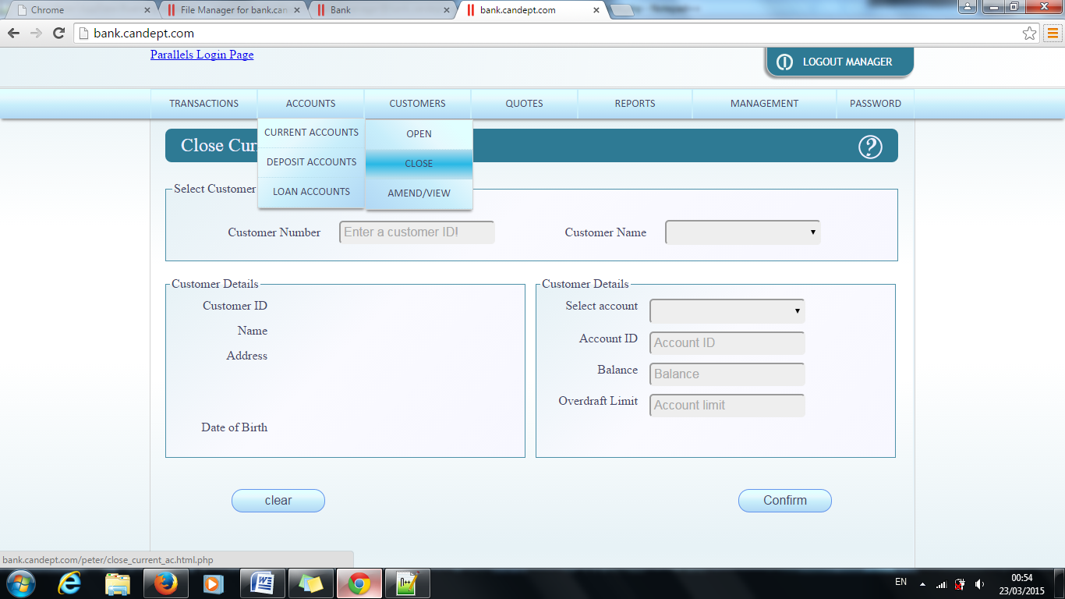

Close current account

<?php

**include** "../tom/verify_user.php";

$_SESSION['helptext'] = "' To close a current account for a <b>existing customer</b></br></br>Step 1:Select the customer to which the account will be assigned by entering the Customer Number or by selecting the Customer name from the list of customer provided once selected the details will display</br></br> Step 2: Once the correct customer is selected click confirm to close account'";

**include** 'head.php';

?>

<form name=**"close_current_ac"** id=**"close_current_ac"** method=**"post"** action=**"close_current.php"** >

<h2>**Close Current Account** <img src=**"../common/images/help-01.png"** alt=**"Help"** id=**"helpbtn"** onmousedown=**"frameToggleHelp() "** ></h2>

<fieldset class=**"fullwidth"**><!--boarder-->

<legend>**Select Customer**</legend></br><!--text in the boarder-->

<label for=**"UserID"**>**Customer Number**</label>

<input type=**"text"** id=**"UserID"** name=**"UserID"** placeholder=**"Enter a customer ID!"** pattern=**"[0-9]+"** oninput=**"closing(this)"** title=**"User ID's are positive integers"**>

<!-- above is to enter customer ID while below is a few spaces to seperate the textbox and listbox-->

<label for=**"listbox"**>**Customer Name**</label>

<?php **include** 'Customers.php'; ?>

</fieldset>

<fieldset class=**"halfwidth"**><!--again a boarder-->

<legend>**Customer Details**</legend>

<!--the divs are used to display details the breaks are to stop the div from messing up the alinement's of the labels-->

<label>**Customer ID** </label><div id=**"CustomerID"** name=**"CustomerID"**>*&nbsp;*<br></div>

<label>**Name** </label><div id=**"CustomerName"** name=**"CustomerName"**>*&nbsp;*<br></div>

<label>**Address** </label><div id=**"Home"** name=**"Home"**>*&nbsp;*<br></br></br></br></div>

<label>**Date of Birth** </label><div id=**"DOB"** name=**"DOB"**>*&nbsp;*</div>

</fieldset>

<fieldset class=**"halfwidth"**><!--again a boarder-->

<legend>**Customer Details**</legend>

<!--the divs are used to display details the breaks are to stop the div from messing up the alinement's of the labels-->

<label>**Select account**</label>

<?php **include** 'accounts.php'?>

<label>**Account ID**</label>

<input type=**"text"** id=**"AccID"** name=**"AccID"** placeholder=**"Account ID"** disabled></input >

<label>**Balance** </label>

<input type=**"text"** id=**"Balance"** name=**"Balance"** placeholder=**"Balance"** disabled></input >

<label>**Overdraft Limit** </label>

<input type=**"text"** id=**"Limit"** name=**"Limit"** disabled placeholder=**"Account limit"** pattern=**"[0-9]+"** title=**"Whole positive integer values "** required></input >

</br>

</fieldset>

<input type=**"submit"** id=**"Confirm"** name=**"Confirm"** value=**"Confirm"** onclick=**"myDelete()"**>

<input type=**"reset"** id=**"clear"** name=**"clear"** value=**"clear"** onclick=**"clean()"**>

</form>

</body>

</html>

Customer

<?php

**include** '../common/db.inc.php';

date_default_timezone_set('Europe/London');

$sql = "SELECT customer.customerNumber, firstName, surname, address1, address2, address_town ,address_county, accountHolder.accountNumber

FROM customer, accountHolder, currentAccount

WHERE customer.customerNumber = accountHolder.customerNumber AND accountHolder.accountNumber = currentAccount.accountNumber AND currentAccount.closed = '0' AND customer.deleted =0

ORDER BY surname desc";

**if**(!$result = **mysql_query**($sql,$con))

{

**die**('Error in query' . **mysql_error**());

}

**echo** "<select name = 'listbox' id='listbox' onclick='pop(this)' onclick='disabled=true'";

**echo** "<br><option id='-1' selected disabled hidden value ='&nbsp;,&nbsp;,&nbsp;,</br>,</br>,</br>'></option>";

$lastID = '-1';

**while**($row = **mysql_fetch_array**($result))

{

$ID= $row['customerNumber'];

$Name = $row['firstName'] . " " . $row['surname'];

$RName = $row['surname'] . " " .$row['firstName'];

$Account =$row['accountNumber'];

$dob = **date**("d-m-y", strtotime($dob));

$Home = $row['address1'] ."<br>" . $row['address2'] ."<br>" . $row['address_town'] ."<br>" . $row['address_county'];

$display ="**$ID**, **$Name**, **$Account**, **$Home**, **$dob**";

**if**($ID == $lastID)

{

**echo**"<option id='**$ID**' value = '**$display**' hidden>**$RName**</option>";

}

**else**

{

**echo**"<option id='**$ID**' value = '**$display**'>**$Name**</option>";

}

$lastID = $ID;

}

**echo**"</select>";

**mysql_close**($con);

?>

Accounts

<?php

**include** '../common/db.inc.php';

date_default_timezone_set('Europe/London');

$sql = "SELECT customer.customerNumber, accountHolder.accountNumber, accountType, overdraftLimit, balance

FROM customer, accountHolder, currentAccount

WHERE customer.customerNumber = accountHolder.customerNumber AND accountHolder.accountNumber = currentAccount.accountNumber AND accountHolder.accountType = 'Current'

ORDER BY surname desc";

//this sql query is to get different current acount customers acount set up to be displayed

**if**(!$result = **mysql_query**($sql,$con))

{

**die**('Error unable to load accounts ' . **mysql_error**());

}

**echo** "<select name='Accounts' id='Accounts' onclick='myAccounts()'>";

**echo** "<br><option id='-1' selected disabled hidden value =','></option>";

**while**($row = **mysql_fetch_array**($result))

{

$ID= $row['customerNumber'];

$Account = $row['accountNumber'];

$Bal =$row['balance'];

$Limit =$row['overdraftLimit'];

$Type =$row['accountType'];

$Details ="**$ID**,**$Account**,**$Bal**,**$Limit**";

**echo**"<option id='**$ID**' value ='**$Details**' hidden>**$Type** **$Account**</option>";

}

**echo**"</select>";

**mysql_close**($con);

?>

Head

<!DOCTYPE HTML>

<html lang=**"en"**>

<head>

<script type=**"text/javascript"** src=**"../common/iframe.js"**></script>

<link rel=**"stylesheet"** type=**"text/css"** href=**"../common/style.css"**>

<script type=**"text/javascript"** src=**"Current_Account_Javascript.js"** ></script>

<!--Please take note all script in Current_Account_Javascript.js script that only affect pages in my personal folder-->

</head>

<body onmousedown=**"ihideMenu()"** <?php **echo** 'onload="loadHelp(' . $_SESSION['helptext'] . ')"'; ?> >

Javascript

/*The following code is broken in to different section based of the file being used*/

/* Open Current Account Java functions*/

***function*** populate**(**caller**)**

**{** //populat function for open current account

***var*** Details**;**

***var*** targetID**;**

***var*** result**;**

***if*(** caller**.**name **==** "UserID"**)**

**{** Details **=** document**.**getElementById**(**'listbox'**);**

targetID **=** document**.**getElementById**(**caller**.**value**);**

***if*(**targetID **==** null**)**

**{**

empty**();**

**}**

***else*{**result **=** targetID**.**value**;}**

document**.**getElementById**(**'listbox'**).**disabled **=*true*;** //if the lsitbox is not disabled it check the list box to the

**}**

***else***

**{** Details **=** document**.**getElementById**(**'listbox'**);**

result **=** Details**.**options**[**Details**.**selectedIndex**].**value**;**

**}**

***var*** personalDetails **=** result**.**split**(**','**);**

document**.**getElementById**(**"CustomerID"**).**innerHTML **=** personalDetails**[**0**];**

document**.**getElementById**(**"UserID"**).**value**=** personalDetails**[**0**];**

document**.**getElementById**(**"CustomerName"**).**innerHTML **=** personalDetails**[**1**];**

document**.**getElementById**(**"CustomerAddress"**).**innerHTML **=** personalDetails**[**2**];**

document**.**getElementById**(**"CustomerDOB"**).**type **=** "text"**;**

document**.**getElementById**(**"CustomerDOB"**).**innerHTML **=** personalDetails**[**3**];**

document**.**getElementById**(**'listbox'**).**disabled **=*false*;**

**}**/*end of populate*/

***function*** empty**()**

**{** /*this function is used to clear the divs for the customer detail breaks are used to keep everything the same size

this function is to clear the open current account page*/

document**.**getElementById**(**"CustomerID"**).**innerHTML **=** "</br>"**;**

document**.**getElementById**(**"CustomerName"**).**innerHTML **=** "</br>"**;**

document**.**getElementById**(**"CustomerAddress"**).**innerHTML **=** "</br></br></br></br>"**;**

document**.**getElementById**(**"CustomerDOB"**).**innerHTML **=** "</br>"**;**

**}**/*end of empty*/

***function*** myCreate**()**

**{**

***var*** reponse **=** confirm**(**"Are you sure hyou want to proceed with this action"**);**

***if*(**reponse **==** ***true*)**

**{** // this one is for the open current account

alert**(**"A new current account has been created for customer account: " **+** document**.**getElementById**(**"UserID"**).**value**);**

***return*** ***true*;**

**}**

***else***

**{**

***return*** ***false*;**

**}**

**}**/* end of myCreate*/

/*This ends the Open current account functions*/

/*This beings the Amend current account functions*/

***function*** pop**(**caller**)**

**{** //populate function for close & admend current account

***var*** Details**;**

***var*** targetID**;**

***var*** result**;**

***if*(**caller**.**name **==** "UserID"**)**

**{**

Details **=** document**.**getElementById**(**'listbox'**);**

targetID **=** document**.**getElementById**(**caller**.**value**);**

***if*(**targetID **==** null**)**

**{**

clean**();**

**}**

***else***

**{**

result **=** targetID**.**value**;**

**}**

document**.**getElementById**(**'listbox'**).**disabled **=*true*;**

**}**

***else***

**{**

Details **=** document**.**getElementById**(**'listbox'**);**

result **=** Details**.**options**[**Details**.**selectedIndex**].**value**;**

**}**

***var*** personalDetails **=** result**.**split**(**','**);**

document**.**getElementById**(**"UserID"**).**value**=** personalDetails**[**0**];**

document**.**getElementById**(**"CustomerID"**).**innerHTML **=** personalDetails**[**0**];**

document**.**getElementById**(**"CustomerName"**).**innerHTML **=** personalDetails**[**1**];**

document**.**getElementById**(**"Home"**).**innerHTML **=** personalDetails**[**3**];**

document**.**getElementById**(**"DOB"**).**innerHTML **=** "text"**;**

document**.**getElementById**(**"DOB"**).**innerHTML **=** personalDetails**[**4**];**

ShowAccounts**(**personalDetails**[**0**]);**//this is to pass the user ID to the account list

document**.**getElementById**(**'listbox'**).**disabled **=*false*;**

**}**/*end of pop*/

***function*** clean**()**

**{** //to clear the divs in the admend file

document**.**getElementById**(**"CustomerID"**).**innerHTML **=** "</br>"**;**

document**.**getElementById**(**"CustomerName"**).**innerHTML **=** "</br>"**;**

document**.**getElementById**(**"Balance"**).**innerHTML **=** "</br>"**;**

document**.**getElementById**(**"Limit"**).**innerHTML **=** "</br>"**;**

**}**/*end of clean*/

***function*** myUpdate**()**

**{**// this one is for the open current account

***var*** reponse **=** confirm**(**"Are you sure you want to proceed with this action"**);**

***if*(**reponse **==** ***true*)** **{**

alert**(**"Account " **+** document**.**getElementById**(**"AccountID"**).**value **+** " has been updated"**);**

***return*** ***true*;**

**}**

***else*{**

***return*** ***false*;**

**}**

**}**/* end of myUpdate*/

/*This ends the Amend current account functions*/

/*This beings the Close current account functions*/

***function*** closing**(**caller**)**

**{** //populate function for adment current account

***var*** Details**;**

***var*** targetID**;**

***var*** result**;**

***if*(**caller**.**name **==** "UserID"**)**

**{**

Details **=** document**.**getElementById**(**'listbox'**);**

targetID **=** document**.**getElementById**(**caller**.**value**);**

***if*(**targetID **==** null**)**

**{**

cleaning**();**

**}**

***else***

**{**

result **=** targetID**.**value**;**

**}**

document**.**getElementById**(**'listbox'**).**disabled **=*true*;**

**}**

***else***

**{**

Details **=** document**.**getElementById**(**'listbox'**);**

result **=** Details**.**options**[**Details**.**selectedIndex**].**value**;**

**}**

***var*** personalDetails **=** result**.**split**(**','**);**

document**.**getElementById**(**"CustomerID"**).**innerHTML **=** personalDetails**[**0**];**

document**.**getElementById**(**"CustomerName"**).**innerHTML **=** personalDetails**[**1**];**

document**.**getElementById**(**"Home"**).**innerHTML **=** personalDetails**[**2**];**

document**.**getElementById**(**"DOB"**).**innerHTML **=** personalDetails**[**3**];**

document**.**getElementById**(**"AccountID"**).**value **=** personalDetails**[**4**];**

document**.**getElementById**(**"Balance"**).**innerHTML **=** personalDetails**[**5**];**

document**.**getElementById**(**"Limit"**).**innerHTML **=** personalDetails**[**6**];**

document**.**getElementById**(**'listbox'**).**disabled **=*false*;**

**}**/*end of closing*/

***function*** cleaning**()**

**{** //to clear the divs in the admend file

document**.**getElementById**(**"CustomerID"**).**innerHTML **=** "</br>"**;**

document**.**getElementById**(**"CustomerName"**).**innerHTML **=** "</br>"**;**

document**.**getElementById**(**"AccID"**).**innerHTML **=** "</br>"**;**

document**.**getElementById**(**"Balance"**).**innerHTML **=** "</br>"**;**

document**.**getElementById**(**"Limit"**).**innerHTML **=** "</br>"**;**

document**.**getElementById**(**"Home"**).**innerHTML **=** "</br></br></br></br>"**;**

document**.**getElementById**(**"DOB"**).**innerHTML **=** "</br>"**;**

**}**/*end of cleaning*/

***function*** myDelete**()**

**{**

***var*** reponse **=** confirm**(**"Are you sure you want to proceed with this action"**);**

***if*(**reponse **==** ***true*)**

**{** // this one is for the admend & close current account pages

alert**(**"Account " **+** document**.**getElementById**(**"AccountID"**).**value **+** " has been closed"**);**

***return*** ***true*;**

**}**

***else***

**{**

***return*** ***false*;**

**}**

**}**/* end of myDelete*/

/*This ends the Close current account functions*/

/*The following function is share by bought Admend & close */

***function*** myAccounts**()**

**{**

***var*** Details **=** document**.**getElementById**(**'Accounts'**);**

***var*** result **=** Details**.**options**[**Details**.**selectedIndex**].**value**;**

***var*** personalDetails **=** result**.**split**(**','**);**

document**.**getElementById**(**"AccID"**).**value **=** personalDetails**[**1**];**

document**.**getElementById**(**"Balance"**).**value **=** personalDetails**[**2**];**

document**.**getElementById**(**"Limit"**).**value **=** personalDetails**[**3**];**

**}**

***function*** ShowAccounts**(**Customer**)**

**{**

***var*** Details **=** document**.**getElementById**(**'Accounts'**);**

***var*** loop**=**1**;**

***var*** accountDetails**;**

***while*(**loop **<=** Details**.**options**.**length**)**

**{**

accountDetails **=** Details**.**options**[**loop**].**value**;**

accountDetails **=** accountDetails**.**split**(**','**);**

***if*(**Customer **==** accountDetails**[**0**])**

**{**

Details**.**options**[**loop**].**hidden **=** ***false*;**

**}**

***else***

**{**

Details**.**options**[**loop**].**hidden **=** ***true*;**

Details**.**selectedIndex**.**hidden **=*true*;**

document**.**getElementById**(**"AccID"**).**value **=** ""**;**

document**.**getElementById**(**"Balance"**).**value **=** ""**;**

document**.**getElementById**(**"Limit"**).**value **=** ""**;**

**}**

loop**++;**

**}**

**}**/*end of ShowAccounts()*/

/*This beings the Withdraw from accounts functions*/

***function*** Withdraw**(**caller**)** //populate function for the withdrawals page

**{**

***var*** Details**;**

***var*** targetID**;**

***var*** result**;**

***var*** personalDetails**;**

***if*(** caller**.**name **==** "UserID"**)**

**{**

Details **=** document**.**getElementById**(**'listbox'**);**

targetID **=** document**.**getElementById**(**caller**.**value**);**

***if*(**targetID **==** null**)**

**{**

Cleanup**();**

**}**

***else*{**

result **=** targetID**.**value**;**

**}**

// document.getElementById('listbox').disabled = true; //if the lsitbox is not disabled it check the list box to the

**}**

***else***

**{**

Details **=** document**.**getElementById**(**'listbox'**);**

result **=** Details**.**options**[**Details**.**selectedIndex**].**value**;**

**}**

personalDetails **=** result**.**split**(**','**);**

document**.**getElementById**(**"CustomerID"**).**innerHTML **=** personalDetails**[**0**];**

document**.**getElementById**(**"UserID"**).**value**=** personalDetails**[**0**];**

document**.**getElementById**(**"CustomerName"**).**innerHTML **=** personalDetails**[**1**];**

document**.**getElementById**(**"CustomerAddress"**).**innerHTML **=** personalDetails**[**2**];**

document**.**getElementById**(**"CustomerPhone"**).**innerHTML **=** personalDetails**[**3**];**

Showdetails**(**personalDetails**[**0**]);**//this is to pass the user ID to the account list

document**.**getElementById**(**'listbox'**).**disabled **=*false*;**

**}**/*end of Withdraw*/

***function*** Showdetails**(**Customer**)**

**{**

***var*** Details **=** document**.**getElementById**(**'Accountlist'**);**

***var*** loop**=**1**;**

***var*** accountDetails**;**

***while*(**loop **<** Details**.**options**.**length**)**

**{**

accountDetails **=** Details**.**options**[**loop**].**value**;**

accountDetails **=** accountDetails**.**split**(**','**);**

***if*(**Customer **==** accountDetails**[**0**])**

**{**

Details**.**options**[**loop**].**hidden **=** ***false*;**

**}**

***else***

**{**

Details**.**options**[**loop**].**hidden **=** ***true*;**

Details**.**selectedIndex**.**hidden **=*true*;**

document**.**getElementById**(**"AccountID"**).**value **=** ""**;**

document**.**getElementById**(**"Balance"**).**value **=** ""**;**

**}**

loop**++;**

**}**

**}**/*end of Showdetails()*/

***function*** Cleanup**()**

**{**

***var*** Details **=** document**.**getElementById**(**'Accountlist'**);**

***var*** loop**=**1**;**

document**.**getElementById**(**"CustomerID"**).**innerHTML **=** "</br>"**;**

document**.**getElementById**(**"CustomerName"**).**innerHTML **=** "</br>"**;**

document**.**getElementById**(**"CustomerAddress"**).**innerHTML **=** "</br></br></br></br>"**;**

document**.**getElementById**(**"CustomerPhone"**).**innerHTML **=** "</br>"**;**

***while*(**loop **<=** Details**.**options**.**length**)**

**{**

Details**.**options**[**loop**].**hidden **=** ***true*;**

loop**++;**

**}**

**}**

***function*** Withdrawn**()**

**{**

***var*** reponse **=** confirm**(**"Are you sure you want to proceed with this transaction"**);**

***if*(**reponse **==** ***true*)**

**{** // this one is for the admend & close current account pages

alert**(**"Account " **+** document**.**getElementById**(**"AccID"**).**value **+** " has been deducted " **+** document**.**getElementById**(**"Amount"**).**value**);**

***return*** ***true*;**

**}**

***else***

**{**

***return*** ***false*;**

**}**

**}**/* end of myDelete*/

/*This ends the Withdraw account functions*/

/*This beings the charge current form accounts functions*/

***function*** Charge**()**

**{** //populate the charge overdraft form for current account

***var*** Details**;**

***var*** targetID**;**

***var*** result**;**

Details **=** document**.**getElementById**(**'listbox'**);**

result **=** Details**.**options**[**Details**.**selectedIndex**].**value**;**

***var*** personalDetails **=** result**.**split**(**','**);**

document**.**getElementById**(**"CustomerID"**).**innerHTML **=** personalDetails**[**0**];**

document**.**getElementById**(**"CustomerName"**).**innerHTML **=** personalDetails**[**1**];**

document**.**getElementById**(**"CustomerAddress"**).**innerHTML **=** personalDetails**[**2**];**

document**.**getElementById**(**"CustomerPhone"**).**type **=** "text"**;**

document**.**getElementById**(**"CustomerPhone"**).**innerHTML **=** personalDetails**[**3**];**

Showdetails**(**personalDetails**[**0**]);**

**}**/*end of Charge*/

***function*** Tidy**()**

**{** /*this function is used to clear the divs for the customer detail breaks are used to keep everything the same size

this function is to clear the open current account page*/

document**.**getElementById**(**"CustomerID"**).**innerHTML **=** "</br>"**;**

document**.**getElementById**(**"CustomerName"**).**innerHTML **=** "</br>"**;**

document**.**getElementById**(**"CustomerAddress"**).**innerHTML **=** "</br></br></br></br>"**;**

document**.**getElementById**(**"CustomerPhone"**).**innerHTML **=** "</br>"**;**

**}**/*end of empty*/

***function*** Chargedrates**()**

**{** ***var*** reponse **=** confirm**(**"Are you sure you want to proceed with this transaction"**);**

***if*(**reponse **==** ***true*)**

**{** alert**(**"Account " **+** document**.**getElementById**(**"AccID"**).**value **+** " has been charged overdraft of " **+** document**.**getElementById**(**"Amount"**).**value**);**

***return*** ***true*;**

**}**

***else***

**{**

***return*** ***false*;**

**}**

**}**/* end of myDelete*/

***function*** showCharge**()**

**{** //Please note that this function is also used buy the charge rates

***var*** Details **=** document**.**getElementById**(**'Accountlist'**);**

***var*** result **=** Details**.**options**[**Details**.**selectedIndex**].**value**;**

***var*** personalDetails **=** result**.**split**(**','**);**

document**.**getElementById**(**"AccountID"**).**value **=** personalDetails**[**1**];**

document**.**getElementById**(**"Balance"**).**value **=** personalDetails**[**2**];**

document**.**getElementById**(**"IntRates"**).**value **=** personalDetails**[**3**];**

**}**

***function*** showBal**()**

**{** //Please note that this function is also used buy the charge rates

***var*** Details **=** document**.**getElementById**(**'Accountlist'**);**

***var*** result **=** Details**.**options**[**Details**.**selectedIndex**].**value**;**

***var*** personalDetails **=** result**.**split**(**','**);**

document**.**getElementById**(**"AccID"**).**value **=** personalDetails**[**1**];**

document**.**getElementById**(**"AccType"**).**value **=** personalDetails**[**2**];**

document**.**getElementById**(**"Balance"**).**value **=** personalDetails**[**3**];**

**}**

***function*** enable**(**sender**)**

**{**

sender**.**disabled**=*false*;**

**}**

Open account

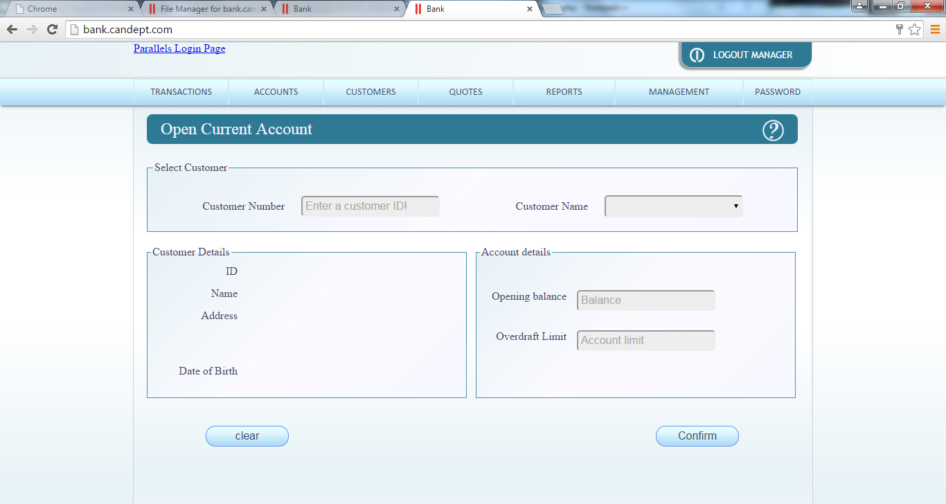

HTML form

<!--Coder:Peter Elliott

N.B Please use google chrome to view website please-->

<?php

**include** "../tom/verify_user.php";

$_SESSION['helptext'] = "'To open a current account for a <b>existing customer</b></br></br>Step 1:Select the customer to which the account will be assigned by entering the Customer Number or by selecting the Customer name from the list of customer provided once selected the details will display</br></br> Step 2: Once the correct customer is selected enter an opening balance (optional) and an Overdraft limit (required) in the box's to the right remember whole integer numbers</br></br>Step 3: Once a Overdraft Limit has been entered click confirm to create the Current Account else click cancel to clear details'";

**include** 'head.php';

?>

<form name=**"open_current_ac"** id=**"open_current_ac"** method=**"post"** action=**"add_current.php"** onsubmit=**"return myCreate()"**>

<h2>**Open Current Account** <img src=**"../common/images/help-01.png"** alt=**"Help"** id=**"helpbtn"** onmousedown=**"frameToggleHelp() "** ></h2>

<fieldset class=**"fullwidth"**><!--boarder-->

<legend>**Select Customer**</legend></br><!--text in the boarder-->

<label>**Customer Number**</label>

<input type=**"text"** id=**"UserID"** name=**"UserID"** placeholder=**"Enter a customer ID!"** pattern=**"[0-9]+"** oninput=**"populate(this)"** title=**"User ID's are positive integers"** required>

<!-- above is to enter customer ID while below is a few spaces to seperate the textbox and listbox-->

*&nbsp;&nbsp;&nbsp;&nbsp;*

<label for=**"listbox"**>**Customer Name**</label>

<?php **include** 'open_current_ac.php'; ?>

</fieldset>

<fieldset class=**"halfwidth"**><!--again a boarder-->

<legend>**Customer Details**</legend><!--the divs are used to display details the breaks are to stop the div from messing up the alinement's of the labels-->

<label>**ID** </label><div id=**"CustomerID"** name=**"CustomerID"**>*&nbsp;*</div><br>

<label>**Name** </label><div id=**"CustomerName"** name=**"CustomerName"**>*&nbsp;*<br></div>

<label>**Address** </label><div id=**"CustomerAddress"** name=**"CustomerAddress"**>*&nbsp;*<br></br></br></br></div>

<label>**Date of Birth** </label><div id=**"CustomerDOB"** name=**"CustomerDOB"**>*&nbsp;*</div>

</fieldset>

<fieldset class=**"halfwidth"**>

<legend>**Account details**</legend>

</br></br>

<label>**Opening balance** </label>

<input type=**"text"** id=**"Balance"** name=**"Balance"** placeholder=**"Balance"** pattern=**"[0-9.]+"** title=**"Whole positive integer values "**>

</br></br>

<label>**Overdraft Limit** </label>

<input type=**"text"** id=**"Limit"** name=**"Limit"** placeholder=**"Account limit"** pattern=**"[0-9.]+"** title=**"Whole positive integer values "** required>

</fieldset>

<input type=**"submit"** id=**"Confirm"** name=**"Confirm"** value=**"Confirm"**>

<input type=**"reset"** id=**"clear"** name=**"clear"** value=**"clear"** onclick=**"empty()"**><!--the method empty is used to clear the divs-->

</form>

</body>

</html>

Open current account

<?php

**include** '../common/db.inc.php';

**include** "db.inc.php";

date_default_timezone_set('Europe/London');

$sql = "Select customerNumber, firstName, surname, address1, address2, address_town ,address_county, birthDate

FROM customer";

**if**(!$result = **mysql_query**($sql,$con))

{

**die**('Error in query' . **mysql_error**());

}

**echo** "<select name='listbox' id='listbox' onclick='populate(this)'";

**echo** "<br><option id='-1' selected disabled hidden value ='&nbsp;,</br>,</br></br></br></br>,</br>'></option>";

**while**($row = **mysql_fetch_array**($result))

{

$ID= $row['customerNumber'];

$Fname = $row['firstName'];

$Sname = $row['surname'];

$dob = $row['birthDate'];

$dob = **date**("d-m-y", strtotime($dob));

$Home = $row['address1'] ."<br>" . $row['address2'] ."<br>" . $row['address_town'] ."<br>" . $row['address_county'];

$display ="**$ID**, **$Fname** **$Sname** ,**$Home** ,**$dob**";

**echo**"<option id='**$ID**' value = '**$display**'>**$Sname** **$Fname**</option>";

}

**echo**"</select>";

**mysql_close**($con);

?>

Add current Account

<?php

date_default_timezone_set('Europe/London');

**include** 'db.inc.php';

$sql = "SELECT max(accountNumber) as Max

FROM accountHolder";

//max get the highest vaule in the field of the table

**if** (!$result = **mysql_query**($sql, $con))

{

**die** ('Error in querying the database ' . **mysql_error**());

}

$Rowcounter = **mysql_affected_rows**();

**if** ($Rowcounter == 1)

{

$Row= **mysql_fetch_array**($result);

$_SESSION['accountNumber'] = $Row['Max'] +1;

}

**else**

{

$_SESSION['accountNumber'] = 1;

}

$Opendate = **date**('Y-m-d');

$sql = "INSERT INTO currentAccount(accountNumber, balance, overdraftLimit, openDate)

VALUES('**$_SESSION**[accountNumber]', '**$_POST**[Balance]', '**$_POST**[Limit]', '**$Opendate**')";

**if** (!$result = **mysql_query**($sql, $con))

{

**die** ('Error unable to create current account ' . **mysql_error**());

}

$sql = "INSERT INTO accountHolder(customerNumber, accountNumber, accountType)

VALUES('**$_POST**[UserID]', '**$_SESSION**[accountNumber]', 'Current')";

**if** (!$result = **mysql_query**($sql, $con))

{

**die** ('Error could not inset account holder ' . **mysql_error**());

}

**mysql_close**($con);

header ("location: open_current_ac.html.php") ;

?>

Withdrawals

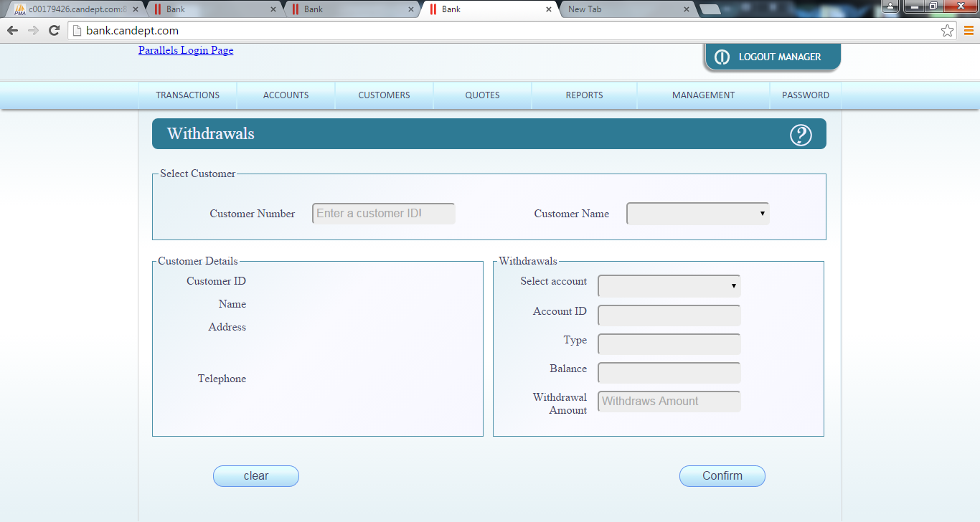

<?php

**include** "../tom/verify_user.php";

$_SESSION['helptext'] = "'Please the select a customer from one of the provided methods available next enter in the amount to be withdrawn then click confirm to complete the action'";

withdrawals form'";

**include** 'head.php';

?>

<form name=**"withdrawals"** id=**"withdrawals"** method=**"post"** action=**"withdrawals.php"** onsubmit=**"return Withdrawn()"**>

<h2>**Withdrawals** <img src=**"../common/images/help-01.png"** alt=**"Help"** id=**"helpbtn"** onmousedown=**"frameToggleHelp() "** ></h2>

<fieldset class=**"fullwidth"**><!--boarder-->

<legend>**Select Customer**</legend></br><!--text in the boarder-->

<label>**Customer Number**</label>

<input type=**"text"** id=**"UserID"** name=**"UserID"** placeholder=**"Enter a customer ID!"** pattern=**"[0-9]+"** oninput=**"Withdraw(this)"** title=**"User ID's are positive integers"**>

<!-- above is to enter customer ID while below is a few spaces to seperate the textbox and listbox-->

*&nbsp;&nbsp;&nbsp;&nbsp;*

<label for=**"listbox"**>**Customer Name**</label>

<?php **include** 'Customers.php'; ?>

</fieldset>

<fieldset class=**"halfwidth"**><!--again a boarder-->

<legend>**Customer Details**</legend><!--the divs are used to display details the breaks are to stop the div from messing up the alinement's of the labels-->

<label>**Customer ID** </label><div id=**"CustomerID"** name=**"CustomerID"**>*&nbsp;*</div><br>

<label>**Name** </label><div id=**"CustomerName"** name=**"CustomerName"**>*&nbsp;*</div><br>

<label>**Address** </label><div id=**"CustomerAddress"** name=**"CustomerAddress"**>*&nbsp;*</br></br></br></div>

<label>**Telephone** </label><div id=**"CustomerPhone"** name=**"CustomerPhone"**>*&nbsp;*</div>

</fieldset>

<fieldset class=**"halfwidth"**>

<legend>**Withdrawals**</legend>

<label>**Select account**</label>

<?php **include** 'account_type.php'?>

<label>**Account ID**</label>

<input type=**"text"** id=**"AccID"** name=**"AccID"**>

<label>**Type** </label>

<input type=**"text"** id=**"AccType"** name=**"AccType"**>

<label>**Balance** </label>

<input type=**"text"** id=**"Balance"** name=**"Balance"**>

<label>**Withdrawal Amount** </label>

<input type=**"text"** id=**"Amount"** name=**"Amount"** placeholder=**"Withdraws Amount"** required pattern=**"[0-9]+[.][0-9]{2}"** title=**"Whole positive integer values "**>

</fieldset>

<input type=**"submit"** id=**"Confirm"** name=**"Confirm"** value=**"Confirm"** >

<input type=**"reset"** id=**"clear"** name=**"clear"** value=**"clear"** onclick=**"Cleanup()"**><!--the method empty is used to clear the divs-->

</form>

</body>

</html>

Withdrawals_customer

<?php

**include** '../common/db.inc.php';

date_default_timezone_set('Europe/London');

$sql = "SELECT DISTINCT customer.customerNumber, accountHolder.accountNumber, firstName, surname, address1, address2, address_town, address_county, telephone, accountHolder.accountType, currentAccount.closed, depositAccount.closed

FROM customer, accountHolder, currentAccount, depositAccount

WHERE customer.customerNumber = accountHolder.customerNumber AND accountHolder.accountType != 'loan' AND currentAccount.closed ='0'";

**if**(!$result = **mysql_query**($sql,$con))

{

**die**('Error in query' . **mysql_error**());

}

**echo** "<select name = 'listbox' id='listbox' onclick='Withdraw(this)'";

**echo** "<br><option id='-1' selected disabled hidden value ='&nbsp;,</br>,</br>,</br>'></option>";

$lastID = '-1';

**while**($row = **mysql_fetch_array**($result))

{

$ID= $row['customerNumber'];

$Name = $row['firstName'] . " " . $row['surname'];

$Home = $row['address1'] ."<br>" . $row['address2'] ."<br>" . $row['address_town'] ."<br>" . $row['address_county'];

$Phone = $row['telephone'];

$Type = $row['accountType'];

$Account = $row['accountNumber'];

$display ="**$ID**,**$Name**,**$Home**,**$Phone**";

**if**($ID == $lastID)

{

**echo**"<option id='**$ID**' value = '**$display**' hidden>**$Name**</option>";

}

**else**

{

**echo**"<option id='**$ID**' value = '**$display**'>**$Name**</option>";

}

$lastID = $ID;

}

**echo**"</select>";

**mysql_close**($con);

?>

Withdrawals

<?php

date_default_timezone_set('Europe/London');

**include** '../common/db.inc.php';

$TrainsAct = **date**('Y-m-d');

$sql = "SELECT max(transactionID) as Max

FROM transaction";

**if** (!$result = **mysql_query**($sql, $con))

{

**die** ('Error unable to create transaction for account ' . **mysql_error**());

}

$Rowcounter = **mysql_affected_rows**();

**if**($Rowcounter == 1)

{

$Row= **mysql_fetch_array**($result);

$_SESSION['transactionID'] = $Row['Max'] +1;

}

**else**

{

$_SESSION['transactionID'] = 1;

}

$Bal = $_POST['Balance'];

$withdrawn = $_POST['Amount'];

$AfterTrainsAct = $Bal - $withdrawn;

$sql = "INSERT INTO transaction(transactionID, accountNumber, amount, date, balanceAfter, type)

VALUES('**$_SESSION**[transactionID]', '**$_POST**[AccID]', '**$_POST**[Amount]', '**$TrainsAct**', '**$AfterTrainsAct**', 'Withdrawal')";

**if** (!$result = **mysql_query**($sql, $con))

{

**die** ('Error unable to process transaction ' . **mysql_error**());

}

$Type = $_POST['AccType'] . 'Account';

$sql = "UPDATE **$Type**

SET balance = '**$AfterTrainsAct**'

Where **$Type**.accountNumber = '**$_POST**[AccID]'";

**if** (!$result = **mysql_query**($sql, $con))

{

**die** ('Error unable to update account ' . **mysql_error**());

}

**mysql_close**($con);

header("location: withdrawals.html.php");

?>